
Pupil Premium strategy statement – Donnington Wood CE Junior 2026- 2027
Year 3 of 3
Introduction
Nationally, the attainment gap for disadvantaged pupils remains a significant challenge, with research continuing to highlight the complex and often widening barriers faced by children experiencing disadvantage. At Donnington Wood Junior School, we recognise that there is no single intervention that can overcome entrenched disadvantage. Instead, our approach is deliberately multi-faceted, inclusive and highly responsive, combining academic support, emotional wellbeing, attendance, behaviour, SEND provision and family engagement to remove barriers to success.
This statement outlines how we have used Pupil Premium funding to support disadvantaged pupils and improve outcomes. Importantly, our definition of disadvantage extends beyond funding eligibility alone. Many of our pupils face overlapping challenges, including SEND, social care involvement, trauma, adverse childhood experiences, low prior attainment, SEMH needs and English as an Additional Language. As a result, our strategy is founded on the principle that effective support must be tailored, relational and responsive to the individual needs of each child.
Our commitment to inclusion is a significant strength of the school. We have worked hard to create a culture where every pupil belongs, every barrier is recognised, and every child is supported to achieve ambitious outcomes. This work has received external recognition through our status as an ARC Alex Timpson Learning Hub, one of only a small number of schools nationally recognised for excellence in attachment-aware and trauma-informed practice. During 2025-2026, this was further recognised through becoming the Regional Winner of the ARC Alex Timpson Award, reflecting the impact of our approach on some of our most vulnerable pupils.
Our inclusive practice extends well beyond pastoral care. Through our leadership of the PINS Project, strengthened SEND provision, highly effective multi-agency working and commitment to the principle that "Behaviour is Communication", we have developed systems that ensure pupils receive timely support before difficulties become entrenched. This has enabled disadvantaged pupils, including those with additional needs, to access learning more successfully and make stronger progress from their starting points.
During 2026-2027, we will further strengthen this work through the publication of a dedicated Inclusion Action Plan. While focused on SEND development, there is significant overlap between SEND and disadvantage within our community. Consequently, this work will complement and strengthen our disadvantaged strategy by ensuring pupils with multiple vulnerabilities receive coordinated and effective support.
We are also clear about the realities of our context. Our school serves a community with a high level of need, and many disadvantaged pupils present with complex and multiple barriers to learning. However, we reject the notion that circumstance should determine achievement. Whilst we acknowledge these challenges openly, they do not diminish our expectations. We remain firmly committed to ensuring that all pupils, regardless of background, receive access to an ambitious curriculum, high-quality teaching and the support necessary to flourish.
Our strategy therefore balances compassion with ambition. We are proud of the progress our disadvantaged pupils make, particularly in attendance, engagement, emotional wellbeing and readiness to learn. At the same time, we remain relentlessly focused on improving academic outcomes further, ensuring that every pupil is equipped with the knowledge, skills and confidence needed for future success. Through high expectations, evidence-informed practice and an unwavering commitment to inclusion, we continue to work towards narrowing gaps and enabling all pupils to thrive.
When creating this document we used: https://assets.publishing.service.gov.uk/media/68e661e3dadf7616351e4f5b/Using_pupil_premium_guidance.pdf as guidance including the menus on page 6.
School overview (as of 25/9/26) THIS IS INTIAL DRAFT, while awaiting validated data and funding numbers
Detail | Data
Number of pupils in school | 176 (keeps changing)
Proportion (%) of pupil premium eligible pupils | 113 class as Ofsted disadvantaged (63%)
 | 109 as FSm and 113 as disadvantaged. There is also information about pupil premium plus coming gout.
Academic year/years that our current pupil premium strategy plan covers (3 year plans are recommended – you must still publish an updated statement each academic year) | 3 of 3 final year of three
Date this statement was published | 10/10/2025  Review 23/9/26 for end of year 2.  This statement date 25/9/26
Date on which it will be reviewed | Fully annually, but will update in Jan with final numbers.
Statement authorised by | Governors
Pupil premium lead | Robert Fox
Governor / Trustee lead | Kerry Deebenham

Funding overview
Detail | Amount
Pupil premium funding allocation this academic year | £198,440 April to April 26-27  132’920 April to April 27-28
Pupil premium funding carried forward from previous years (enter £0 if not applicable) | £0
Total budget for this academic year | £198,440

Part A: Pupil premium strategy plan

Statement of intent
Our School Vision
Our school is a community where each person is valued as a child of God. We are a Church of England school, inspired and guided by the life and teaching of Jesus. We work together to create a caring, friendly and safe school family, to enable the whole school community to flourish and each person reach their full God-given potential.

Our Motto “The ones who plant and the ones who water work together as a team with the same purpose.” 1 Corinthians 3:8 We believe that with God’s help when we all work as a TEAM - Together Everyone Achieves More

Our three core values of Hope, Perseverance and Friendship will provide our disadvantaged pupils with the skill to succeed in life and overcome the barriers to this success in the local area.

Our Mission (INTENT) At Donnington Wood CE Junior School we will:

• put the safety of everyone as a priority so we can work in trust and peace.
• encourage everyone to understand the true meaning of friendship, fellowship and community by acting with humility, compassion and in service to each other.
• be inclusive so everyone is valued and respected and where tolerance and diversity are celebrated.
• seek out every opportunity to ensure that all of us flourish in all that we do, developing wisdom and creativity, through an ambitious and broad curriculum that challenges expectations, deepens knowledge and develops skills.
• empower pupils and adults to develop hope and perseverance, so that they are able to engage/explore the challenges of school and the wider world.
• nurture the spiritual development of our school fellowship, develop tolerance of other faiths, beliefs and cultures and build religious literacy through collective worship of God and teaching of RE.
• champion our values to equip our children ready for their future as respectful individuals, life-long learners and active citizens in society (justice).

This Vision and Mission will be evident in all we do, from the way we work together to the attitudes to life you will see us show. This Policy is one of our most important to deliver the above.

At the start of 2026/2027 90% of pupils are either SEND, Disadvantaged or EAL. With nearly 40% in 2 or more categories.

Leaders act in the best interest of pupils, we champion children despite the complex realities of the school demographic.

Our disadvantaged pupils are safe, successful and flourish in this school, based on their complex realties.

We use this document Primary | EEF to support our rationale strategies.

Challenges
This details the key challenges to achievement that we have identified among our disadvantaged pupils.
Challenge number | Detail of challenge
1 | Academic outcome is lower than the national disadvantaged average.  Significantly below in Reading and Maths, and widening  2025 2026 Data Last year highlighted a specific group of writers.  There is a new measure of comparing like for like and disadvantaged with disadvantaged.  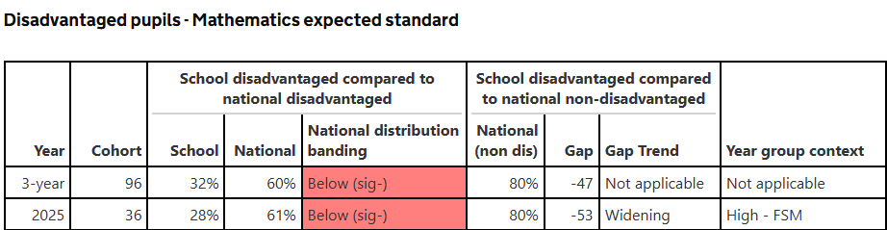  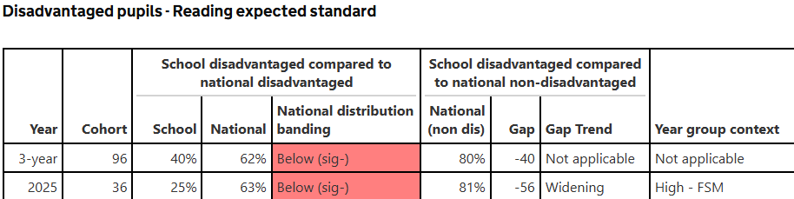
2 | Attendance for disadvantaged pupils fluctuates over the year (due to crisis) which reduces their attainment.
3 | High Mobility: EAL disadvantaged and disadvantaged Mobility means missed learning and pupils arriving with multiple gaps in knowledge- the last three years have seen a 25% change in demographic.
4 | Pupils who are Disadvantaged also have other multiple barriers, compounding existing barriers such as poor attendance, low literacy, and unmet emotional needs.  Especially:  High levels of neglect  High Unmet emotional needs which leads to anxiety, low self-esteem, and difficulty forming relationships.  High levels of Hunger  High level of Trauma  Low levels of attendance  Low parental engagement  Low trip and enrichment engagement including obesity.  High levels of CP. CIN and CIC.  High attainers are less likely to flourish, due to lack of access to resource at home.

Intended outcomes
This explains the outcomes we are aiming for by the end of our current strategy plan, and how we will measure whether they have been achieved.
Intended outcome |  | Success criteria
A The difference in the Maths achievement between Disadvantaged and disadvantaged nationally will close.  3 year data below.  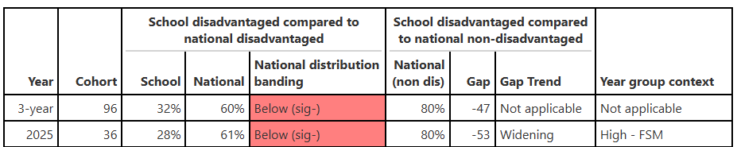 |  | Internal year 4, 5 and external year 6 data will show increased attainment toward 3 year target of national disadvantage ARE 60%  NCETM Project and Mastering Number Oracy Project Milestones are met (see Action Plan).  Osted 25 Judgement: On the whole, pupils achieve well. Typically, this will be reflected in their attainment and progress in national tests and examinations, which are broadly in line with national averages, including for disadvantaged pupils.
B This difference in the reading achievement rate between Disadvantaged and National disadvantaged in school and to national will close. (continued)  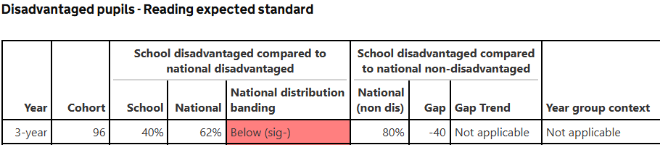 |  | Internal data indicates increased rates of progress.  External data continues to diminish difference to national SDP targets
C PPG pupil’s vocabulary in all subjects will increase to allow pupils to access the curriculum fully through forever facts and retrieval practices. |  | Pupils will increase their reading fluency scores through online reading assessment.  NCETM Mastering Number project will give pupils language to access reasoning.
D The lates and absence of disadvantage pupils linked to crisis in the family home will decrease.  Ofsted: Any reasonable adjustments or adaptations to attendance and/or behaviour strategies are timely and appropriate, including for disadvantaged pupils, those with SEND, those who are known (or previously known) to children’s social care, and those who face barriers to their learning and/or well-being, such as young carers. Any interventions are timely, well chosen and targeted. |  | YVED data communities to exceed target for our attendance.  Disadvantaged pupils who travel a long way and with SW/ Family hubs are supported.
E Disadvantaged pupils, who have multiple barriers, have provision to aid them in meeting their baseline, whether being academic and life milestones.  Of Disadvantaged pupils who are not making progress only 5 are just Disadvantaged. | Informed TEAM of senior leaders able to identify and allocate support (ARC learning Hub) to measure:  1. Emotional Safety and Wellbeing  - Pupils demonstrate improved emotional regulation through reduced incidents of dysregulation or crisis.  - Pupils can identify and access a trusted adult in school when distressed.  - Staff consistently apply trauma-informed strategies in response to behaviour.  2. Engagement and Attendance  - Attendance of targeted pupils improves and is monitored weekly with clear intervention steps.  - Pupils arrive at school ready to learn, with reduced lateness and increased participation in lessons.  - Engagement in learning activities increases, as evidenced by pupil voice and teacher observation.  - free or subsided enrichment through HAFF, Embrace and in school contributions (equal opportunities remit).  3. Academic Progress  - Pupils make measurable progress in reading, writing, and maths from their individual starting points.  - Gaps in attainment between disadvantaged/SEND pupils and their peers begin to narrow over time.  - Targeted interventions (e.g., literacy catch-up, SEMH support) show positive impact in assessment data.  4. Behaviour and Relationships  - Incidents of behaviour linked to unmet emotional needs decrease over the term.  - Pupils demonstrate improved peer relationships and social interaction.  - Staff use restorative approaches consistently to resolve conflict and build trust.  5. Parental and Multi-Agency Engagement  - Increased parental engagement in school activities, meetings, or support plans.  - Effective collaboration with external agencies (e.g., social care, CAMHS) is documented and reviewed.  - Families report feeling supported and involved in their child’s education.  6. Staff Knowledge and Practice  - Staff can articulate the impact of neglect on learning and behaviour.  - All staff receive regular CPD on trauma-informed practice and SEMH strategies.  - Classroom environments reflect inclusive, nurturing principles (e.g., calm spaces, visual supports).

Activity in this academic year
This details how we intend to spend our pupil premium (and recovery premium) funding this academic year to address the challenges listed above.

Teaching (for example, CPD, recruitment and retention)
Budgeted cost: £100’000 [insert amount]
Activity | Evidence that supports this approach | Challenge number(s) addressed
Targeting Disadvantaged Pupils through Quality First Teaching  1. ca for All  - Whole-School QFT Strategy: Ensure all pupils, including those who are disadvantaged, consistently access high-quality teaching from their class teacher.  - Inclusive Planning and Delivery: Embed adaptive teaching strategies, scaffolding, and formative assessment to meet diverse learning needs within mainstream classrooms.  2. Mathematics Focus  - White Rose Maths CPD: Continue professional development focused on reasoning and fluency, using White Rose resources to build conceptual understanding.  - NCETM Supplementary Training: Enhance staff expertise through National Centre for Excellence in the Teaching of Mathematics modules.  - SHAW Maths Hub Project: Engage in the SHAW Maths Hub initiative (launched January 2025) to collaborate on mastery approaches and share best practice. This included Mastery Number approach.  - Digital Access: Provide tablets and Seesaw learning platform to support independent practice and feedback for disadvantaged pupils. This wil  3. English and Literacy Development  - Updated Reading Resources: Purchase and implement high-quality whole-class texts to improve reading fluency and comprehension across all year groups. (Telford Pride bid for developing library)  - SLE Writing Project (Severn Training Alliance): Develop a structured writing program for lower-attaining writers, particularly EAL pupils, by breaking skills into manageable chunks and closing gaps through targeted instruction- included Spelling.  4. Monitoring and Impact  - Pupil Progress Tracking: Use assessment data to monitor the impact of QFT and interventions on disadvantaged pupils.  - Staff Reflection and Coaching: Embed regular coaching and peer review to refine teaching practice and ensure consistency across classrooms.  - ECT support in line with expectations and standards. | Proven Strategies to Boost Progress  Mastery Learning (+5 months)  Breaks learning into clear units. Pupils master each before moving on, with extra support if needed.  EEF Mastery Learning  Feedback (+6 to +8 months)  Timely, specific feedback helps pupils and teachers adjust actions to meet learning goals.  Sutton Trust Feedback Guidance  Reading Comprehension Strategies (+6 to +7 months)  Focuses on understanding texts through summarising, questioning, and predicting.  EEF Reading Comprehension  This has shown greatest improvement area. | 1
Curriculum, Vocabulary, and Digital Equity  1. Curriculum Review and Knowledge Retention  - Whole-School Curriculum Review: Conduct a systematic review of curriculum content to ensure alignment, progression, and clarity of core knowledge.  - Forever Facts and Retrieval Fridays: Embed weekly retrieval practice across subjects to reinforce key knowledge ("forever facts") and improve long-term memory retention.  2. Vocabulary Development  - CPD on Vocabulary Instruction: Deliver staff training on effective vocabulary teaching strategies, including tiered vocabulary, etymology, and context-based learning.  - Classroom Displays and Resources: Ensure all classrooms have subject-specific vocabulary walls and visual aids to support language acquisition.  - Word Development Strategy: Introduce a whole-school approach to word learning, including morphology, root words, and cross-curricular vocabulary links.  3. Digital Access and Home Learning  - Tablet Provision for All Pupils: Purchase and distribute tablets to ensure 100% of pupils can access learning at home, complete homework, and engage with digital platforms.  - Parental Engagement via Technology: Use platforms like Seesaw or ClassDojo to keep parents informed of their child’s learning and progress, fostering home-school collaboration. | Language Gap at School Entry  According to the EEF, low literacy and language skills are among the biggest barriers to attainment for disadvantaged pupils.  Children from disadvantaged backgrounds are less likely to experience language-rich environments, leading to reduced vocabulary and oral fluency at school entry.  One report highlights that middle- and upper-income homes provide more exposure to spoken language, which widens the gap early on.  You can explore this further in the Language & Vocabulary Toolkit and the EEF’s Pupil Premium Guide.  Collaborative Learning (+5 months progress)  Structured collaborative learning—where pupils work together on well-designed tasks—can lead to +5 months’ progress, especially when roles and goals are clear.  It supports language development, peer modelling, and social interaction, which are vital for pupils with limited vocabulary or EAL needs.  See the EEF’s summary here: Collaborative Learning Toolkit  COVID-19 and EAL Impact  The Education Policy Institute reports that the disadvantage gap widened during the pandemic, with pupils from low-income and EAL backgrounds disproportionately affected. Current year 6s were in nursery and Reception when lockdowns occurred, key areas for impact.  Schools with 50%+ EAL pupils face compounded challenges in vocabulary acquisition and curriculum access.  Explore more in the RS Network blog on empowering disadvantaged learners. | C 1 4

Targeted academic support (for example, tutoring, one-to-one support, structured interventions)
Budgeted cost: £80’000
Activity | Evidence that supports this approach | Challenge number(s) addressed
Targeted Academic Support to Overcome Learning Barriers  1. Identification and Monitoring  - Pupil Progress Meetings: Regular meetings to identify pupils requiring additional support and track progress against individual learning barriers.  2. Specialist and Targeted Support  - Haberdasher Adams ATOM Learning Support: Provide structured academic support for identified pupils through adaptive online learning.  - Haberdasher High Achiever Small Groups: Deliver enrichment sessions for high-potential pupils to stretch and challenge learning.  - Miss Ganderton Booster and Year 6 Booster targeted at pupils within -3.  - Purchase and weekly support and focus for target pupils to complete work at home, including pre teach purchase of the reading books and the work books. Including year 4 Timetables.  3. SEND Provision  - Mini School Model: Implement SEND-focused provision within class settings, including precision teaching for targeted skill development. Refinement of within a class with training for additional team.  - Precision Teaching Interventions: Use short, focused sessions to close gaps in literacy and numeracy for SEND and disadvantaged pupils.  - SEND PPG triage additional support meetings to identify additional needs.  4. Language and Literacy Development  - Phonics Support: Deliver systematic phonics instruction to address language gaps, especially for early learners and EAL pupils.  - Race to English Programme: Provide small-group EAL and speech support to accelerate language acquisition.  - IDL Literacy Pathway: Use diagnostic tools to identify dyslexia and provide tailored writing support.  - Beanstalk readers in school to read with most vulnerable  5. Curriculum Access and Vocabulary Growth  - Vocabulary Focus for PPG Pupils: Embed subject-specific vocabulary instruction across all subjects to improve curriculum access.  - Pre-Teach and Mastering Number: Curriculum leaders deliver pre-teaching and mastery-based maths support for EAL and PPG pupils, followed by targeted follow-up.  6. Catch-Up and Booster Provision  - Booster Groups: Run focused catch-up sessions for disadvantaged pupils who have missed learning due to absence or other barriers. | Improved Evidence-Based Summary  Individualised Instruction (+2 months)  According to the Education Endowment Foundation (EEF), individualised instruction involves adapting tasks, activities, and pacing to meet the specific needs of each learner. This approach is grounded in the belief that learners progress at different rates and benefit from tailored support.  Key Features:  Pupils receive different tasks or levels of challenge based on their current understanding.  Teachers adjust the pace of learning to ensure mastery before moving forward.  Support may include targeted feedback, scaffolding, or one-to-one guidance.  Impact:  On average, this approach leads to +2 months' progress.  Most effective when combined with high-quality assessment and structured planning.  Particularly beneficial for SEND and disadvantaged pupils, who may need more personalized pathways to access the curriculum.  Implementation Considerations:  - Requires strong classroom management and clear routines to avoid fragmentation.  - Works best when embedded within Quality First Teaching, not as a replacement for whole-class instruction. | All
Staff Development and Targeted Support  1. Teacher CPD and Pedagogical Excellence  - Teach Like a Champion CPD Programme: Deliver structured professional development for teachers using Doug Lemov’s strategies to improve classroom culture, engagement, and instructional delivery.  - Rosenshine’s Principles CPD Review: Embed evidence-based teaching practices through whole-school CPD focused on modelling, questioning, and scaffolding.  2. Support Staff Training and Deployment  - Flexible TA Deployment: Align teaching assistant interventions with pupil-specific goals, SEND PDRs, and progress data to maximize impact.  - Comprehensive CPD for Support Staff: Provide tailored training packages for TAs and pastoral staff based on current best practices in SEND, SEMH, and inclusive education.  3. Resource Investment  - Purchase of Training Courses and Books: Invest in high-quality professional learning materials to support staff development and deepen pedagogical knowledge.  4. Targeted Literacy Support  - Precision Teaching Literacy Pathway: Implement structured, short-burst interventions to close gaps in reading and writing, particularly for pupils with SEND and those identified through progress meetings. | Evidence Statement: Strategic TA Deployment  According to the Education Endowment Foundation’s Guidance Report on Teaching Assistants, the most effective use of TAs involves:  Supplementing, not replacing the work of the class teacher.  Ensuring TAs are well-prepared for their role through structured training and planning.  Deploying TAs to deliver targeted, evidence-based interventions, especially for pupils with SEND or those who are disadvantaged.  The report highlights that unstructured TA support can have limited impact, but when TAs are strategically used to reinforce learning and promote independence, they can significantly boost pupil progress. This is particularly important for priority pupils, who benefit most from consistent, high-quality support aligned with classroom instruction.  Evidence of Impact  1. Improved Teaching Practice  TLAC is based on observational research of highly effective teachers, particularly in high-poverty schools. Lemov identified repeatable techniques that consistently led to better student engagement and learning outcomes.  According to Readingraphics and TES Magazine, TLAC helps teachers:  - Build strong classroom culture  - Increase academic expectations  - Use formative assessment more effectively  - Improve pupil participation and accountability  2. Impact on Student Outcomes  While TLAC is not a single intervention evaluated by the EEF, its techniques align with high-impact strategies such as:  - Feedback (+6 to +8 months)  - Metacognition and self-regulation (+7 months)  - Behaviour interventions (+4 months)  These strategies are embedded in TLAC’s approach to routines, questioning, and student ownership of learning.  3. Adoption and Endorsement  TLAC has been implemented in hundreds of schools across the UK and internationally, especially in multi-academy trusts and schools serving disadvantaged pupils.  The program is often cited in Ofsted reports and school improvement plans as a key driver of improved teaching consistency and pupil progress.  🔗 Teach Like a Champion Official Site  🔗 TES Pedagogy Focus on TLAC  🔗 Teach Like a Champion Analysis – The Teaching Couple

Wider strategies (for example, related to attendance, behaviour, wellbeing)
Budgeted cost: £18’440
Activity | Evidence that supports this approach | Challenge number(s) addressed
Supporting Pupils with SEMH and Disadvantaged Backgrounds  1. Identification and Pastoral Response  Weekly Pupil Triage Meetings: Cross-team meetings to identify pupils in need of pastoral support, focusing on disadvantaged pupils and those facing multiple barriers.  Care Leaders Online Pastoral Support: Teaching assistants and care leaders provide targeted online support for pupils affected by Adverse Childhood Experiences (ACEs).  2. Specialist Mental Health Support  Bedazzle Mental Health Services: External specialist support for pupils with complex emotional needs delivered through forest school.  BSAT Support: Engagement with Behaviour Support Advisory Teams to guide interventions and staff training inc AFC telford, House one and AP 23.  BeeU and Pods parents evening workshops inc.  Catch 22: Child Criminal exploitation.  3. Curriculum Integration  Mental Health and Wellbeing Texts: Purchase and embed high-quality texts across the curriculum to promote emotional literacy and resilience.  Loudmouth Safety Workshops: Deliver interactive sessions focused on safeguarding, personal safety, and emotional wellbeing.  4. Trauma-Informed Practice  Staff CPD on Trauma-Informed Approaches: Recognize behavioural signals as symptoms of unmet emotional needs and respond with empathy and consistency.  Consistent Adult Relationships: Assign key adults to vulnerable pupils to provide stability and build trust.  Targeted Interventions: Implement tailored literacy, counselling, and SEMH programs based on individual pupil profiles. Purchase of books and research to create staff library  PINS Project behaviour is communication. (although project has finished, ideas continue)  5. Multi-Agency Collaboration  External Partnerships: Work closely with social services, BeeU, and family support networks to address root causes and ensure wraparound care. Governemnt Free Breakfast club for all to reduce barreirs)  6. Recognition and Sharing Best Practice  ARC Accredited Learning Hub: As one of only 20 ARC-accredited schools in England, share best practice nationally and Regioanl winner, workshops on ARC to national schools. | Supporting Mental Health and Wellbeing to Enable Learning  At our school, we believe that pupils cannot thrive academically unless their mental health and wellbeing are supported. This belief is grounded in both research and practice. As Bennathan (2012) states, “All behaviour is communication”—a principle that underpins our trauma-informed and relational approach to behaviour and learning.  We have shared our expertise at a regional level through PINS and trauma-informed education networks, reflecting our commitment to best practice and system-wide improvement.  Evidence-Informed Understanding of Need  The Department for Education (2015) highlights that pupils who have experienced trauma or adversity may struggle with:  - Forming trusting relationships with adults  - Developing social skills and peer relationships  - Coping with transitions and change  - Planning, organising, and remembering  - Inhibiting impulses and maintaining attention  - Speech, language, and communication  - Managing strong emotions such as shame, anxiety, and anger  https://educationendowmentfoundation.org.uk/education-evidence/guidance-reports/metacognition  These challenges are echoed in key texts such as Trauma-Informed Practices for Early Childhood Educators and Darren McGarvey’s Poverty Safari, which explore the lived experiences of children growing up in adversity.  Embedding Research into Practice  We take a holistic and equitable approach to supporting pupils, recognising the impact of background, life events, and systemic disadvantage—without lowering expectations.  Our practice is aligned with the following evidence-based frameworks from the [Education Endowment Foundation (EEF)]:  - Social and Emotional Learning: +4 months’ progress. Supports self-awareness, social skills, and emotional regulation.  - Metacognition and Self-Regulation: +7 months’ progress. Helps pupils reflect on their learning and manage their emotions.  - Neuroscience and Education: Explores how understanding brain development can inform effective teaching and behaviour support.  Louise Bomber – Attachment and Trauma in Education  Louise Bomber’s seminal works, including What About Me? and Inside I’m Hurting, offer deep insight into the challenges faced by pupils with disrupted attachment and developmental trauma—many of whom are also disadvantaged.  - In What About Me?, Bomber outlines how children with attachment difficulties often struggle with:  - Trusting adults and forming relationships  - Managing transitions and emotional regulation  - Accessing learning due to hypervigilance or shutdown responses  - She emphasizes the importance of relational safety, predictable routines, and emotionally available adults in schools to help these pupils thrive.  “Children who have experienced relational trauma need connection before correction.” – Louise Bomber  These texts are widely used in trauma-informed training and are referenced in national guidance on supporting vulnerable learners.  Darren McGarvey – Poverty and Educational Inequality  In Poverty Safari (often referred to as “the Poor book”), Darren McGarvey offers a first-person account of growing up in poverty and the systemic barriers that disadvantaged children face.  - He highlights how toxic stress, instability, and lack of access to early language and enrichment shape a child’s capacity to engage in education.  - McGarvey argues that schools must understand the lived experience of poverty to respond effectively—not with pity, but with high expectations and relational support.  “Poverty is not just a lack of money—it’s a lack of power, stability, and voice.” – Darren McGarvey  His work is often cited in discussions about equity, social justice, and the role of education in breaking cycles of | All- as our means of assessing and challenging.  Especially 4
Improving Attendance  1. Recognition and Motivation  - Top Table Incentives: Weekly recognition for pupils with excellent or improved attendance, including certificates and rewards.  - Celebration Assemblies: Highlight attendance achievements to build a culture of pride and consistency.  - Beat the bell.  2. Transport Support  - Bus Passes and Taxi Provision: Offer transport assistance for pupils facing logistical barriers to attending school regularly.  3. Targeted Pastoral Monitoring  - Pastoral Manager Oversight: Daily monitoring of pupil attendance with rapid follow-up on absences.  - First-Day Response System: Immediate contact with families when a pupil is absent to ensure safety and encourage return. (JF case study linked to safeguarding)  4. Inclusive Provision  - All breakfast club free for all- currently 22 pupils accessing.  - Enrichment opportunities, voluntary contributions only.  - Traveller Liaison Support: Work with Karen Towers and the Traveller Liaison Office to implement the new government strategy and support attendance among Traveller families.  5. Family and Agency Collaboration  - Close Work with Family Hubs: Strengthen relationships with local family hubs to address wider barriers to attendance. Including parents evening.  - Education Welfare Officer (EWO): Regular case reviews and joint action plans for persistent absentees.  - Named Lead – Racheal Ganderton and EWO of Leanne Hayward: Coordinate multi-agency efforts and lead strategic attendance initiatives.  - Family Learning Workshops and course- EAL, How to support children with maths and other courses. | Evidence Summary: Attendance and Attainment  1. EEF – Attendance Context and Impact  - The EEF highlights that persistent absence (missing 10% or more of school) is nearly twice as common among disadvantaged pupils compared to their peers.  - There is a clear link between poor attendance and poor attainment, with absence also contributing to behavioural challenges.  - Tackling attendance is described as an essential strategy for improving outcomes, particularly post-COVID when absence rates rose sharply.  🔗 EEF Attendance Context  2. EEF Analysis – School Priorities  - In a 2023 analysis of Pupil Premium strategy statements, 75% of schools identified poor attendance as one of the top barriers to progress for disadvantaged pupils.  - Schools also cited low reading levels and SEMH needs, often exacerbated by inconsistent school attendance.  🔗 EEF News: Attendance and Reading Barriers  3. Parliamentary Report – Educational Outcomes  - A 2025 House of Commons report on disadvantaged children found that only 25% of disadvantaged pupils achieved grade 5 or above in English and Maths GCSEs, compared to 52% of their peers.  - The report stresses that improving attendance is critical to narrowing this gap and enhancing life chances.  🔗 Parliament Report on Disadvantaged Pupils  Key Takeaways  - Consistent attendance enables access to high-quality teaching, curriculum continuity, and peer interaction.  - Disadvantaged pupils are disproportionately affected by absence, making attendance interventions a high-impact strategy.  - Schools should combine first-day response systems, pastoral support, and family engagement to improve attendance.  Summary Report Actions:  Continue to improve attendance, particularly for disadvantaged pupils and those with additional needs, reducing persistent absence and supporting stronger outcomes.  Continue to refine, in line with pupils’ changing needs, how teaching is adapted for all pupils.  Review the enrichment offer across the school.  Continue to strengthen the identification, monitoring and support of disadvantaged pupils, particularly those facing multiple barriers, to ensure gaps identified through the PPG strategy are addressed rapidly and consistently. | 1 2 3 4  EWO funded through PPG.
Equality to overcome lack of resources  To ensure all pupils have equal access to learning by removing barriers caused by lack of basic school equipment.  Purchase and provide all essential learning equipment (e.g. pens, pencils, rulers, calculators, exercise books, reading books, PE kits) for every pupil, regardless of background.  Access to events and community: Energize project with 2 well-being days and educational visits subsidised. Every child will access educational visits, no barriers. HAFF holiday clubs set up, first time in the area. | Digital Access: Tablets and Technology  According to the Education Endowment Foundation’s EdTech review:  - Access to devices like tablets can support disadvantaged pupils by enabling independent learning, home engagement, and personalised instruction.  - The impact is greatest when technology is used to complement high-quality teaching, not replace it.  - Effective EdTech interventions include structured feedback, adaptive learning platforms, and parental involvement.  The EEF also notes that digital access helps close the gap when pupils can continue learning outside school hours, especially during disruptions like COVID-19.  School Uniforms and Equality  The EEF Teaching and Learning Toolkit states that:  - The impact of school uniforms on academic outcomes is unclear, but they may contribute to a positive school ethos, discipline, and social cohesion.  - Uniforms can reduce visible economic differences, helping disadvantaged pupils feel more included and less stigmatized.  - A Scottish Government Equality Impact Assessment found that uniform policies can benefit pupils by promoting inclusiveness and reducing social pressures | 1234
Pupil Premium Plus- CP and LAC  Access training, ARC events and Showcasing pupils success.  Head is Virtual School Governor | These courses will help us stay up to date with latest research.

Part B: Review of the previous academic year

Outcomes for disadvantaged pupils
Evaluation of Disadvantaged Strategy 2025-2026
Overview
Whilst final validated outcomes are awaited, current assessment, attendance, behaviour and pastoral evidence indicate that the school's disadvantaged strategy has been effective in ensuring pupils make increasingly strong progress from their individual starting points. The strategy has been characterised by early identification of need, timely intervention, responsive teaching and strong pastoral support, ensuring barriers to learning are addressed swiftly and appropriately.
Leaders have maintained a clear focus on meeting the needs of disadvantaged pupils through a combination of high-quality teaching, targeted academic intervention and trauma-informed pastoral provision. This approach aligns with the Department for Education's expectation that schools identify and respond rapidly to pupils at risk of underachievement and use evidence-informed approaches to remove barriers to learning.

Quality of Identification and Timely Intervention
A key strength of the strategy has been the school's increasingly effective use of assessment information to identify emerging gaps and respond quickly. The introduction and embedding of assessment systems, including SMART Grade and KIRFs, have strengthened teachers' understanding of pupil needs and enabled more responsive classroom practice.
Assessment information is reviewed regularly, allowing disadvantaged pupils at risk of falling behind to be identified early and provided with targeted support. Precision teaching, small-group interventions, provision mapping and structured SEND support have ensured intervention is increasingly well matched to need.
The impact of this approach is evident in the progress made by disadvantaged pupils over the year. Internal assessment data shows improving attainment and narrowing knowledge gaps, particularly in Years 4 and 5, with disadvantaged pupils making stronger progress than their peers in several areas.
Over two terms:
- Reading scaled scores increased from 97.1 to 100.7.
- SPaG scaled scores increased from 97.3 to 99.8.
- The mathematics attainment gap reduced, with disadvantaged pupils gaining ground on their peers.
This demonstrates that targeted support is having a positive impact and that gaps are beginning to close.

Academic Impact
Leaders recognise that attainment for disadvantaged pupils remains below national averages, particularly within the 2026 Year 6 cohort. However, the school's evaluation places appropriate emphasis on progress from starting points and the effectiveness of interventions in addressing entrenched disadvantage.
The data shows:
- Improved attainment across all assessed subjects.
- Reading increased from 52% to 57%.
- Writing increased from 37% to 52%.
- Mathematics increased from 39% to 44%.
Writing remained the weakest area for disadvantaged pupils. However, this cohort included a significant number of pupils with complex SEND, SEMH and safeguarding needs whose attainment outcomes do not fully reflect the substantial progress made from their starting points. For many pupils, the most significant gains were seen in communication, emotional regulation, resilience, attendance and readiness for secondary education.
Leaders can demonstrate that support was adapted quickly where impact was limited. As a result, disadvantaged pupils benefited from increasingly refined interventions and a greater focus on Quality First Teaching across the curriculum.
Particularly strong outcomes were evident amongst disadvantaged pupils who also have EAL needs, where targeted language and literacy support resulted in exceptional progress from very low starting points.

Pastoral Impact and Removal of Barriers
The strongest evidence of impact lies within the school's pastoral provision and its contribution to readiness to learn.
Leaders understand that for many disadvantaged pupils, barriers extend beyond academic learning. Consequently, significant investment has been directed towards trauma-informed practice, SEMH provision, attendance support and multi-agency working.
Evidence demonstrates that this has had a substantial impact:
- Attendance improved from 94.5% to 94.8% and remains in line with national figures.
- Attendance for disadvantaged pupils is above national averages.
- Behaviour systems are embedded and leading to fewer incidents for the majority of pupils.
- Suspensions remain low.
- Pupils report feeling safe, supported and able to access help when required.
- Emotional regulation and engagement in learning have improved significantly.
The school's attachment-aware and trauma-informed approach has enabled disadvantaged pupils with complex social, emotional and mental health needs to remain engaged in education and access learning successfully.
This work has been externally validated through recognition as the Regional Winner of the ARC Alex Timpson Award and the school's status as an ARC Learning Hub, reflecting highly effective practice in supporting vulnerable pupils.

Inclusion and Vulnerable Learners
The disadvantaged strategy has been particularly successful in supporting pupils facing multiple layers of disadvantage, including those with SEND, SEMH needs, safeguarding concerns and social care involvement.
The PINS project has strengthened provision mapping and graduated responses, ensuring interventions are carefully tailored and monitored. Staff demonstrate a strong understanding of small-step progression and take collective responsibility for pupil outcomes.
As a result, disadvantaged pupils with additional needs are increasingly able to access learning, regulate emotions and participate fully in school life.
Leaders have also demonstrated effective multi-agency working, ensuring barriers are addressed through coordinated support rather than isolated interventions. This reflects strong alignment with best practice for disadvantaged pupils and vulnerable learners.

Overall Evaluation
The disadvantaged strategy has met the expected standard in 2025-2026.
Although attainment gaps remain, evidence shows that disadvantaged pupils are making suitable and often accelerated progress from their starting points. Systems for identifying need are robust, interventions are increasingly timely and targeted, and leaders evaluate impact effectively.
The school's greatest success has been in establishing the conditions necessary for academic success through improved attendance, behaviour, emotional wellbeing and readiness to learn. These improvements have created a secure foundation upon which future academic gains can be built.
Current evidence indicates that:
- Disadvantaged pupils are making stronger progress than their peers in several key areas.
- Knowledge gaps are closing.
- Academic interventions are becoming more precisely targeted.
- Attendance and engagement remain strengths.
- Pastoral provision effectively removes barriers to learning.
- Staff have high expectations and an increasingly sophisticated understanding of disadvantage.
Leaders are accurate in recognising that attainment outcomes, particularly in writing, require further improvement. Consequently, the revised strategy for 2026-2027 appropriately prioritises Quality First Teaching, staff development, precision intervention and continued work to address entrenched disadvantage.
Overall, the evidence demonstrates a well-targeted, evidence-informed disadvantaged strategy that is improving outcomes, reducing barriers and ensuring disadvantaged pupils are increasingly able to flourish both academically and personally.
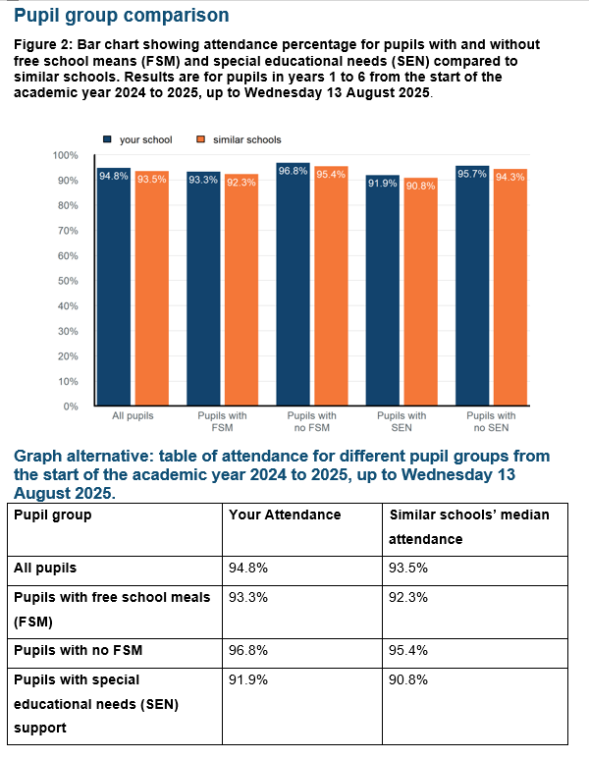
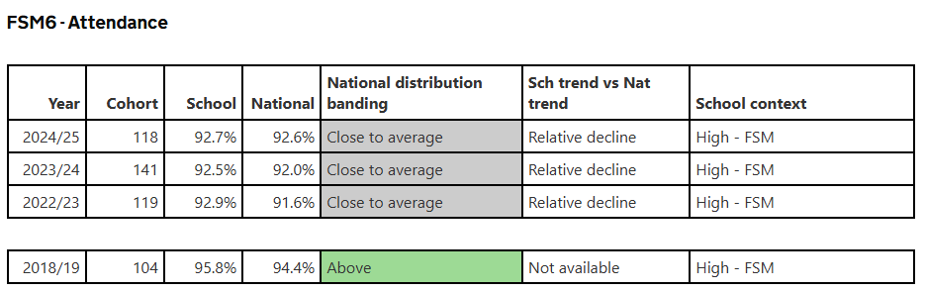
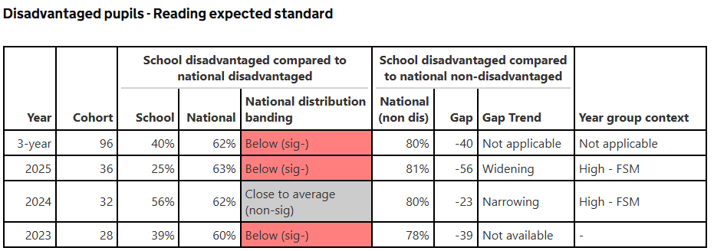
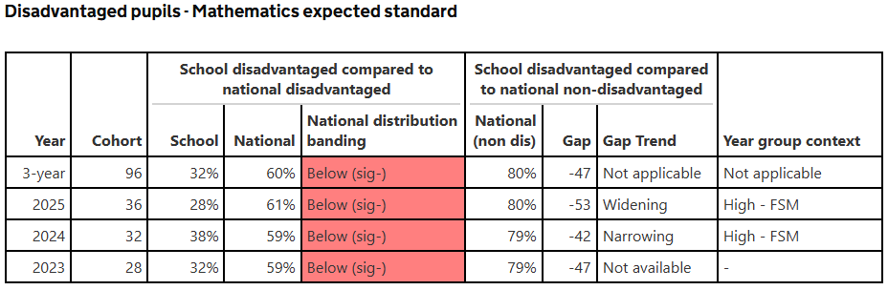
ENLGISH- pending

Externally provided programmes
Please include the names of any non-DfE programmes that you used your pupil premium (or recovery premium) to fund in the previous academic year.
Programme | Provider
Bedazzle Support for Readiness to learn | Bedazzle
Beanstalk Readers | Beanstalk readers
IDL | IDL
Timetable Rockstar | TTRS
SeeSaw Learning platform | SeeSaw
Dynamo | Dynamo

Service pupil premium funding (optional)
For schools that receive this funding, you may wish to provide the following information: How our service pupil premium allocation was spent last academic year
Pastoral support for pupils – this group has reduced in size. 3 pupils (from 4). Money was used to support activities for deployment when parents was away through pastoral activities
Review form last year was positive
The impact of that spending on service pupil premium eligible pupils
Pupils feel included and welcome and supported through pastoral events and trips and visits.
Last term one parent was deployed for 6 months, weekly activities to support and project with local artist.

