Donnington Wood CE Junior School

BEHAVIOUR and PERSONAL DEVELOPMENT POLICY 2026-27

School Vision  Our school is a community where each person is valued as a child of God. We are a Church of England school, inspired and guided by the life and teaching of Jesus. We work together to create a caring, friendly and safe school family, to enable the whole school community to flourish and each person reach their full God-given potential. | 
The School Logo links to our Motto.

“The ones who plant and the ones who water work together as a team with the same purpose.”
1 Corinthians 3:8

We believe that with God’s help when we all work as a TEAM - Together Everyone Achieves More.

Our core values are - friendship, hope and perseverance.


Our Mission (INTENT)

At Donnington Wood CE Junior School, we will:

- put the safety of everyone as a priority so we can work in trust and peace.
- encourage everyone to understand the true meaning of friendship, fellowship and community by acting with humility, compassion and in service to each other.
- be inclusive so everyone is valued and respected and where tolerance and diversity are celebrated.
- seek out every opportunity to ensure that all of us flourish in all that we do, developing wisdom and creativity, through an ambitious and broad curriculum that challenges expectations, deepens knowledge and develops skills.
- empower pupils and adults to develop hope and perseverance, so that they are able to engage/explore the challenges of school and the wider world.
- nurture the spiritual development of our school fellowship, develop tolerance of other faiths, beliefs and cultures and build religious literacy through collective worship of God and teaching of RE.
- champion our values to equip our children ready for their future as respectful individuals, life-long learners and active citizens in society, advocating justice.

This policy adds further detail to how we achieve our Mission and should be read in unison with our Vision document (see website)

Introduction

At Donnington Wood CE Junior School, we are committed to ensuring that the children in our care learn in a happy, secure and safe environment where mutual respect and understanding is fostered and developed in every lesson and throughout the school day.

As a school, we aim to foster positive relationships and behaviour in our pupils, in line with our vision, and encourage them to take an increasing responsibility for managing their own behaviour and regulating their emotions. We want a school where children can and want to learn and where staff provide necessary support for those pupils who find managing their own behaviour and regulating their strong emotions especially difficult.

The Aims of this policy to achieve our vision
- To develop an ethos of mutual respect and understanding through a set of Whole School Rules that apply to everyone. (friendship, fellowship, trust and peace)
- To have a clearly structured positive behaviour plan that is applied throughout the school in a consistent manner. (justice)
- To define what is meant by unacceptable behaviour and deal with inappropriate behaviour quickly and efficiently
- Summarise the roles and responsibilities of different people in the school community with regards to behaviour management. (service)
- To keep parents well informed about the behaviour of pupils (trust)
- To foster an atmosphere of mutual support with the implementation of the behaviour plan

We believe that any policy has to be based on a clear set of principles with a clear structure that will underpin any concrete action. Therefore, this policy has been developed after consultation with governors, parents, pupils and staff, and in conjunction with our development of PSHE throughout the school.

This policy is based on advice from the Department for Education (DfE) on:

Improving behaviour in schools - GOV.UK
Searching, screening and confiscation at school
The Equality Act 2010
Restrictive interventions, including use of reasonable force, in schools
Supporting pupils with medical conditions at school
Behaviour in schools
Mobile Phones in schools

It is also based on the special educational needs and disability (SEND) code of practice.
In addition, this policy is based on:
- Section 175 of the Education Act 2002, which outlines a school’s duty to safeguard and promote the welfare of its pupils
- Sections 88-94 of the Education and Inspections Act 2006, which require schools to regulate pupils’ behaviour and publish a behaviour policy and written statement of behaviour principles, and give schools the authority to confiscate pupils’ property

We will adhere to the statutory guidance Working together to safeguard children: statutory guidance (publishing.service.gov.uk) and Keeping children safe in education 2026. We will follow the DfE of What to do if you are Worried a Child is Being Abused - Advice for Practitioners, and have regard to Sexual violence and sexual harassment between children in schools and colleges (September 2021). We recognise the NSPCC website also provides us additional information on abuse and neglect and what to look out for.

All child protection matters will be dealt with in line with the arrangements of Telford and Wrekin Safeguarding Partnership (TWSP) and West Midlands Child Protection and Safeguarding Procedures or, if relevant, the safeguarding partnership area children reside in or are under the care of.

Much of the policy also draws from our child protection and safeguarding policy (to be updated) and our child friendly child on child abuse policy.

This policy replaces the previous policy of September 2025.

Principles
As a school, we have agreed on the following principles when dealing with pupils’ behaviour:
- Every pupil understands they have the right to feel safe, valued and respected, and learn free from the disruption of others.
- Adults will act as positive role models for children at all times in the way they interact with each other and children.
- All pupils, staff and visitors are free from any form of discrimination.
- Rewards, sanctions and reasonable force are used consistently by staff, in line with the behaviour policy.
- The behaviour policy is understood by pupils and staff and is applied consistently and fairly.
- Pupils are helped to take responsibility for their actions and co-regulate strong emotions.
- Families are involved in behaviour incidents to foster good relationships between the school and pupils’ home life.
- Adults will deal calmly, positively and respectfully with behaviour and will NOT shout at children nor humiliate or embarrass children.
- Adults will seek ways to support children who find it difficult to manage their own behaviour and will not ‘label’ children as ‘naughty’. (see below for rationales)

We believe in promoting positive behaviour, rewarding acceptable behaviour and promoting equal rights to promote our core values of friendship, hope and perseverance.

We will not accept:
- Refusal of requests from adults
- Dishonesty, including stealing
- Child-on-child abuse
- Bullying of any kind, including cyber-bullying (online)
- Racism, sexism or homophobia including name-calling or any type of harassment or discrimination.
- Verbal or physical aggression
- Anything illegal being brought into school
- Abusive or foul language to anyone
- Damage to property, including graffiti

Key principles
We ask all children to be:
- Ready
- Respectful
- Safe
Our school rules encapsulate these key principles of being ready for learning, respectful to everyone and staying safe at all times.

Our Main School Rules (Golden Rules)
- We listen to and follow all adult instructions (safe, ready and respectful)
- We treat others with respect and understanding (respectful)
- We listen when others are speaking and to others points of view (ready and respectful)
- We do not hurt others through words or actions (respectful and safe)
- We take responsibility for our own actions and do not blame others (ready and respectful)

As a school, we feel that it is vital that there is a consistent approach to behaviour management if it is to be as successful as possible. Therefore, we have devised a WHOLE SCHOOL BEHAVIOUR PLAN that applies to everyone in our school and will be applied consistently by all members of staff.

It is important to note that as a school, we recognise that there are some pupils who have significant behaviour difficulties and therefore the behaviour plan may not be appropriate for all children. In most cases, these children will have an IBP (Individual Behaviour Plan)

A copy of ‘Our Golden Rules’ is on display in every classroom for adults and pupils to refer to along with strategies for emotion coaching and co-regulation.

Our Home school Agreement also sets out expectations.

Community Voice

Pupil Voice
Pupils voice is incredibly important to us, we survey pupils once a term to evaluate behaviour.,
From this voice, improvement have been made in Golden time, reflection and communication with pupils.

For example pupils cite that behaviour has improved this term.

We also refer to their progress in behaviour, as well as academic.

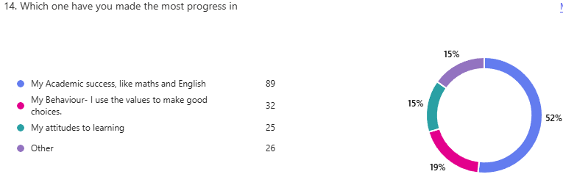
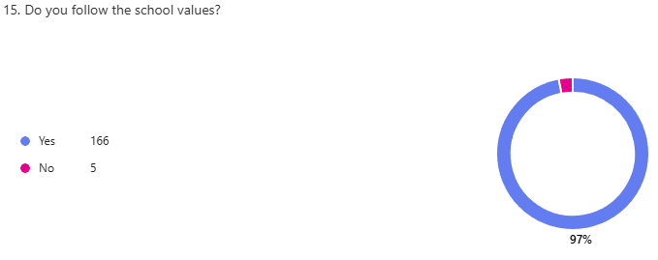
Ofsted and SIAMS feedback
SIAMS 2024 reported:
- The Christian vision is made real through the core values of hope, friendship and perseverance. These have a profound and positive impact on how pupils and adults flourish in their personal growth.
- Care for more vulnerable pupils and their families is exemplary and inspired by Christian teachings. The school is a safe haven for those who face challenges in their lives and learning.
- The curriculum is creative and inspiring. As a result, pupils grow in hope and aspire to a bright future.
- Relationships across the school are warm and trusting. The Christian vision and values are a lived reality so that behaviour is excellent. New pupils are readily integrated and part of the extended family that is Donnington.

Ofsted 2024 reported
- Pupils behave well and know the importance of good listening and showing respect. They understand what bullying is and feel confident that trusted adults will help should they feel threatened. Pupils recognise that everybody is different and that this should be celebrated. They welcome those who arrive new to the school and make sure that they feel included and safe.
- Donnington Wood Juniors is a caring school. It is a place where pupils develop close friendships and are kind to each other. Pupils understand the importance of perseverance and maintaining hope when things become challenging. Parents know that their children are happy and safe. Many are grateful for the support they receive when they need help.

Parent Voice 2026: This is a draft document out for consultation now and will update with more feedback.
At our Spring Parents Evening parents’ feedback:

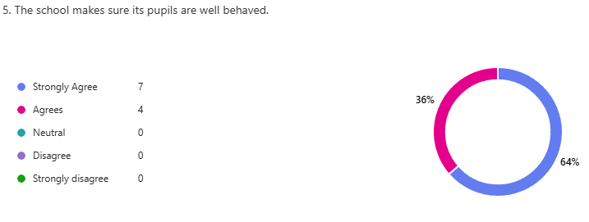

Our Behaviour Policy
Our behaviour policy is based on rewarding positive behaviour, maintaining relationships and discouraging inappropriate behaviour through a carefully planned rewards and consequences structure.

The policy is structured to help adults to deal with inappropriate behaviour in a calm, consistent way that minimises the impact on the other pupils, maintains positive relationships and reduces the loss of teaching and learning time to an absolute minimum.

The 4 R’s (Relationships, Recognition, Reinforcement, Reward)
At the heart of how we treat each other at Donnington Wood CE Junior School is the Christian value of love. We endeavour to build relationships of trust and respect, and this is expressed through positive interactions and behaviours between all members of our school community.

We believe strongly that appropriate behaviour should be recognised, and all staff will endeavour to acknowledge pupils who are displaying expected behaviours. This recognition will promote and reinforce the positive ethos and values of the school. Positive praise will be given regularly and is the most effective form of behaviour feedback.
Rewards – when pupils display exemplary behaviour they will be rewarded in a number of appropriate ways:
- Stickers can be awarded by any member of staff for anything that they feel demonstrates positive behaviour or attitude and at any time throughout the school day.
- For behaviours that follow our school values pupils are awarded Class Dojo points. Totals and milestones of Dojo points are displayed and celebrated each week by staff and SLT.
- These Dojo points will earn children further rewards, including a special Dojo Party in the last week of term. Certificates are given out for 25, 50, 75 and 100 Dojo points.
- Notes home – certificates or short notes can be sent home to inform parents of how pleased with a child’s behaviour, effort and attitude.
- Head teacher/ Deputy Head teacher awards are given each week to those children who have made an exemplary effort and displayed our school values. Anyone, staff or pupil can nominate a child for a Head teacher’s award.

Other rationale behind our policy

Relationship‑based Behaviour Philosophy
A relationship‑based behaviour philosophy places positive, trusting relationships at the heart of behaviour management: adults proactively teach and model expected behaviours, use predictable routines and calm, consistent responses, and interpret behaviour as communication of unmet needs; by prioritising connection, curiosity and repair over punishment, staff reduce escalation, support emotional regulation, and co‑construct strategies with pupils and families so children learn alternative skills, feel safe to engage in learning, and are more likely to sustain positive behaviour over time.

Behaviour is communication
Behaviour is communication means that a pupil’s actions express needs, feelings or unmet expectations; rather than seeing behaviour as simply defiance, we interpret it as information about what a child is trying to tell us. In practice this approach asks staff to notice triggers, consider underlying causes (emotional distress, sensory needs, language gaps, trauma, or unmet basic needs), and respond with curiosity, consistent boundaries and supportive interventions that teach alternative ways to get needs met.

Key takeaways
Observe before you judge: gather context (when, where, who, what happened before) to understand the message behind the behaviour.
Respond with curiosity and structure: use calm, non‑punitive language, predictable routines and clear choices to reduce anxiety and teach new skills.
Teach replacement skills: explicitly model and practise communication, self‑regulation and problem‑solving so pupils can express needs safely.

Attachment Trauma
Our school is a multi-nominated ARC Timpson nominated school for our work on attachment trauma, we often use this lens when identify the next steps.

Attachment, trauma and ACEs shape how children feel, behave and learn: attachment describes early caregiver bonds; trauma refers to overwhelming experiences that dysregulate stress systems; ACEs are specific childhood adversities that increase risk of long-term harm.

Attachment is the lasting emotional bond between a child and their caregivers that provides a “secure base” for exploration and learning. Secure attachment supports emotional regulation, trust and engagement; insecure or disrupted attachment can lead to difficulties with concentration, relationships and behaviour.
Practical classroom implications: notice patterns (seeking, avoidance, disorganisation), offer predictable routines, consistent adults and relational repair after incidents to act as a secondary secure base.

Trauma and trauma-informed practice — what to expect and how schools respond
Trauma describes experiences that overwhelm a child’s capacity to cope and can produce hyperarousal, dissociation, intrusive memories and impaired executive functioning. A trauma-informed approach asks “What happened to you?” rather than “What’s wrong with you?” and embeds safety, trust, choice and collaboration across the school.
Key actions for schools: create predictable environments, train staff to recognise signs, map referral pathways, and ensure identification is matched by capacity to support.

ACEs are potentially traumatic events in childhood (abuse, neglect, household dysfunction and other adversities) that, especially in accumulation, raise the risk of poor physical, mental and social outcomes across the lifespan. The original ACE research shows a dose–response relationship: more ACEs correlate with greater long-term risk.
In practice: ACEs can dysregulate stress systems, impair learning readiness and increase vulnerability to mental-health difficulties; protective relationships and early support buffer these effects.

Giving pupils a voice, helping pupils understand behaviour and feeling
Staff will often use Lanyards to help pupils identify their feelings and relate it to an animal- this helps pupils develop their understanding. The Animals of regulation Film is found here Animals of Regulation - Script by Charissa Fry.

If you are having difficulties at home, we can help you use the language below.
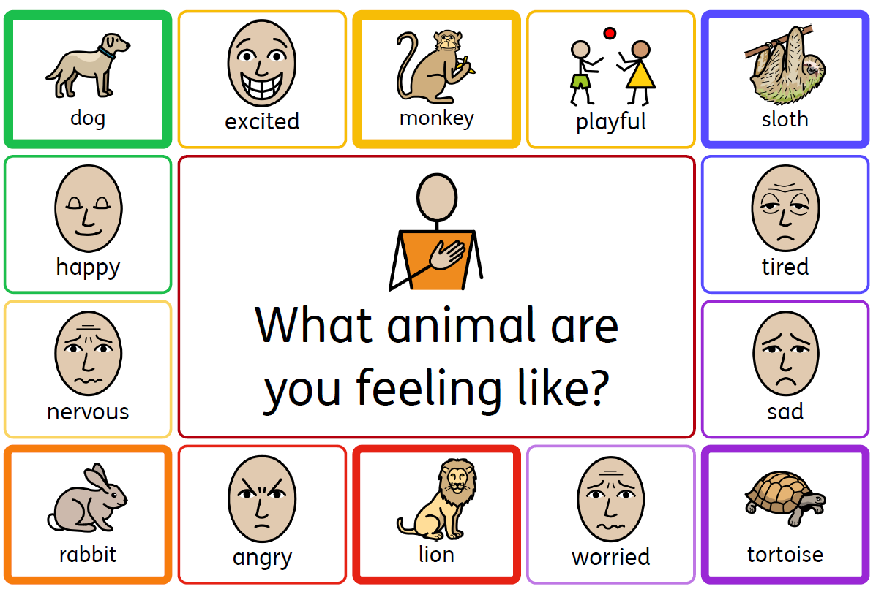
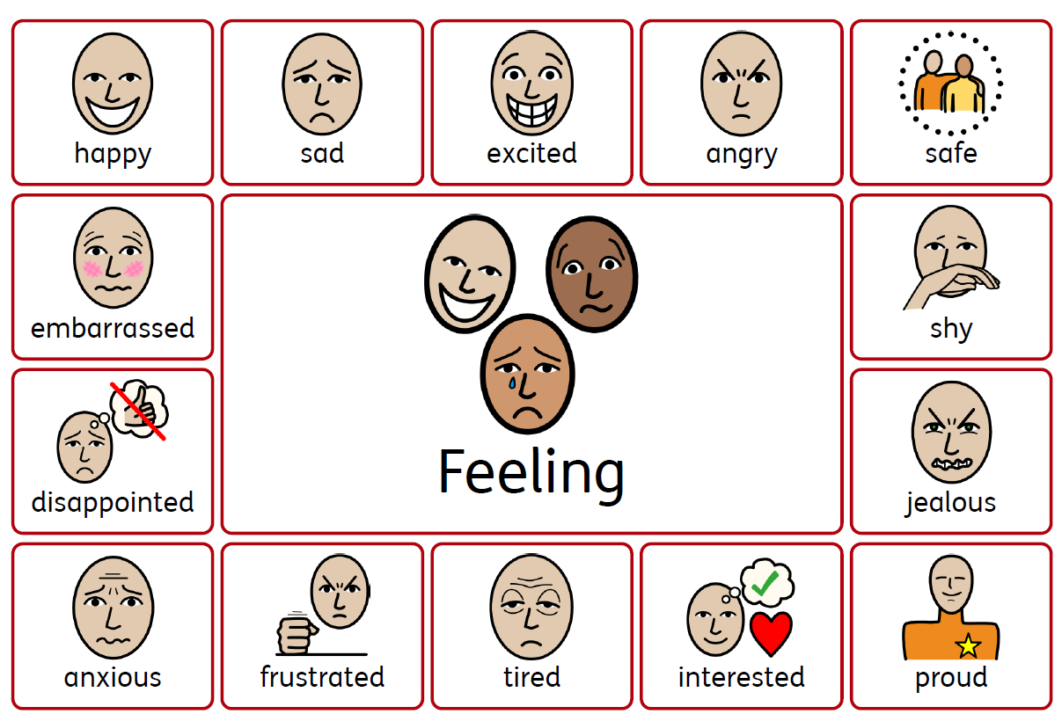

TEAM PUPIL Tirage
With all this information above, the School TEAM Pupil will then meet (triage) to offer further support. See below

Attendance Award
At the end of each week, the Headteacher gives an award to the class who has 100% attendance. This class earn an extra playtime. We monitor attendance regularly and look for patterns of behaviour and poor attendance. It is essential all pupils be at school every day.

Golden Time
All children automatically have 30 minutes of ‘Golden time’ at the end of every week. This is a special time of fun activities run on Friday afternoons that pupils can select at the beginning of each week.
During any week, 10 minutes of Reflection time may be needed during Golden Time for inappropriate behaviour IF behaviour continues to be unacceptable AFTER a Final Reminder and Time Out have been issued, or multiple reflections. This Reflection time is discussed with the pupil and the Head, and strategies and behaviour targets set for the following week.

Steps to managing unacceptable behaviour
In responding to behaviour in school we can refer to a level system concept derived from the “Incredible 5 Point Scale” (Kari Dunn Buron; http://www.5pointscale.com) which is a cognitive-behavioural visual system to assist pupils in understanding social, emotional, and behavioural concepts and expectations and to recognize and respond effectively to varying levels of stress and anxiety.

Level of Escalation | What PUPIL Says and Do | What STAFF Say and Do
Level 1 Engagement | - Expected behaviours  - Behaviours that demonstrate engagement | - Acknowledgement and praise  ‘Well done for… I like how you are…  - Preventative interventions & supports  - Engagement strategies/ adaptations
Level 2  Anxiety | - Disengagement  - Slight changes in behaviour | - Strategies for re-engagement/ Positive reframing  ‘I need you to..’ ‘Please can you…’  - Supports to alleviate anxiety / Provide structure/ Reminders of rules and routines  - Teach self-regulation  ‘I can see you are struggling to…’  ‘How can you return to your inner dog?’
Level 3  Agitation | - Noticeable increase in behaviour  - Obvious change in behaviour | - Time-out to reduce demands  - Evaluate environment for stressors  - Utilise emotion coaching strategies  “I can see you are struggling to..” “I wonder if you are feeling...” “What might help you to be able to...”
Level 4  Anger | - Verbal aggression / threats  - Minor property damage | - Time-out protocol to provide a safe environment  - Use of recovery to return to timetable
Level 5  Aggression | - Imminent danger to self or others | - Crisis / Emergency Intervention Plan (EIP)  - Red Card may be issued by SLT
Level 6  Recovery | - Restorative/Calming behaviours  - Readiness to return to timetable  - Reflection | - Supports to return to timetable  - Reflection time

It is vital that all adults follow the Behaviour Policy consistently and therefore the following steps MUST be applied.
- De-escalation strategies
When children first show signs of disengagement, it is important that staff attempt to de-escalate the behaviour through a number of different strategies. These include
  - tactical ignoring or pausing,
  - non-verbal cues,
  - redirection,
  - use of visual timetable
  - distraction
  - directed choices.
Take up time is provided, and gentle directives given to act as an informal reminder of the expected behaviour. These strategies are used to provide pupils with an opportunity to regulate, re-engage with the classwork and quickly stop behaving inappropriately and prevent disruption to the lesson. This is usually all that is needed, but if the inappropriate behaviour continues the Behaviour Policy MUST be followed using the following steps: -
- A Final Reminder - Behaviour is corrected and a reminder of expectations given (positively framed) using a scripted response (“I need you to…” “Please can you…”). A final reminder should be recorded by the teacher and time given to allow for a response.
- 5-minute timer – A pupil will be given the choice ‘Timetable or time-out?’ to encourage engagement with expectations. If time-out is chosen a child will have a timer placed on their table and their behaviour monitored for 1-5 minutes. Emotion coaching strategies are used to help reset. (“ I can see you are struggling to…”/ “ I wonder if you feel…”/ “What might help you to be able to…”). During this time, if the pupil has responded and re-engaged, the timer is removed, and the pupil continues with their activity. It may be necessary to relocate the child for this timed period (time out), such as to another desk or special calm area of the classroom. Children should only be placed outside of the class to calm down or diffuse a situation; this should be no longer than for 3 minutes. At break times/lunchtimes, the child should be directed to the Reflection room for 5-10 minutes. The duty staff are responsible for monitoring and timing this’ isolation’.
- Restorative Conversations – any pupils that get to this stage will be expected to have a brief reflection discussion (5 mins max) to address their behaviour that led to the sanctions. This will take place at the end of the lesson/activity. (see Appendix)
- Reflection Time – If after the reminders and time out the child has not responded then they will be directed to Reflection Time for 10 minutes min either at playtime, lunchtime or at the end of the week during Golden Time. The teacher records when and why they have chosen Reflection Time on a proforma. The Head must be informed if this stage has been reached by a pupil. Reflection Time forms are given to the Head for monitoring. The Head will issue a letter to inform parents of this step. This letter will be issued through Arbour.
- Time out with a Senior Leader/Pastoral Support Manager – Continued unacceptable behaviour or high-level disruption will result in a senior leader being sent for to discuss the behaviour with the pupil. Decisions on the next steps then rest with the Senior Leader/PSM.
- Red Card – These are only issued if inappropriate behaviour continues after all other steps have been followed or due to high-level disruption. A Red card results in removal from the class or playground by the Headteacher, Senior Leader or Pastoral Support Manager. Parents will be contacted, and a behaviour meeting will be arranged. Children will miss the following day’s playtimes and a Behaviour Plan will be drawn up to support the child’s behaviour.
- Severe incident – see below.

If it becomes necessary to issue a Red card, a Senior Leader will attend and potentially remove the child.

The Senior Leader will fill in a Red card notification log. Red cards can only be issued by a member of senior staff.

At all points the focus is to educate and reduce the incidents happening again. A behaviour chart will be issued.

This is then monitored by the Head and Class teacher.

Severe Incidents
Sometimes it is necessary to issue an instant Red card missing out the above steps in the following circumstances
- A deliberate and unprovoked act of violence towards another person
- Behaviour that puts themselves or others at risk of harm
- Damaging school property.

If any child puts himself or herself at severe risk through actual aggression or inappropriate behaviour, or at potential risk to others (threatening behaviour) then certain staff have been sanctioned to use physical intervention. These staff members are trained in the CPI (MAPA) approach that ensures the care, welfare, safety and security of all involved.

Physical restraint will (More information in Child protection and safeguarding policy)
- Always be used only as a last resort.
- Be applied using the minimum amount of force and for the minimum amount of time possible
- Be used in a way that maintains the safety and dignity of all concerned
- Never be used as a form of punishment
- Be recorded and reported to parents. They will be invited in to discuss the incident, to minimise further risks.
- For further details, please see Use of reasonable force and other restrictive interventions guidance which we adopt.

The above procedure in italics must still be followed.

Suspension
This is used as a very last resort when a child's behaviour is totally unacceptable and will only be used when there is danger of a pupil/s endangering his or her own safety, or that of other members of the community.
Internal exclusion can be used in a limited way but parents will be informed and a record made of the reason and the length of time used. This may include working on their own, supervised by a member of the senior management team or senior teacher.
Fixed term suspension away from school. The first exclusion for any child would be fixed term depending on the circumstances. Usually this would be 1 to 3 days (this can be extended up to 5 days)
Permanent exclusion. This would only be the last resort when all other avenues have been explored and decided by the Headteacher and Chair of Governors.
As a Telford and Wrekin School, we also follow the Rarely Exclusion 2025 document, which sets out the process and protocol. The school will also consult the suspension hotline for advice and next steps. Link to 2023 document as no current digital link)
Off-site behaviour
Sanctions may be applied where a pupil has misbehaved off-site when representing the school, such as on a school trip or inter-school competition, or on the way to or from school.

Confiscation
Any prohibited items found in pupils’ possession will be confiscated. These items will be returned to parents. We will also confiscate any item which is harmful or detrimental to school discipline. These items will be returned to pupils after discussion with senior leaders and parents, if appropriate.

Searching and screening pupils is conducted in line with the DfE’s latest guidance on searching, screening and confiscation.

Online Behaviour
As a school we also expect our online behaviour to be as good as our school behaviour, and we will apply the rules of the behaviour policy to any infractions of the policy.

Incidents occurring out of school on social media, or any internet-connected device will be taken seriously and acted upon if they break these rules. We do not tolerate abuse/bullying in any form. All pupils regularly receive Online Safety training from the school and the NSPCC and know the standard expected.

We teach pupils through the 4 Cs and Project Evolve.

We promote the message, STOP, SPEAK, SUPPORT. This is part of a national campaign to change the behaviour of young people who are ‘bystanders’ to online bullying and give them information and support.

Further examples and consequences can be found in your home school agreement, the Authorised Use Policy (AUP) and in our safeguarding policy.

Informing parents
Parents play a very important role in behaviour management and should be supportive of the school policy. Parents receive a Home /School agreement to agree their support.

New parents can access the Behaviour plan, and its use and purpose are explained at the Year 3 induction meeting, and online.

Parents are encouraged to share any concerns that they have about behaviour with the school through contact with the Deputy Head, class teacher, Parent Governors or by contacting the Head teacher directly.

Parents will be contacted when incidents occur involving their child, and whenever pupils have received Reflection Time during Golden time or received a Red Card through Arbour.

Confidentiality
If parents approach any staff for information regarding an incident at school, the staff member must direct them to the appropriate Class teacher, Pastoral Support manager, Deputy Head or Head.

It is very important to remember that all incidents should be treated as confidential, and the school will not discuss consequences, actions or outcomes for other children.

Pupil support
The school recognises its legal duty under the Equality Act 2010 to prevent pupils with a protected characteristic from being at a disadvantage. Consequently, our approach to challenging behaviour may be differentiated to cater to the needs of each pupil.
The school’s special educational needs co-ordinator (SENDCO) will evaluate a pupil who exhibits challenging behaviour, through TEAM PUPIL, to determine whether they may have underlying needs that are not currently being met.
Where necessary, support and advice will also be sought from specialist teachers (BSAT), an educational psychologist, medical practitioners and/or others, to identify or support specific needs.
When acute needs are identified in a pupil, we will liaise with external agencies and plan support programmes for that child. We will work with parents to create an Individual Behaviour Plan (IBP) and review it on a regular basis.
For roles of staff see below

Attendance
A key part of this policy is that we expect good Attendance, as a school we set a target of 97% attendance. Attendance below 95% will be challenged. Please see attendance policy for further information. See our attendance policy online.

Pupil Groups/Peer support
At Donnington Wood CE Junior School, there are a number of ways pupils can encourage and support their peers’ responsibilities and behaviour:

School Council (Values Champions)
We have a group of elected class representatives, two from each class, who hold this responsibility for a year. These are called out Values Champions as they represent the best enactment and behaviour of our school’s core values.

Children can be nominated by their peers or put themselves forward to become the class representative. Each child then has to make a short presentation to the class stating why they think they would make a good school councillor. The class then vote, by secret ballot, for their chosen representative.
Values Champions meet regularly with the Pastoral Support Assistant. Champions are encouraged to bring any concerns from class members to their meetings for discussion.
The Values Champions have an important role in the decision-making process for school improvement and celebration of our school values.

The School Day
We recognise that some children have difficulty behaving in the way we expect them to when they are outside of a classroom.
Several initiatives have been put into place to support children during these times.
- Before School – The school gates are opened at 8.22am and registers close at 8.25am. Teachers and TAs are in classes from this time to receive and greet children. Children are discouraged from arriving at school before 8.22am unless they are attending Early Bird Club (breakfast Club). From 8.22am until 8.30am, SLT staff are on duty outside to greet children and parents as they arrive.

- Playtime – To monitor children’s safety at playtime it has been agreed that there will be two members of staff/year group on duty at playtime. Pupils are zoned in different areas and classes rotate around these zones during the week. These areas include the Wooden Adventure Zone, the Metal Adventure Zone, The Bottom Yard and Top Yard, our school field (weather dependent) and the Bikes and Scooter Zone. Staff are supported by our Playground Buddies who are on duty throughout playtime.

- Lunchtime -Children are expected to display good behaviour when eating in our dinner hall. These include using good manners, eating reasonably quietly and clearing up after themselves, before leaving the dining hall in an orderly manner. If children come into the hall for their lunch, they are expected to queue up respectfully and sit quietly at a table whilst eating.

- Lunchtime Play – The playground area is split into a number of ‘Zones’ where different activities take place (ball games take place on the Top yard, or the field for example) Teaching Assistants act as Lunchtime supervisors for their Year group classes and work in different ‘Zones’ on a rota basis. They are responsible for getting out any necessary equipment and putting it away.

- At the end of the day – Children are expected to leave school and travel home respectfully and safely. A member of staff escorts children from the school premises at the end of each day. On rare occasions, incidents do occur, and these may involve children from other schools. The school follows up any incidents that occur in a sensitive and sympathetic manner and if necessary, support is sought from, the Community Police, who may decide to patrol the area at home time for a few days.

Playground Buddies
Playground Buddies are children with a desire to support others at playtime and lunchtime.
Children who wish to become Playground Buddies fill in an application form and go through an interview process. The Pastoral Support Assistant and School Council carry out interviews.
If their application is successful, the children join the Playground Buddy team and support staff at playtimes and lunchtimes on the playground.

Playground Buddies:
- Mediate between pupils to solve minor disputes
- Play with children who are lonely or upset
- Introduce playtime games
- Hold regular meetings with the Pastoral Support Manager to discuss issues related to playtimes.

Playground Buddies have a significant part to play in the overall management of behaviour at our school and their contribution is highly valued by all staff.

Safeguarding and Behaviour
The school recognises that changes in behaviour may be an indicator that a pupil is in need of help or protection. We will consider whether a pupil’s misbehaviour may be linked to them suffering, or likely to suffer, significant harm. Certain behaviour may warrant us to deal with them in line with our Safeguarding Policy and Child Protection routines. We are aware that safeguarding issues can manifest themselves via child-on-child abuse. This is most likely to include, but may not be limited to:

• bullying (including cyberbullying and Allergy discrimination (Benedicts law)).
• physical abuse such as hitting, kicking, shaking, biting, hair pulling, or otherwise causing physical harm.
• sexual violence and sexual harassment.
• sexting (also known as youth produced sexual imagery); and
• initiation/hazing type violence and rituals.
We do not tolerate any forms of abuse. All incidents of concern are passed immediately to the school’s DSL and logged on CPOMS.
See our Child on Child abuse policy.
We also have a risk assessment to support pupils who experience any abuse.
The Definition of Bullying in our school is STOP- Several times on purpose. Any bullying should be reported to the Class teacher for investigation.

Pupil transition
To ensure a smooth transition into the next year, pupils have transition sessions with their new teacher(s). This is when expectations of behaviour and routines are explained and established. In addition, staff members hold transition meetings to discuss pupil information.
To ensure behaviour is continually monitored and the right support is in place, information related to pupil behaviour issues may be transferred to relevant staff at the start of the term or year. Information on behaviour issues is transferred from Infant school and records may also be shared with new settings for those pupils transferring to other schools.

TEAM PUPIL- how we all work together to improve behaviour.

Roles and responsibilities
Before and after the school day Pupils remain the responsibility of the responsible adult before the start times of the day. This is in the home school agreement above.

The governing body
Our governors are responsible for reviewing and approving the written statement of behaviour principles. Governors will also review this behaviour policy in conjunction with the Head teacher and monitor the policy’s effectiveness, holding the Head teacher to account for its implementation.

The Head teacher
Mr Fox, the Head teacher is responsible for reviewing this behaviour policy in conjunction with the governing body giving due consideration to the school’s statement of behaviour principles. The Head teacher will also approve this policy.

The Head teacher will ensure that the school environment encourages positive behaviour and that staff deal effectively with poor behaviour and will monitor how staff implement this policy to ensure rewards and sanctions are applied consistently.

The head will also monitor behaviour chart use and follow up concerns in school.

TEAM PUPILS (Triage)
Any child experiencing difficulties with following the rules of ready, respectful or safe- will be presented at our internal Triage. This brings together a knowledgeable team to identify pupils next steps. This could then mean a referral to FAP (fair access panel) for external support, such as the Behaviour Support Team) or internal support.

Deputy Head
Mr Rawson, the Deputy Head is responsible for the day-to-day implementation and monitoring of our school Behaviour Policy. He will ensure that the school environment encourages positive behaviour and that staff deal effectively with poor behaviour and will monitor how staff implement this policy to ensure rewards and sanctions are applied consistently. He will monitor awards and Dojo points, issuing certificates and prizes. He will also monitor pupils’ reflections.

Inclusion lead and Pastoral Support Manager (PSM): Miss Ganderton.
Miss Ganderton, the Assistant Head for Inclusion plays a significant role in the Personal Development and Behaviour Management of our pupils. She will work with pupils and their families, to provide support and access additional services through the Early Help Process.

The Assistant Head for Inclusion leads the TEAM Pupil meeting to identify next steps, in order to modify the negative behaviour patterns exhibited by pupils.

SENDCO
Mrs Jenks, the SENCO leads the school’s needs-led response to behaviour by identifying underlying causes, coordinating assessment and targeted provision, and ensuring staff use consistent, evidence-based strategies so behaviour is understood as communication rather than simply misconduct; they gather and triangulate data (observations, incident logs, teacher and family input, screening tools and specialist reports), write and monitor individual behaviour support plans within the Assess-Plan-Do-Review cycle, coach and train staff in proactive routines and de-escalation scripts, liaise with families and external agencies (e.g., educational psychology, CAMHS, social care) to secure timely interventions, and track outcomes so adjustments and referrals are made where needed, thereby reducing exclusions and improving access to learning.

Behaviour Support lead
Mrs Billingham runs our rainbow room at play and lunch and will often support pupils with supported play. Mrs Billinghmam will often support through further restorative conversations.

Staff
Staff are responsible for:
- Implementing the behaviour policy consistently
- Modelling positive behaviour in a calm and controlled manner.
- Providing a personalised approach to the specific behavioural needs of particular pupils
- Recording behaviour incidents
The senior leadership team will support staff in responding to behaviour incidents.

Parents
Parents are expected to:
- Support their child in adhering to the pupil code of conduct
- Inform the school of any changes in circumstances that may affect their child’s behaviour
- Discuss any behavioural concerns with the class teacher promptly

Conclusion: General Summary Statement
As a school, we recognise that behaviour management is the responsibility of everyone in the school (TEAM) and our behaviour policy is regularly discussed and reviewed by all. If you have any concerns about behaviour or actions taken, please contact us, we pride ourselves on being able to find a solution.

We strongly believe that a POSITIVE approach is far more effective than a negative one and work hard to avoid negative comments and use PRAISE as often as possible to raise children’s self-esteem and encourage positive behaviour throughout our school.

Behaviour and personal development are monitored as part of the schools Self Evaluation procedures.

Ofsted commented: The behaviour of pupils is a strength of the school. During the inspection, pupils were exceptionally courteous, kind and polite.

We expect this every day.

Along with other policies, we will measure the impact of this policy through the Ofsted standards.

Ofsted’s toolkit expects schools to create calm, orderly learning environments through clear routines, taught behaviour expectations, consistent adult responses, and robust monitoring — with emphasis on relationships, restorative practice, and evidence that behaviour policy is applied fairly and effectively.

Core principles from the Ofsted toolkit
Ofsted looks for a school culture where behaviour, relationships and respect are strong: pupils and staff demonstrate courtesy, routines are well-rehearsed, and low-level disruption is rare. Inspectors expect leaders to set high expectations, make behaviour a whole-school priority, and ensure staff model and teach the behaviours required for learning.

What good practice looks like (practical summary)

- Teach behaviour as a curriculum: make expectations explicit, model desired actions, and rehearse routines (lining up, transitions, listening). Behaviour should be taught not assumed.
- Consistent adult responses: staff apply the policy fairly and predictably; consequences and rewards are understood by pupils and used to restore relationships where needed.
- Proactive over reactive: prioritise prevention (clear routines, seating, task design) and use short, scripted interventions to de-escalate rather than relying solely on sanctions.
- Focus on relationships: every pupil should have at least one trusted adult; positive relationships underpin behaviour improvement and reduce exclusions.

Evidence and monitoring inspectors expect
Inspectors will look for consistent records showing how behaviour is monitored, how incidents are followed up, and how support is provided for pupils with additional needs. Schools should be able to show training records, incident logs, restorative outcomes, and how behaviour data informs targeted support.

Responding to misbehaviour (key expectations)
- Immediate, proportionate action that keeps pupils safe and learning.
- Restorative conversations to repair harm and teach alternatives.
- Reasonable adjustments for pupils with SEND or trauma histories, with clear records of support and adaptations.

Leadership and staff development
Leaders must model visible leadership, ensure consistent training on behaviour approaches, and evaluate the impact of strategies. Staff should be coached in both proactive classroom routines and scripted, calm responses to incidents.

APPENDIX

Behaviour Scripts Development Guide

Universal supports and behaviour plan interventions & strategies outlined below are written in script format and organized in a level system to support implementation consistency and fidelity.

This level system concept is derived from the “Incredible 5 Point Scale” (Kari Dunn Buron; http://www.5pointscale.com) which is a cognitive-behavioural visual system to assist pupils in understanding social, emotional, and behavioural concepts and expectations and to recognize and respond effectively to varying levels of stress and anxiety. Additional information on a variety of uses of this scale can be found on the Autism Internet Modules website (www.autisminternetmodules.org). An adaption of the scale, outlined in this guide, describes the process of developing behavioural response scripts and provides examples of scripts for staff on how to implement a variety of interventions. The considerations provided are intended to guide and prompt team discussion, however all decisions about behavioural responding for individual pupils should be made by a team on a case-by-case basis and informed by data.

The PURPOSE of a script is to empower adults to consistently respond to pupil behaviour in ways that reduce escalation and teach self-regulation skills.

The graphic below outlines the basic organization of level scripts and the primary staff responses at each level.

Level of Escalation | What PUPIL Says and Do | What STAFF Says and Do
Level 1 Engagement | - Expected behaviours  - Behaviours that demonstrate engagement | - Acknowledgement and praise  ‘Well done for… I like how you are…  - Preventative interventions & supports  - Engagement strategies/ adaptations
Level 2  Anxiety | - Disengagement  - Slight changes in behaviour | - Strategies for re-engagement/ Positive reframing  ‘I need you to..’ ‘Please can you…’  - Supports to alleviate anxiety / Provide structure/ Reminders of rules and routines  - Teach self-regulation  ‘I can see you are struggling to…’  ‘How can you return to your inner dog?’
Level 3  Agitation | - Noticeable increase in behaviour  - Obvious change in behaviour | - Time-out to reduce demands  - Evaluate environment for stressors  - Utilise emotion coaching strategies  “I can see you are struggling to..” “I wonder if you are feeling...” “What might help you to be able to...”
Level 4  Anger | - Verbal aggression / threats  - Minor property damage | - Time-out protocol to provide a safe environment  - Use of recovery to return to timetable
Level 5  Aggression | - Imminent danger to self or others | - Crisis / Emergency Intervention Plan (EIP)
Level 6  Recovery | - Restorative/Calming behaviours  - Readiness to return to timetable  - Reflection | - Supports to return to timetable  - Reflection time

The example scripts below are designed to assist teams in the development of individual behaviour plan scripts.

Level 1: Engagement
This level represents behaviours that demonstrate engagement.

Level 1 Behaviours: Follows instructions, is actively and independently engaged in expected tasks, lack of challenging behaviours

PURPOSE: This level represents universal supports & other intervention scripts that increase engagement and prevent behavioural challenges. In addition to the example scripts detailed below, teams should ensure that pupil instruction is engaging and explicit with high rates of opportunities to respond and the implementation of classroom PBIS (Positive Behavioural Interventions and Supports).

Visual Timetable Script:
- Use an individual visual timetable and at the beginning of the day and at each transition, ask X to check the timetable NOW/NEXT /THEN (e.g. “check your timetable” or “let’s see what’s next”).
- The activity just completed should be crossed off, ticked off, moved in some way to indicate “done”, “now” and “next.”
- To increase level of predictability in the timetable, add details to the timetable and/or on a separate post it. Always interact with the timetable after each step. Options include:
- Who the adult/teacher is for each activity
- What book/materials are needed
- Location of the class/activity
- Routine of the class / activity (e.g. listen to teacher, complete Seesaw activity (page 1, 2, 3), turn in book, check timetable).
- To increase choice opportunities:
- Have X choose which way to interact with the timetable
- Ask X whether he/she wants adult or self to interact with it (with support or independent?)
- Ask X which equipment to use to interact with the timetable
- Once the item is crossed off, have X read the next activity and then on the timetable or post-it, write the routine for that next activity (e.g. open your Red book, get equipment, select a place to wait, choose a wait activity if ready).
- If X doesn’t respond to the instruction to check the timetable within 1 minute, provide a visual prompt to “check timetable.”
- If X still doesn’t respond, provide a gestural prompt (point to or touch the timetable) and with authentic positiveness, say “cross it off; what’s next?” or some version of this.
- If X still doesn’t respond, either provide a model prompt and move on with the timetable or offer timetable/timeout.
- At any time, if verbal instruction is given and X doesn’t respond, write it down on mini whiteboard/post it.

Write it Down Script:
- If staff give a verbal instruction and X doesn’t follow it, write the instruction down (on a post it, on a section on the timetable, mini whiteboard, etc.).
- If X responds, use the Acknowledgement Script and continue with the timetable.
- If X doesn’t respond, point / gesture to the written instruction and give time (list time) for response.
- If X still doesn’t respond, offer a choice of support (e.g. “I do it or you do it?”).
- If X still doesn’t respond, move to Level 2 / Disengagement / One More Script.

Acknowledgement Script:
- Regularly give X positive praise such as high 5’s, fist bumps, authentic verbal praise (e.g. awesome; great job) when engaged and participating in the expected work, and not engaging in identified target behaviours.
- Provide X at least 3X as many positive acknowledgements for every 1 correction, prompt, or help to prevent the correction, prompts or help from becoming aversive.

Engagement Scripts: During large group instruction:
- Have peer(s) or adult translate teacher’s instructions (step by step), expectations, core discussion points, answers peers are providing, etc. on a whiteboard, post it, paper, etc. This will help keep X oriented to key information in the instructional environment.
- If the teacher is asking for peers to respond, visually prompt X to “raise your hand” and wait for the teacher to call on.
  - To decrease anxiety with having to come up with the right answer, write down the correct answer (on a post it, whiteboard, etc.) so X doesn’t have to generate it (even if you know X knows the answer) -- anxiety can prevent recall.
  - If the teacher calls on X, visually prompt X to read the answer out loud and then provide an authentic high 5 or thumbs up for a “great job.” This will help X learn what it means to be a pupil and engage with the class.

During small group / independent instruction:
- Have selected peers or TA sit near X and do the expected work (as if a pupil in the class) in order to model what X is expected to do.
- Visually prompt X to do what peer/TA is doing.
- Differentiate all work to a level X can do it independently.
- Provide authentic high 5’s, thumbs up, “great job” or other authentic feedback as X interacts with assignments.

Choices Script:
- Offer choices whenever possible. If X tries to negotiate something, occasionally “give in” but make it a choice in the timetable so X sees that all options are based on adult offered choices and some things are negotiable and some are not.
- Choice ideas: type of writing utensil, where to sit, who to sit next to, section of the work to complete first, reward to work for, etc.
- Embed choices in the timetable where and when there are options. This will help teach that there are times when choices are and time when choices aren’t an option.

Questions Script:
- If X asks a question, verbally answer it.
- If X asks again, write it down and show it (say nothing more).
- If needed, depending on the question, say “these are the choices right now” or “that is not a choice right now” or “check your timetable, when is that a choice?”
- If X asks a 3rd time, say and show “check your timetable; what are we doing right now.”
- If X responds and checks timetable, give authentic acknowledgement and move on with the timetable.
- If X does not respond and continues to ask questions, ask if X needs a break/time out or wants to continue with the timetable.
- If X chooses timetable, proceed; if X chooses break, follow break/time out protocol; if X doesn’t choose, follow break/time out protocol.

Work / Choice Script:
- During independent work (or during 1:1 work with the TA as described in the “small group” engagement script), for every 5 items X completes or 10 minutes of time X works, offer less than 2-3 minute choice time (a choice of reinforcing activities preferably ones that can be completed in the room / at desk)
- Once X has made choice, set timer and engage with X during the chosen activity to pair self with reinforcer (e.g If X is playing with toys, authentically play too, asking to share/participate. If X is drawing, draw too. If X is watching video, watch too and make periodic comments about liking the clip or laughing at something funny. This will help pair the adults as sources of reinforcement in the environment.)

Level 2: Anxiety (Disengagement)
Level 2 Behaviours:
- Often identified as “Houston” (as in “Houston, we have a problem!”), this level is the initial sign that escalation may occur
- Behaviours at this level include minor changes in pupil behaviour that suggest an escalation may begin (NOTE: Staff often miss these minor behavioural signals so objective observation is recommended to identify these behaviours)

- Examples
  - Lack of engagement
  - Minor disruptions
  - Passive refusals
  - Not following expectations
  - Minor motor or verbal behaviours
  - Fidgeting / busy hands
  - Withdrawal
  - Darting / veiled eyes

Disengagement, refusals, minor disruptions, withdrawal, minor motor / verbal behaviours
This level is intended to outline strategies to re-engage the pupil as well as prevent the probability of further escalation. It is best to limit staff opportunities to re-engage to 3-4 opportunities so staff do not become a precipitating factor to escalation. A general hierarchy of opportunities may include:

- Consideration of antecedent variables or function of behaviour that can be immediately adjusted or corrected (e.g. work expectations are not clear, not enough visual information, work is too difficult and needs to be differentiated to a lower demand).
- Offer a choice within the assignment (see choices script).
- Use the “one more” script.
- Offer timetable / choice (see script).

Disengagement Script:
- If X is not engaged, visually prompt X back to task (e.g. “check your timetable, what are you supposed to be doing right now” or “back to your Reading.”)
- If that is not successful, visually prompt X to complete a very specific task in the activity (e.g. “do No 7” or “write the date”) and/or differentiate the expectation to lower demand (e.g. offer choices, respond on tablet) AND increase the use of the acknowledgement script.
- If this is not successful, offer a choice within the activity. Examples include “you do one, I do one,” “I’ll write, you copy?” “you pick which one you want to do,” “do you want to do the first ½ or the 2nd ½” etc. Peers can be used to pair with X to accomplish this or another adult.
- If this is not successful, use the One More Script.
- If this is not successful, move to Level 3 and break/time out protocol

One More Script:
- If X does not respond to the Disengagement Script, visually give the prompt “One More then Choice Time” and be specific about what “one more” X is expected to do to get choice time. Make “one more” VERY limited in demand.
- If X completes “one more”, use the Acknowledgement Script and offer visual choices for a brief choice time (5 minutes or less). Design choice options in advance. After choice time, return to the Engagement Script and continue as is needed to maintain engagement.
- If X does not respond to “one more,” follow the Timetable/Time-out Script.

Timetable / Time out Script:
- If the One More Script is not successful, visually prompt X and say “timetable or time-out.”
- If X says timetable, return to the expected task and use the One More script as soon as needed to keep X engaged.
- If X says “time-out,” follow break/time-out protocol.
- If X says nothing or says timetable but continues to disengage or have challenging behaviours, visually prompt and say “it’s time for time-out/a break” and go to Level 3 and follow time-out/break protocol.

Level 3: Agitation
Level 3 Behaviours: Noticeable disruption, pacing, active refusals, increased voice volume, eloping
Pupils at this level are vulnerable as they are potentially on the brink of the full escalation. As such, this level includes a staff-initiated break to interrupt escalation, protect the pupil’s dignity, and minimize disruption to the classroom.

Time-out/Break Protocol:
- If X chooses time out/break or it is directed, show the timer/break out card and say “time -out for a break” and direct X to the time-out area / activity. NOTE: The area / activity (e.g. walk down the corridor, get a drink of water, use the toilet; sit in a quiet area, sit quietly at the desk) needs to be benign in reinforcing value to the pupil. There is a natural reinforcing value to time-out/break because the pupil is being removed from the aversive stimuli (e.g. classroom, teacher, assignment). However, time-out/break is used to 1) ensure staff do not push the pupil to further escalation (NOTE: The presumption is that if the pupil isn’t engaging after multiple engagement strategies including enticement of a reinforcer, it is likely the pupil is beginning an escalation cycle) and 2) to allow the pupil brief time-out in order to de-escalate and re-attempt to engage. However, if there are additional reinforcing elements to the environment or activity, we risk inadvertently reinforcing challenging behaviour).
- If time-out is an area, go to the area and then disengage from all interaction. Do not respond to questions, comments, discussion, etc.
- After a pre-designated time period (1 minute -- no more than 5 minutes), say and show the visual “timetable or time-out?” If X chooses to continue time-out, say “ok” and disengage again for the designated time period.
- Offer the choice of “timetable or time-out” each time after the designated time period.
- Default is always time-out so if X doesn’t choose timetable or time-out or tries to engage in a discussion or asks questions, show and say “you have chosen time-out.”
- After 3 “timetable / time-out” opportunities and X does not choose to return to timetable, try providing more detail about the timetable by writing down what is next (e.g. Play or time-out; Lunch or time-out; Reading or time-out (rather than saying “timetable” or time-out).
- If providing the detailed timetable doesn’t engage X in 3 more opportunities, add a choice opportunity that would follow a low demand timetable requirement (e.g. 1 Maths activity, then choice).

Return to Timetable Protocol:
- Once X chooses to return to timetable, have a visual mini timetable of the steps for returning to timetable (e.g. open book, sit at desk, follow teacher instructions, etc.) and go over them with X.
- These initial steps are considered “readiness tasks” for staff to evaluate X’s readiness to follow instructions and re-enter the timetable.
- Use LOTS of authentic high 5’s, fist bumps, and verbal praise for choosing to return to timetable and have X cross off each task in preparation for returning to the timetable.
- If X begins to engage in target behaviours during this time, offer “timetable or time-out” and respond accordingly.
- This will need to be followed up later with Reflection time at break, lunch or Golden time.

Level 4: Anger
Level 4 Behaviours: Verbal aggression, minor property damage, screaming / yelling / swearing, threats to harm
The purpose of this level is to provide a safe environment for the pupil to de-escalate and to prevent behaviours that are a danger to self or others. This is a very vulnerable level since pupils are at risk for a full escalation. In most cases, a time-out protocol is used at this level as well (see Level 3 break/time-out protocol). In addition, preparing for a full escalation may be needed (see Safety Plan Script).

Safety Plan Script:
- Radio SLT.
- Once the SLT arrives, they stay out of sight unless they are instructed by staff member to enter (EIP Protocol).
- Staff member is the “gatekeeper,” directing members of the team in and out as is deemed necessary for support.
- Follow basic Time-out Protocol except once established time is up, wait until X has a quiet body and voice for 15 second and offer “timetable / time-out.” If X screams at staff offer, disengage and repeat.
- If X becomes aggressive toward others (e.g. attempts to attack, throw objects at someone, etc.) or toward himself (e.g. head-banging, etc.), staff will call in at least 2 members of the SLT for support and utilise the EIP protocol.
- If X attempts to leave the room, do not stop them. A team adult should trail at a distance behind to ensure X goes to one of the identified safety areas.
- If X goes to one of these places, refer to the Time out/Break procedures.
- If X does not go to one of the safe places, refer to the EIP protocol.

Level 5: Aggression
Level 5 Behaviours: Imminent danger to self and/or others
The purpose of this level is to provide a safe environment until the pupil de-escalates which may include the use of an Emergency Intervention Plan (EIP)/ MAPA. Should restrictive procedures be needed (i.e. emergency use of seclusion & restraint), it is critical the script aligns with the procedures set forth in school policy.

Level 6: Recovery / Return to Timetable/ Reflection
Level 6 Behaviours: De-escalation, sleeping, crying, responsiveness to instruction
This purpose of this level is to ensure the pupil returns to Level 1 / regulated behaviours before returning to the timetable to prevent re-escalating the pupils by returning too soon.

Recovery:
- Based on EIP, if the pupil has chosen “return to timetable,” begin the Return to Timetable Protocol.
- It may be necessary to add 1-2 additional Readiness Tasks to give X time to de-escalate.
- No debriefing or reflection on the incident with the pupil should occur during Recovery due to risk of re-escalation.
- Upon the pupil’s return to timetable, set up a time for staff to debrief and complete the necessary paperwork.
- Pupil completes Reflection at a later break time or Golden time.

Significant incident Form
Name of young Person:

Name of person filling in form:

Name of other people present:

Date:

Time/ Location:

Details of behaviour leading up to the measures taken? (What was happening, saying, acting)

Detail methods used to deescalate.
School Behaviour Policy |  |  | Verbal Warning
 |  |  | Timer
 |  |  | Time with SLT
Humour | Verbal and supportive |  |  | Diversion |  | Negotiation |  |  | Limited choices |  | Distraction |  | Firm clear directions
Clam Talking | Calm Stance |  |  | Patience |  | Swap adults. |  |  | Reminders |  | Reassurances |  | Planned ignored
Any other comments on de-escalation:
NEXT STEPS Why was this the measure is necessary?
WHY
Risk to others |  | Risk to Safe Physical Environment |  |  | Risk to self |  |  | Risk to Psychological Environment |  | Prevention of physiological harm |  | Prevention of criminal offence
A description of what you did; what you did and said? How it progressed?
Y/ N G?
Restrictive intervention: a means to prevent, restrict, or subdue movement of the body, or part of the body, of a pupil. This guidance uses ‘restrictive interventions’ as the umbrella term to describe both physical and non-physical actions aimed to restrain pupils in different ways.
Reasonable force: a term used in legislation which includes physical restrictive interventions. All members of school staff have the legal power to use reasonable force in limited circumstances. Reasonable means using no more force than is necessary for the least amount of time, the application of which will depend on the circumstances.
Significant incident: any incident where the use of force goes beyond appropriate physical contact between pupils and staff as described in ‘Other physical contact with pupils’ within this document. This includes when physical force is used to implement a non-physical restrictive intervention.
Seclusion: a non-disciplinary intervention involving keeping a pupil confined to a place away from others, and preventing them from leaving either by physical obstruction, blocking, or making them believe they will be punished if they try to leave.
Restraint: a term used in legislation referring to a non-disciplinary intervention which immobilises a pupil or limits their movement. This may or may not include direct physical contact. For example, holding a pupil’s arms to their sides or removing a pupil’s crutches would both be considered forms of restraint.
Use of reasonable force and other restrictive interventions guidance
Details of any hold MAPA (Safety Interventions) (times and who, what hold) Duration of any measure or restrictions in minutes and time intervals between provision of active support.
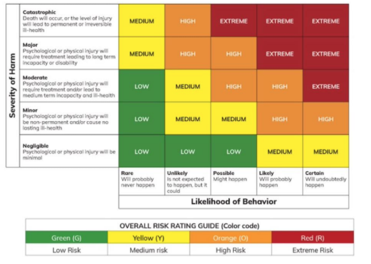 |  |  |  |  |  |  |  | Last Resort  Acting out of necessity  Harm is imminent or Immediate  There is no alternative  Reasonable  The Individuals potential to cause harm  The individuals INTENT to cause harm  Proportionate  Not acting as a way of punishment or revenge  Equal to or less than the harm that may arise from the persons behaviour
It is illegal to use force on a pupil for the purpose of punishment.
Is it necessary?
• Staff should consider whether there are other more effective, less restrictive ways to manage a situation.
• Staff should assess whether a restrictive intervention is likely to successfully reduce the relevant risks, or whether its use would escalate the situation further or cause more harm than the behaviour itself.
• Where possible, staff should communicate with other staff members to understand any broader risks in the environment.

Is it proportionate?
• Staff should use the least amount of force or least restrictive intervention necessary for the least amount of time required to reduce the relevant risks.
• If the intervention itself is escalating the situation, staff should reconsider their approach and attempt an alternative strategy.
• Staff should consider the personal circumstances of the pupil such as medical conditions, special educational needs or other vulnerabilities, their characteristics such as age and size, and must consider relevant equality implications under the Equality Act 2010.14
Have you considered the pupil’s welfare?
• Staff should consider the impact on the pupil’s overall welfare, balanced against any actions taken. For example, pupils who have experienced an adverse life event, with diagnosed or undiagnosed medical conditions or sensory impairments, past trauma or neglect, communication difficulties, or other needs, may find the use of restrictive interventions particularly distressing.
• Staff should seek to maintain respect for a pupil’s dignity. This may include, where possible, considering the location and environment where any intervention is used, such as in front of their peers.
• Where possible, staff should clearly and calmly communicate to the pupil what is happening, why, and explain what the pupil needs to do.
• For pupils with difficulties with speech, language and communication, or with English as an additional language, verbal and/or non-verbal strategies should be used to ensure the pupil understands what is happening and has adequate time to process information and respond.
• Staff should seek to understand how the pupil is feeling and use this information to determine whether the restrictive intervention should be, or continue to be, applied, reduced or stopped.
Any consequences of the use of measure:
A description of any injury to the child concerned or any other person.
A description of any medical treatment offered, or administered?
Information shared with external agencies.

Social Worker

External Agencies

Medical referral

Health and Safety (RIDDOR)

LADO

Responsible parent.

Placing authority

REVIEW OF ACTIONS
Restorative actions taken:
Young Person voice of incident:
Learning/Effectiveness of measures/Actions taken

Name and signature of person
Name of team member supervising this document:

Behaviour Scripts--BLANK
Pupil Name (DOB): Class: Date:
Level of Escalation | What PUPIL Says / Do (observable) | What STAFF Says and Do in Response to Pupil Behaviour
Level 1
Engaged
Level 2
Anxiety
Level 3 Agitation
Level 4
Anger
Level 5 Aggression
Level 6
Recovery

