Donnington Wood CE Junior School
 | Our School Vision  Our school is a community where each person is valued as a child of God. We are a Church of England school, inspired and guided by the life and teaching of Jesus. We work together to create a caring, friendly and safe school family, to enable the whole school community to flourish and each person reach their full God-given potential. | Our core values  friendship  hope  perseverance
Our Motto  “The ones who plant and the ones who water work together as a team with the same purpose.”  1 Corinthians 3:8  We believe that with God’s help when we all work as a TEAM - Together Everyone Achieves More. |  | Our core values  friendship  hope  perseverance

The progression of curriculum concepts/skills in Art
Key Concepts/Golden threads
Subject concepts act as coat-hangers to hook information onto and ‘Golden threads’ that run throughout the curriculum. This allows the pupils to store this knowledge into the long term memory and to remember for longer. Developed on research by Jan Meyer and Ray Land (2003), the use of concepts in our curriculum are used to capture the most important essence (knowledge) of the subject. The same concepts are explored in every year group and students will gradually increase their understanding of them.
artistic skills  drawing, painting, use of materials, sculpture | generating ideas | knowledge of artists | evaluation and reflection | elements of art  line, colour, shape, texture, tone, form, space, pattern

Concept | Coverage/context
Concept | KS1 | Year 3 | Year 4 | Year 5 | Year 6
Sources  Knowledge of artists, themes and movements  Pupils need to be taught how to extract what they need from a source, then adapt it to suit their own idea. |  | LS Lowry  – Urban landscapes | Roman mosaic | SCULPTURE  Egyptian -style pottery | Mayan Textiles
 |  | Celtic Designs | Wassily Kandinsky Abstract | Peter Thorpe  Space art in pastels | Frida Kahlo  Self-portraits pastels and coloured pencils
 |  | Alfred Wallis  -Seascapes  Naïve art | Exploring colour - David Hockney  Pop Art | Van Gogh  PAINTING -Mediterranean scenes  Dutch Post-Impressionism style | Henri Rousseau  Painting rainforest scenes  French Post-Impressionism style  Animals are Naive style
Elements of art  Line  Shape  Tone  Colour  Pattern  Texture  Form  Composition  for children to understand them to the extent that they can apply them to their own work, or understand how an artist has used them to create effect or meaning. | Elements of art will depend on skills used. Different elements will be shown depending on the medium.
Whole-School Art Forever Facts
- I have learnt that art is a way of expressing ideas, feelings and experiences.
- I have learnt that artists observe, create, evaluate and improve their work.
- I have learnt that artists use materials and techniques for a purpose.
- I have learnt that art reflects different cultures, places and periods in history.
- I have learnt that artists learn through experimentation, practice and reflection.

 | Year 1: How do artists show what they see?  - I have learnt that artists use lines, shapes and colours to create pictures.  - I have learnt that different tools can make different marks.  - I have learnt that artists look carefully at objects before drawing them.  I have learnt that  - colours can be mixed to create new colours.  - I have learnt that every artist's work is unique.  Year 2: How do artists express ideas?  - I have learnt that artists use pattern, texture and colour to share ideas.  - I have learnt that artwork can communicate feelings and tell stories.  - I have learnt that artists use a variety of materials, including paint, clay and collage.  - I have learnt that artists can be inspired by the world around them.  - I have learnt that talking about artwork helps us understand it better. | Year 3: How do artists develop their skills?  - I have learnt that artists practise techniques to improve their work.  - I have learnt that sketchbooks are used to record and develop ideas.  - I have learnt that artists choose materials for a specific purpose.  - I have learnt that observation helps artists draw accurately.  - I have learnt that artists can learn from the work of other artists. | Year 4: How does art influence the way we think?  - I have learnt that artists use colour, line, shape, form and texture to create an effect.  - I have learnt that artists refine and improve their work over time.  - I have learnt that art reflects different cultures, beliefs and experiences.  - I have learnt that artists make choices that affect how viewers respond to their work.  - I have learnt that evaluating artwork helps artists improve. | Year 5: How do artists communicate meaning?  - I have learnt that artists make deliberate choices to communicate ideas and messages.  - I have learnt that composition influences how artwork is viewed.  - I have learnt that artists experiment with techniques to achieve different outcomes.  - I have learnt that art can reflect historical events and cultural traditions.  - I have learnt that different people may interpret artwork in different ways. | Year 6: How does art help us understand the world?  - I have learnt that artists use visual elements and techniques to communicate meaning and purpose.  - I have learnt that art can challenge, inspire and influence society.  - I have learnt that artists draw inspiration from a range of cultures, movements and artists.  - I have learnt that evaluating and justifying artistic choices helps artists develop their work.  - I have learnt that art helps us understand ourselves, other people and the world around us.
Developing ideas  Creativity, ideas, imagination, intentions | • Explore ideas and collect visual information.  • Explore different methods and materials as ideas develop.  - Respond to ideas and starting points. | • Develop ideas from starting points throughout the curriculum.  • Comment on artworks using some visual language.  • Collect information, sketches and resources.  • Explore ideas in a variety of ways. | • Develop ideas from starting points throughout the curriculum.  • Comment on artworks using a developing grasp of visual language.  • Collect information, sketches and resources and develop ideas as they progress. | • Collect information, sketches and resources and present ideas (e.g. mood boards) and use to adapt ideas.  • Use the qualities of materials to develop ideas.  - Develop and  extend ideas from starting points throughout the curriculum.  • Comment on artworks with an increasingly confident grasp of visual language. | - Collect information, sketches and resources and present ideas imaginatively (e.g. mood boards) and use to adapt and refine ideas.  - Use the qualities of materials to enhance ideas.  - Develop and  - imaginatively extend ideas from starting points throughout the curriculum.  • Comment on artworks with a fluent grasp of visual language.
Evaluation and reflection  give pupils to look back over their work and think about what they have done? Which work did they like best and why? What were they frustrated about? What would they like to do again? What do they need to practice? |  | • Replicate some of  the techniques  used by notable  artists, artisans and  designers.  • Create original  pieces that are  influenced by  studies of others.  Use some visual language and some use of year group vocabulary | • Replicate some of  the techniques  used by notable  artists, artisans and  designers.  • Create original  pieces that are  influenced by  studies of others.  Using visual language and class vocabulary linked to art | • Give details  about the style of  some notable  artists and  designers.  • Show how the  work of those  studied was  influential.  • Create original  pieces that show a  range of influences  and styles.  Use some visual language and some use of year group vocabulary | • Give details  about the style of  some notable  artists and  designers.  • Show how the  work of those  studied was  influential.  • Create original  pieces that show a  range of influences  and styles.  Using visual language and class vocabulary linked to art

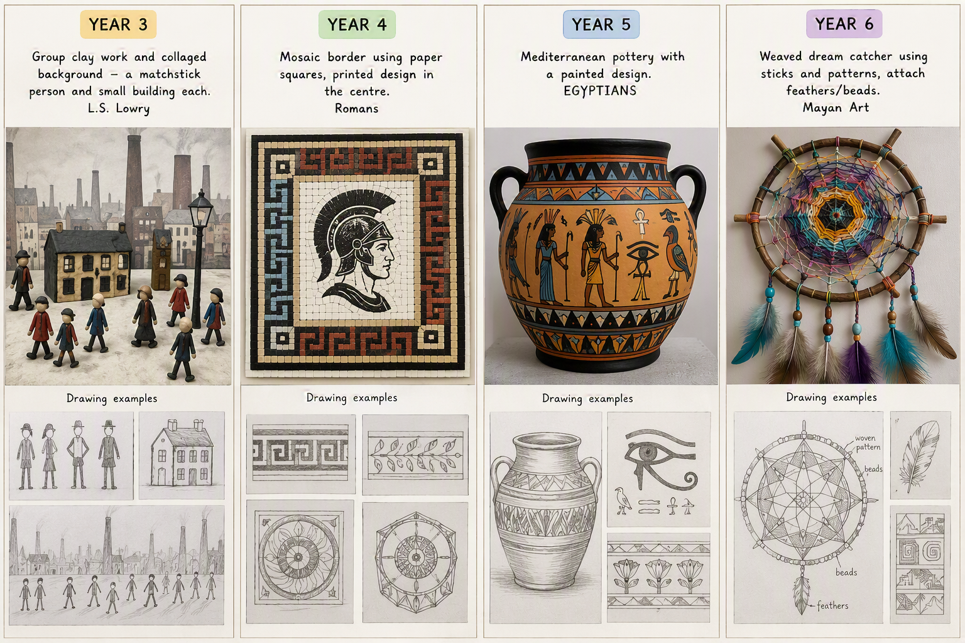
Progression of skills
Drawing | • Draw lines of  different sizes and thickness.  • Show pattern and texture by adding dots and lines.  •Colour in own work. | • Sketch lightly to plan and refine ideas.  • Use shading, hatching and cross-hatching to show light and shadow.  • Investigate and compare marks made by different pencils.  • Use different tones when colouring neatly within lines.  • Begin to create simple texture through pencil marks. | • Sketch lightly and accurately, showing increasing control and proportion.  • Use shading, hatching and cross-hatching to show light, shadow, tone and texture.  • Use a range of pencil grades to achieve different effects.  • Apply tone purposefully when colouring and drawing.  • Use observational drawing to capture detail more accurately | • Select and combine drawing techniques to create specific effects (e.g. reflections, shadows, texture and direction of light).  • Choose appropriate drawing materials and pencil grades for intended outcomes.  • Develop a personal approach by selecting a suitable style (e.g. realistic, expressive or impressionistic).  • Use tone and texture to create depth and atmosphere. | • Independently select and apply a wide range of drawing techniques to depict movement, perspective, shadow, reflection and depth.  • Manipulate tone, texture and line confidently to achieve intended effects.  • Adapt and refine drawing styles for different purposes and audiences.  • Evaluate and explain choices of techniques, materials and styles using appropriate artistic vocabulary.
 |  | Year 3: L.S. Lowry Inspired Street Scene  Final Outcome  Group clay street scene with collaged background  - Matchstick person (clay)  - Small building (clay)  - Collaborative townscape backdrop  Drawing Progression Activities  Activity 1: Exploring Lowry Figures  - Observe Lowry paintings.  - Draw stick figures in different poses.  - Sketch lightly using simple lines.  - Experiment with thick and thin lines.  Activity 2: Adding Movement  - Draw people walking, standing and talking.  - Investigate marks made with different pencils.  - Use simple shading to suggest clothing folds.  Activity 3: Building Studies  - Draw simple houses and factories from observation.  - Focus on basic shapes and proportions.  - Add light shading to show windows and roofs.  Activity 4: Lowry Composition Sketch  - Combine figures and buildings into a street scene.  - Use hatching and cross-hatching for shadows.  - Create a planned design before making clay pieces. | Year 4: Roman Mosaic Design  Final Outcome  Roman-inspired mosaic border with a printed central motif  Drawing Progression Activities  Activity 1: Roman Pattern Investigation  - Sketch Roman mosaics.  - Identify repeating shapes and patterns.  - Use rulers to create accurate layouts.  Activity 2: Pattern Drawing  - Draw geometric Roman borders.  - Practise symmetry and accuracy.  - Use different pencil grades to refine designs.  Activity 3: Texture and Tone Studies  - Draw sections of mosaics using shading.  - Use hatching and cross-hatching to suggest depth.  - Explore how light affects tiled surfaces.  Activity 4: Design Development  - Create several border designs.  - Refine and improve the most successful idea.  - Produce an accurate final drawing for the mosaic. | Year 5: Egyptian Pottery  Final Outcome  Mediterranean-style clay pottery with painted Egyptian design  Drawing Progression Activities  Activity 1: Egyptian Symbol Studies  - Sketch hieroglyphs and Egyptian motifs.  - Explore shape, line and proportion.  - Use observational drawing from artefacts.  Activity 2: Pot Shape Investigation  - Draw different pottery forms.  - Use contour drawing techniques.  - Add shading to show the curved form.  Activity 3: Light and Reflection  - Draw pots from observation.  - Use tone to show highlights and shadows.  - Create the illusion of three-dimensional form.  Activity 4: Design Planning  - Select an artistic style suitable for the final piece.  - Combine Egyptian symbols into a decorative band.  - Plan placement around the pottery. | ear 6: Mayan Dream Catcher Inspired Weaving  Final Outcome  Woven dream catcher using sticks, weaving patterns, feathers and beads inspired by Mayan art  Drawing Progression Activities  Activity 1: Mayan Pattern Analysis  - Sketch Mayan symbols and geometric motifs.  - Examine symmetry and repeated shapes.  - Annotate patterns using art vocabulary.  Activity 2: Perspective and Structure  - Draw circular and radial designs.  - Use construction lines accurately.  - Plan complex woven arrangements.  Activity 3: Texture and Movement  - Use line and tone to represent feathers, strings and woven fibres.  - Draw objects showing movement and overlap.  - Apply advanced shading techniques.  Activity 4: Final Design Proposal  - Create a detailed design sheet.  - Select techniques to show texture, depth and pattern.  - Explain and justify artistic choices.
Drawing vocabulary | thick thin sketch texture shade smudge blend | grades of pencil scale refine alter
Painting | • Use thick and thin brushes appropriately.  • Mix primary colours to make secondary.  • Add white to colours to make tints and black to colours to make tones.  • Create colour wheels. | • Use a range of brushes to create different effects.  • Mix colours effectively.  • Use watercolour paint to produce washes.  • Experiment with creating  mood with colour. | • Use a number of brush techniques using thick and  thin brushes to produce shapes, textures, patterns and lines.  • Mix colours effectively including tertiary colours (browns, neutrals, flesh).  • Use watercolour paint to produce washes for backgrounds then add detail.  • Create mood with colour. | • Sketch (lightly) before painting to combine line and colour.  • Experiment with creating colour palettes.  • Use the qualities of  watercolour and acrylic paints to create visually  interesting pieces.  • Practice skills to create different surfaces  • Develop a personal style of painting, drawing upon ideas from other artists | • Create a colour palette based upon colours observed in the natural or built world.  • Use a wide range of techniques in their work.  • Combine colours, tones and tints to enhance the mood of a piece.  • Use c and the qualities of paint to create texture.  •Explain what their own style of painting is.
Painting vocabulary | paint technique brush size primary& secondary colours  shade acrylic motif wash | Colour scheme spectrum tint |  | Tone hue method warm/cold colours atmosphere
Printing | • Use repeating or overlapping shapes.  • Use objects to  create prints (e.g. fruit, vegetables or  sponges). | • Replicate patterns observed in natural or built  environments.  • Make collograph printing  blocks (e.g. from coiled string glued to a block). | • Use layers of two or more colours.  • Make precise  repeating patterns. | • Build up layers of colours.  • Create an accurate pattern, showing fine detail.  • Use a range of  visual elements to reflect the purpose of the work.
Printing vocabulary | Printing gouge scrape motif | blocking | Block printing | Overprinting motif
Textiles | choose fabrics/threads based on colour, texture and shape.  apply shapes with glue or stitching.  apply decoration using beads, buttons, feathers etc.  apply colour with printing, dipping, fabric crayons.  create fabrics by weaving materials, i.e. grass through twigs. | use a variety of techniques e.g. printing, dyeing, weaving and stitching to create different textural effects.  develop skills in stitching, cutting and joining | use a variety of techniques e.g. printing, dyeing, weaving and stitching to create different textural effects.  develop skills in stitching, cutting and joining | use fabrics to create 3D designs  experiment with a range of media to overlap and layer creating textures, effects and colours. | use fabrics to create 3D designs  experiment with a range of media to overlap and layer creating textures, effects and colours.
Textiles vocabulary | Texture construct material weave sew | Join natural man-made |  | Weave embroider tapestry opaque transparent
Collage | arrange and glue materials to different backgrounds.  fold, crumple, tear and overlap papers. | experiment with a range of collage techniques such as tearing, overlapping and layering to create images and represent textures.  use collage as a means of collecting ideas and information and building up a visual vocabulary. | experiment with a range of collage techniques such as tearing, overlapping and layering to create images and represent textures.  use collage as a means of collecting ideas and information and building up a visual vocabulary. | use a range of media to create collages.  use different techniques, colours and textures when designing and making pieces of work.  use collage as a means of extending work from initial ideas. | use a range of media to create collages.  use different techniques, colours and textures when designing and making pieces of work.  use collage as a means of extending work from initial ideas.
collage vocabulary | Fold tear stick overlap  Collage shape
Sculpture | manipulate malleable materials in a variety of ways i.e. rolling, joining and kneading.  explore sculpture with a range of malleable media.  work safely with materials and tools.  experiment with constructing and joining recycled, natural and manmade materials | plan, design and make models from observation or imagination.  develop skills in joining, extending and modelling clay.  use papier mache to create simple 3D effects.  experiment with constructing and joining recycled, natural and manmade materials.  create textures and patterns in malleable materials including clay. |  | shape, form, model and construct from observation and imagination.  plan a sculpture through drawing and other preparatory work. 3D develop skills in using clay including slabs
Sculpture vocabulary | Knead roll sculpt form | Carving transparent opaque manipulate mould |  | Carving transparent opaque manipulate mould
Digital media |  | • Create images,  video and sound  recordings and  explain why they  were created.  Cross-curricular links  to computing. | • Create images,  video and sound  recordings and  explain why they  were created.  Cross-curricular links  to computing. | • Enhance  digital media by  editing (including  sound, video,  animation, still  images and  installations).  Cross-curricular links  to computing. | • Enhance  digital media by  editing (including  sound, video,  animation, still  images and  installations).  Cross-curricular links  to computing.

