Dear Parents and Carers,

Happy End of Term!
As we reach the end of another successful school year, I would like to extend a huge thank you to everyone in our school community for your continued support and partnership.

This year has been full of memorable moments and wonderful achievements. Highlights have included our fantastic Summer Fayre, an enjoyable Sports Day, and a wide range of exciting educational visits and experiences. We are incredibly proud of all that our pupils have achieved and already have many exciting opportunities planned for next year to further enrich our curriculum, deepen learning and help every child flourish.

Thank you for your ongoing support throughout the year. It has been a pleasure to celebrate so many successes together, and I look forward to sharing many more with you in the year ahead.

Holliday activities
There are loads of activities on the website to do over the summer. Please look: Whole School News – Donnington Wood Church of England Junior School

Staff News
As we come to the end of the year, we would like to recognise and thank some valued members of our school community.

Steve Jones
A huge thank you goes to Steve Jones, our Cleaning Manager, who is retiring from his cleaning role this summer. Steve has been a fantastic colleague, teammate and friend to so many of us over the years. His dedication, commitment and willingness to go above and beyond have made a significant difference to our school.
Steve's exceptional contribution during the COVID-19 pandemic deserves particular recognition. At a time when keeping everyone safe often felt like an impossible task, his tireless hard work, professionalism and determination helped ensure that our school remained a safe environment for both pupils and staff.
Whilst Steve is stepping down from his cleaning role, we are delighted that he will continue to serve our school community as a valued member of the Governing Body.

Miss Husselbee
We would also like to say a fond farewell to Miss Husselbee, who has been teaching in Year 5. Miss Husselbee is moving to a new school to continue her Early Career Teacher (ECT) journey. We thank her for all she has contributed during her time with us and wish her every success and happiness in the next stage of her career.

Miss Ganderton
We are delighted to share that Miss Ganderton will be taking on additional leadership responsibilities as Deputy Headteacher. Alongside her continued commitment to our pupils, staff and families, we know she will bring the same enthusiasm, care and dedication to this important role. We look forward to seeing her continue to help lead and support our school community as we strive to ensure every child flourishes.

Ready for September!
We look forward to welcoming everyone back to school on:
Wednesday 2nd September
Gates open: 8:22am
School day: 8:25am to 2:55pm

Our School Value
Our value for the first term will be: Friendship

Curriculum Information
Our curriculum maps can be found here:
https://donningtonwood.com/portfolio/curriculum-implementation/
These will be updated by Monday.

School Policies
Our updated Behaviour Policy and Safeguarding Policy will be available on the school website by Friday of the first week back.
We will also be sharing our updated Home-School Agreement.

Term Dates
Term dates for 2026-2027 can be found here:
https://donningtonwood.com/wp-content/uploads/2026/04/dwjs-term-dates-2026-2027.docx

Key Dates for Your Diary
A full calendar of events will be sent home in September; however, please make a note of the following dates:
- Wednesday 2nd September – School returns
- Friday 4th September – Potential Reading Picnic (weather dependent). We will confirm during the first week back.
- Friday 25th September – Macmillan Coffee Afternoon
- Thursday 5th November and Friday 6th November – Parent and Carer Evenings
- Thursday 10th December – Christmas Production (one performance in the morning and one in the afternoon)

Finally, I would like to wish all our pupils, families and staff a wonderful, restful and safe summer break. We look forward to welcoming everyone back in September for another exciting year of learning, achievement and success.

Best wishes,
Mr Fox
Headteacher

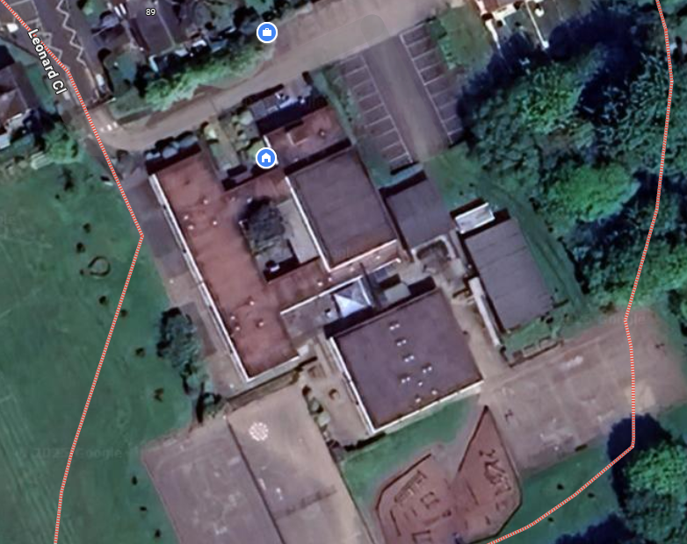
5R
4B
4O
6D
5P
6B
3P

