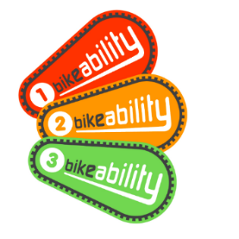



Bikeability Cycle Training week
Dear Parent/Carer,
Bikeability Cycle training week is coming to our school:
- Monday 29th – Friday 3rd October 2025
What is Bikeability? Bikeability is the National Standard for Cycle Training, supported and funded by Active Travel England. The dates above include both Bikeability Level 1 & 2. Details on Level 1 can be found below:
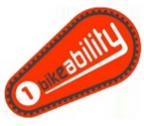
Bikeability Level 1 takes place on the school playground. Children are taught how to check their cycle is ready for a journey, how to safely set off, slow down, stop safely and control their cycle. Once this is completed, children will have achieved their Bikeability Level 1.
All pupils, regardless of cycling ability, will take part in Bikeability Level 1. This can include any pupils who are ‘not-yet-riders’. Cycles and helmets are provided by the training provider but pupils can provide their own roadworthy cycle to take part. Please check https://www.bikeability.org.uk/get-cycling/cycle-training-for-children/ to check your child’s bike is ready for the course.
Children will take part in Level 1 unless you opt out. To opt out of the sessions, please complete the section below. This will mean they won’t take part in any Bikeability training during the dates above.
I DO NOT want them to take part in the Bikeability Level 1 playground sessions.
Childs Name……………………………….
Parent/Carer signature……………………………………………
If you have opted out, please return this letter to the school office or class teacher.

The remainder of the course covers Bikeability Level 2 and you can sign up using the QR code below. Pupils must already be able to cycle independently (without stabilisers) to take part. Information on Level 2 can be found here:


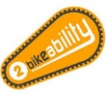
Bikeability Level 2 follows Level 1 and takes place on quiet roads close to school and teaches children how to share the road and communicate with other road users. Pupils learn how to negotiate junctions, pass side roads and turn at T-junctions as well as understand signals and road markings. These are essential skills to help children identify and respond to hazards whilst cycling safely and responsibly. All who complete the course are awarded Bikeability Level 2.

