Donnington Wood C.E. Junior School: School Complaints Policy 2024 25

 | Our School Vision  Our school is a community where each person is valued as a child of God. We are a Church of England school, inspired and guided by the life and teaching of Jesus. We work together to create a caring, friendly and safe school family, to enable the whole school community to flourish and each person reach their full God-given potential.
Our Motto
“The ones who plant and the ones who water work together as a team with the same purpose.”
1 Corinthians 3:8
We believe that with God’s help when we all work as a TEAM - Together Everyone Achieves More.
Our Mission (INTENT)
At Donnington Wood CE Junior School we will
- put the safety of everyone as a priority so we can work in trust and peace.
- encourage everyone to understand the true meaning of friendship, fellowship and community by acting with humility, compassion and in service to each other.
- be inclusive so everyone is valued and respected and where tolerance and diversity are celebrated.
- seek out every opportunity to ensure that all of us flourish in all that we do, developing wisdom and creativity, through an ambitious and broad curriculum that challenges expectations, deepens knowledge and develops skills.
- empower pupils and adults to develop hope and perseverance, so that they are able to engage/explore the challenges of school and the wider world.
- nurture the spiritual development of our school fellowship, develop tolerance of other faiths, beliefs and cultures and build religious literacy through collective worship of God and teaching of RE.
- champion our values to equip our children ready for their future as respectful individuals, life-long learners and active citizens in society (justice).

This Vision and Mission will be evident in all we do, from the way we work together to the attitudes to life you will see us show.

he following policy is based on DFE policy and guidance. It has been reviewed by the school’s Governing Body. Date; February 2025 Review Date; March 2025 Update by; Robert Fox, Headteacher

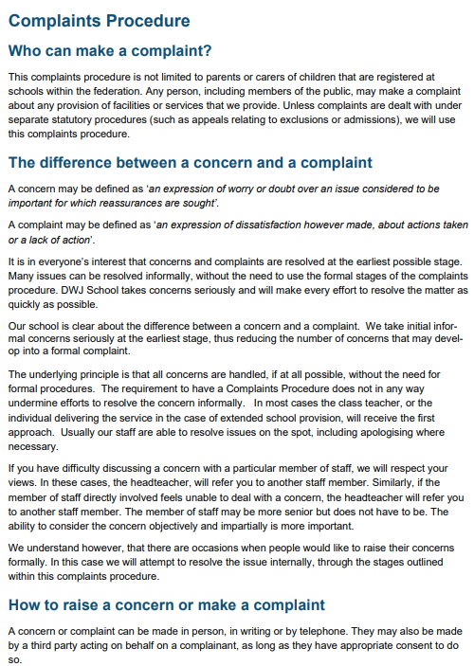

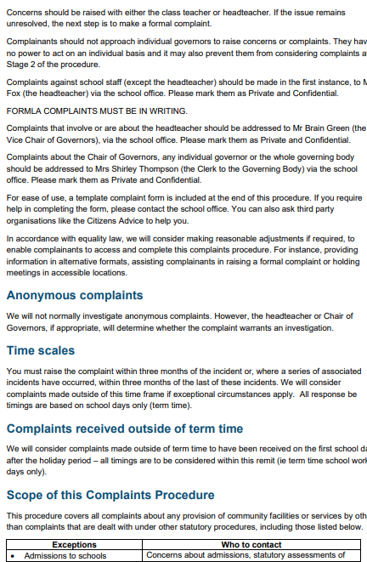

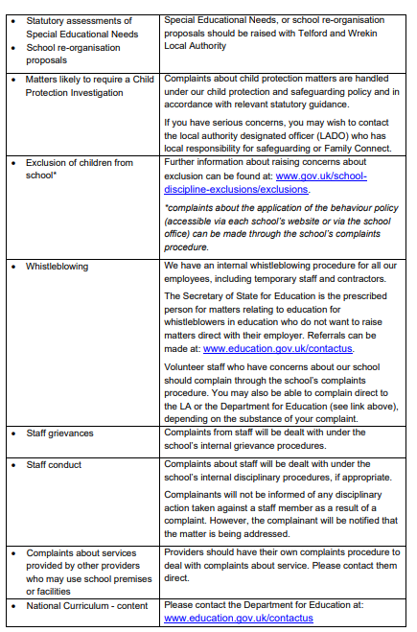
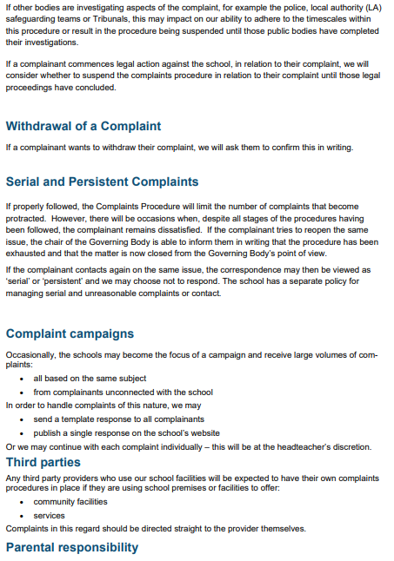

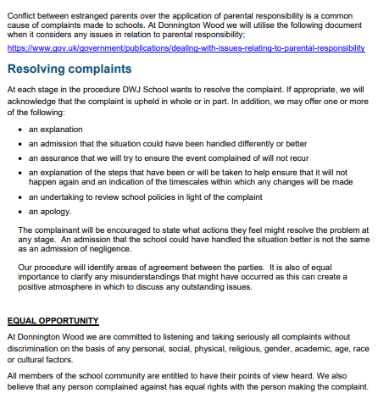
Updated link: https://www.gov.uk/government/publications/dealing-with-issues-relating-to-parental-responsibility/understanding-and-dealing-with-issues-relating-to-parental-responsibility#general-principles-for-schools-and-local-authorities
