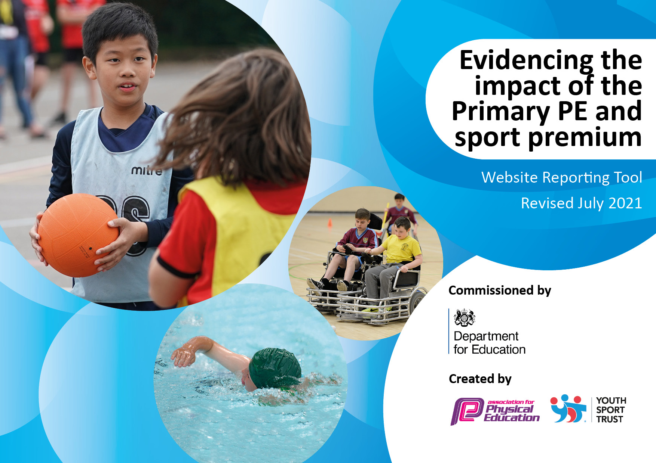
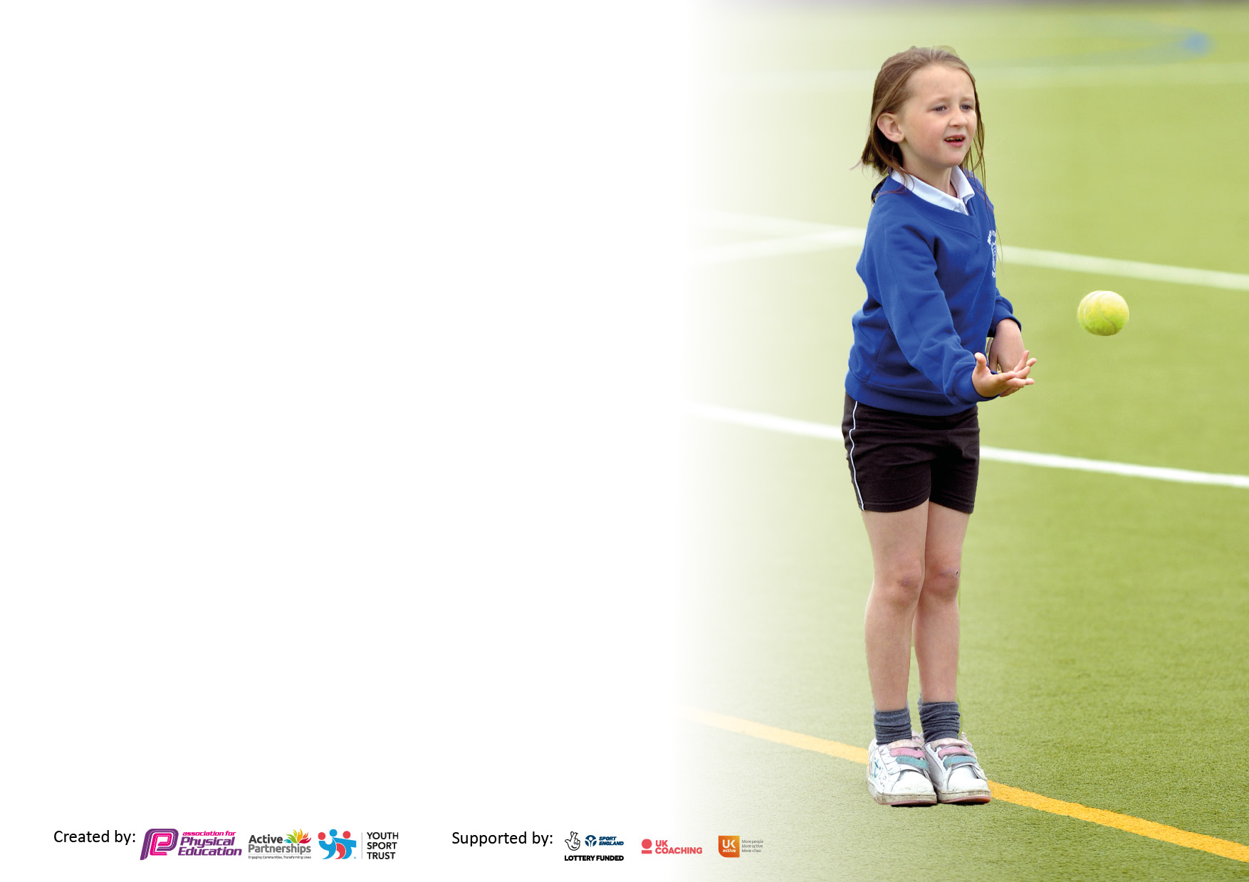

It is important that your grant is used effectively and based on school need. The Education Inspection Framework makes clear there will be a focus on ‘whether leaders and those responsible for governors all understand their respective roles and perform these in a way that enhances the effectiveness of the school’.

Under the Quality of Education Ofsted inspectors consider:
Intent - Curriculum design, coverage and appropriateness
Implementation - Curriculum delivery, Teaching (pedagogy) and Assessment
Impact - Attainment and progress

To assist schools with common transferable language this template has been developed to utilise the same three headings which should make your plans easily transferable between working documents.

Schools must use the funding to make additional and sustainable improvements to the quality of Physical Education, School Sport and Physical Activity (PESSPA) they offer. This means that you should use the Primary PE and sport premium to:

- Develop or add to the PESSPA activities that your school already offer
- Build capacity and capability within the school to ensure that improvements made now will benefit pupils joining the school in future years
- The Primary PE and sport premium should not be used to fund capital spend projects; the school’s budget should fund these.

Pleasevisitgov.ukfortherevisedDfEguidanceincludingthe5keyindicatorsacrosswhichschoolsshoulddemonstrate animprovement.Thisdocumentwillhelpyoutoreviewyourprovisionandtoreportyourspend.DfEencouragesschools to use this template as an effective way of meeting the reporting requirements of the Primary PE and sport premium.

We recommend you start by reflecting on the impact of current provision and reviewing the previous spend.

Schools are required to publish details of how they spend this funding, including any under-spend from 2019/2020, as well as on the impact it has on pupils’ PE and sport participation and attainment. All funding must be spent by 31st July 2022.

We recommend regularly updating the table and publishing it on your website throughout the year. This evidences your ongoing self-evaluation of how you are using the funding to secure maximum, sustainable impact. Final copy must be posted on your website by the end of the academic year and no later than the 31st July 2021. To see an example of how to complete the table please click HERE.


Created by: Supported by:

Details with regard to funding
Please complete the table below.

Total amount carried over from 2022/23 | £0
Total amount allocated for 2023/24 | £18280
How much (if any) do you intend to carry over from this total fund into 2024/25? | £0
Total amount allocated for 2024/25 | £18260
Total amount of funding for 2024/25. To be spent and reported on by 31st July 2025. | £18260
Swimming Data
Please report on your Swimming Data below.

Meeting national curriculum requirements for swimming and water safety.

N.B. Complete this section to your best ability. For example you might have practised safe self-rescue techniques on dry land which you can then transfer to the pool when school swimming restarts.
Due to exceptional circumstances priority should be given to ensuring that pupils can perform safe self rescue even if they do not fully meet the first two requirements of the NC programme of study
What percentage of your current Year 6 cohort swim competently, confidently and proficiently over a distance of at least 25 metres?  N.B. Even though your pupils may swim in another year please report on their attainment on leaving primary school at the end of the summer term 2021.  Please see note above | %44
What percentage of your current Year 6 cohort use a range of strokes effectively [for example, front crawl, backstroke and breaststroke]?  Please see note above | %16
What percentage of your current Year 6 cohort perform safe self-rescue in different water-based situations? | %90
Schools can choose to use the Primary PE and sport premium to provide additional provision for swimming but this must be for activity over and above the national curriculum requirements. Have you used it in this way? | Yes/No

Action Plan and Budget Tracking
Capture your intended annual spend against the 5 key indicators. Clarify the success criteria and evidence of impact that you intend to measure to evaluate for pupils today and for the future.

Academic Year: 2021/22 | Total fund allocated: | Date Updated: July 2022
Key indicator 1: The engagement of all pupils in regular physical activity – Chief Medical Officers guidelines recommend that primary school pupils undertake at least 30 minutes of physical activity a day in school |  |  |  | Percentage of total allocation:
 |  |  |  | %
Intent | Implementation |  | Impact
Your school focus should be clear what you want the pupils to know and be able to do and about  what they need to learn and to  consolidate through practice: | Make sure your actions to achieve are linked to your intentions: | Funding allocated: | Evidence of impact: what do pupils now know and what can they now do? What has changed?: | Sustainability and suggested next steps:
Pupils are ready to learn and can concentrate effectively.  Pupils take part in a variety of afterschool clubs designed to improve health and activity.  All pupils leave the school able to swim. We are raising attainment in primary school swimming to meet requirements of the national curriculum before the end of key stage 2. | Daily mile timetabled every day to engage pupils, performed in the morning and afternoons. Used as a break throughout lessons to engage pupils in further learning.  Carousel of activities introduced throughout PE lessons, shows inclusion and physical activity for the whole session, children are engaged throughout.  A variety of clubs introduced throughout the year which focuses on the inclusion of all pupils. All abilities joined. First Aid and garden club introduced across school to allow children to develop further knowledge about general first aid and what to do in certain situations  Working with Telford and Wrekin and leisure centre to secure further swimming sessions out of the TPS slot, as part of transition. | £100 for certificates  £1000 for new equipment when required.  Staffing and coaching x8 sessions. | Pupils are kept active for the whole PE session, a variety of activities introduced during the carousel, so pupils are learning and knowing a variety of skills for different sports rather than focusing on one skill each week. Impact of pupils constantly active has proven higher engagement and enjoyment within PE. Increased level of daily mile participation has shown more engagement throughout everyday lessons. Also introduced end of term certificates to encourage pupils’ participation.  Due to the variety of clubs, pupils’ engagement and attendance were much higher.  All children at the end of July 2022 have been able to swim at least 5m, data above shows the percentage of children who can swim the national expectance of 25m. | Continue with the carousel of activities for the next academic year to ensure pupils engagement is still high and that all pupils are active constantly. Continue to timetable the daily mile into pupils’ day. More children participating within the daily mile compared to previous years by them being more activate by running, jogging or power walking the mile. Continue with providing end of term certificates for pupils.  Continue to offer a variety of clubs throughout the year, changing clubs and pupils every half term.  Swimming sessions to continue into the next academic year. Leaflets and posters to go out to encourage parents to take children swimming outside the allocation time.
Key indicator 2: The profile of PESSPA being raised across the school as a tool for whole school improvement |  |  |  | Percentage of total allocation:
 |  |  |  | %
Intent | Implementation |  | Impact
Your school focus should be clear what you want the pupils to know and be able to do and about  what they need to learn and to  consolidate through practice: | Make sure your actions to achieve are linked to your intentions: | Funding allocated: | Evidence of impact: what do pupils now know and what can they now do? What has changed?: | Sustainability and suggested next steps:
Increasing pupils to own their own PE and coach and mentor others through leadership rolls.  Embedding physical activity into the school day through encouraging active travel to and from school, active break times and holding active lessons and teaching. | HLTA to lead sports mentors in year groups, as part of her sustainability and responsibility model.  Road Safety – bike ability training in spring and Summer Term. | £7000  £300 | HLTA helped pupils with leadership skills by guiding and supporting them in leading parts of the PE sessions.  Increase in children walking and riding their bikes to school. Pupils are more aware of how to use the road safely. | HLTA to continue to support pupils in different rolls by guiding them on ideas which they can use. HLTA to also confirm sports leaders/ captains per class to help throughout school projects.  Bike ability to be booked for next academic year.

Key indicator 3: Increased confidence, knowledge and skills of all staff in teaching PE and sport |  |  |  | Percentage of total allocation:
 |  |  |  | %
Intent | Implementation |  | Impact
Your school focus should be clear | Make sure your actions to | Funding | Evidence of impact: what do | Sustainability and suggested
what you want the pupils to know | achieve are linked to your | allocated: | pupils now know and what | next steps:
and be able to do and about | intentions: |  | can they now do? What has
what they need to learn and to |  |  | changed?:
consolidate through practice:
Providing staff with professional development, mentoring, appropriate training, and resources to help them teach PE and sport more effectively to all pupils and embed physical activity across your school.  Hiring qualified sports coaches and PE specialists to work alongside teachers to enhance or extend current opportunities offered to pupils. | PE coordinator/ HLTA support for pupils and staff HLTA has Pe degree.  Training for all staff and supported sessions.  Release time for PE lead to attend courses and run workshops.  Peter Blair (x3 sessions a year through partnership). Frankie Williams and Sally Harris to help support PE lead. | £1000  £1500 | Pupils get more knowledgeable teachers who are more confident in PE. HLTA ran coaching sessions for the first term to coach and support teachers with their development. Gymnastic training session ran to support teachers with knowledge on this area. HLTA implemented training based on a carousel of activities to ensure children are active for the whole required national time. Teachers have developed more knowledge due to resources, coaching and planning supplied by the HLTA/ PE lead.  Pupils, teachers and support staff given training by Peter to help develop their confidence and knowledge around playtime and lunch time activities. | HLTA to continue to support staff with development of PE lessons through whole school training.
Key indicator 4: Broader experience of a range of sports and activities offered to all pupils |  |  |  | Percentage of total allocation:
Intent | Implementation |  | Impact
Your school focus should be clear | Make sure your actions to | Funding | Evidence of impact: what do | Sustainability and suggested
what you want the pupils to know | achieve are linked to your | allocated: | pupils now know and what | next steps:
and be able to do and about | intentions: |  | can they now do? What has
what they need to learn and to |  |  | changed?:
consolidate through practice:
Additional achievements:  Introducing a new range of sports and physical activities to encourage more pupils to take up sport and physical activities.  Curriculum has been designed to increase awareness of different sports and PE activities. | New clubs offered every half-termly.  Work with local sports club to signpost, gather interest and increase pupils’ participation outside of the curriculum (tennis club TPS, rugby club Telford Hornets, cricket club Shropshire Cricket, Hockey club St Georges Hockey club).  Pupils given access to try and develop new sports through the variety of the school curriculum. | £5000  £1000 for development of equipment. | Darrell Corfield (Shropshire Cricket) delivered sessions to all children across the school to develop interest in cricket.  Moinul (Kabaddi) delivered sessions to year 5/6 pupils. Pupils participated in a session which introduced them to a different sport/ physical activity. Pupils’ participation in this continues to be high. | Darrell Corfield to continue to work for the first term, implementing cricket sessions across school.  Continue to work closely to schools curriculum to develop variety of sports throughout PE.

Key indicator 5: Increased participation in competitive sport |  |  |  | Percentage of total allocation:
 |  |  |  | %
Intent | Implementation |  | Impact
Your school focus should be clear | Make sure your actions to | Funding | Evidence of impact: what do | Sustainability and suggested
what you want the pupils to know | achieve are linked to your | allocated: | pupils now know and what | next steps:
and be able to do and about | intentions: |  | can they now do? What has
what they need to learn and to |  |  | changed?:
consolidate through practice:
Partnership with sports partnership.  Increasing and actively encouraging pupils’ participation in the School Games  Organising, coordinating, or entering more sport competitions or tournaments within the school or across the local area, including those run by sporting organisations. | Through Sports Partnership funding.  Facilitate adults to attend competitions and transport. | £1000 | All pupils given the opportunity to attend sporting fixtures throughout the year through the school games and local partnerships to increase activity and engagement in a variety of sports.  Attendance and participation in sporting fixtures home and away increased. | Continue to enter different sporting events throughout the next academic year.  ALL pupils given several opportunities to represent the school in activities.

Signed off by
Head Teacher:
Date:
Subject Leader:
Date:
Governor:
Date:

