Donnington Wood C of E Junior School
Self-Harm Policy

“The ones who plant and the ones who water work together as a team with the same purpose.”
1 Corinthians 3:8

We believe that with God’s help when we all work as a TEAM - Together Everyone Achieves More.

Our Mission (INTENT)

At Donnington Wood CE Junior School we will:

- put the safety of everyone as a priority so we can work in trust and peace.
- encourage everyone to understand the true meaning of friendship, fellowship and community by acting with humility, compassion and in service to each other.
- be inclusive so everyone is valued and respected and where tolerance and diversity are celebrated.
- seek out every opportunity to ensure that all of us flourish in all that we do, developing wisdom and creativity, through an ambitious and broad curriculum that challenges expectations, deepens knowledge and develops skills.
- empower pupils and adults to develop hope and perseverance, so that they are able to engage/explore the challenges of school and the wider world.
- nurture the spiritual development of our school fellowship, develop tolerance of other faiths, beliefs and cultures and build religious literacy through collective worship of God and teaching of RE.
- champion our values to equip our children ready for their future as respectful individuals, life-long learners and active citizens in society (justice).

Introduced | July 2024
Review date | July 2025
Person responsible for this policy | Rachael Ganderton

This Policy is divided into 5 sections:
- Purpose of the Policy
- Definitions of Self-Harm
- Aims of the school Team with regard to Self-Harm
- Key Responsibilities
- Links to Other Policies

- Purpose of the Policy
In keeping with the School’s vision and aims, this Policy aims to address the issue of self-harm; it covers the following areas:
- How to deal with pupils who self-harm and how to offer support in the short and long term;
- How to provide support depending upon the individual needs of the pupil;
- How to help all pupils improve their self-esteem and emotional literacy;
- How to support staff members who come into contact with people who self-harm;
- How to prevent self-harm from escalating within the school;
- Providing clear guidelines for staff on who needs to be informed and when parents and outside agencies need to be contacted;
- Providing education about self-harm for pupils and staff.

- Definitions of Self-Harm
Self-Harm
Self-harm is considered to be a coping mechanism for young people who are attempting to deal with high levels of distress and emotional pain. It may be defined as any deliberate, non-suicidal behaviour that causes physical pain or injury and is aimed at reducing the emotional pain and distress of the individual concerned.
These behaviours may include deliberate bone-breaking, cutting, bruising, banging and non-suicidal overdosing, and the behaviours are usually chronic, repetitive and habitual. Young people who self-injure will generally attempt to hide any scarring or injuries and can find it extremely difficult to discuss their behaviours, and the emotions behind them, with others. We understand these behaviours not to be about seeking attention, but rather to be about seeking relief and release from emotional distress.
We also understand that self-injury is not suicidal behaviour. However, the emotional distress that causes these behaviours can lead to suicidal thinking and actions – we will consequently take ALL incidents of self-injury seriously, investigate them, and attempt to provide the most appropriate emotional support possible.
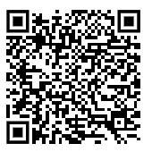
Further information about the definitions of self-harm can be found in this resources from the National Self Harm Network NSHN What is Self Harm- Definitions.

Suicide
While self-injury and suicide are separate, those who self-injure are in emotional distress and those who choose to end their lives are also in emotional distress. It is vital that all emotional distress is taken seriously to minimise the chance of self-injury and suicide. All talk of suicide and warning signs must be taken extremely seriously.
Actions following discovery of a suicide risk:
- Following a report of a risk of suicide from a pupil, staff will report this to a Designated Safeguarding Lead (Robert Fox, Jon Rawson, Rachael Ganderton or Jo Jenks) in discussion with the pastoral care lead will decide on the appropriate course of action. This is likely to include:
- Further exploration with the pupil through conversation
- Contacting parents or carers;
- Arranging professional assistance;
- Immediately removing the student from school and seek further medical advice if their presence in class is likely to cause further distress to themselves or their peers. Alternatively, seeking reassurance that it is in their best interests and in the interests of the wider community that they remain in school and that it is safe for them to do so.
- The pupil will remain in the care of their parents or carers until the school receives sufficient evidence that the pupil is not a significant risk to themselves or others under the normal levels of supervision in a day school. The head teacher may direct and require parents to make use of relevant professional and medical services.
- The school will usually require additional safeguards following a pupil’s return, which may include a commitment to attend appointments with counsellors, the GP, and/or CAMHS. Further information in section - Aims of the school team

- Aims of the School Team with Regard to Self-Harm
Our school team is dedicated to ensuring the emotional, physical and mental well-being of all pupils who attend. We consequently aim to:
- Recognise any warning signs that one of our pupils may be engaging in self-harming behaviours;
- Understand the risk factors associated with these behaviours, including low self-esteem, perfectionism, mental health issues such as anxiety or depression, home or school problems, social isolation, emotional, physical or sexual abuse;
- Be pro-active in discussing this topic with pupils we might feel are deliberately harming themselves;
- Know how to respond to pupils who wish to discuss these behaviours with us and take them seriously at all times;
- Be able to produce short- and long-term care and management plans for such pupils, in conjunction with external agencies if necessary; (See Attachment 1 sheet 4.1 for an example of a safety plan)
- Provide the appropriate level of practical and emotional support for staff dealing with pupils who self-harm and ensure appropriate training and education is available to all staff regarding this issue.
We have a tiered approach to mental health support in school and will decide as a safeguarding team which support is appropriate for each individual case:
- Emotional Literacy Support Assistants, Bedazzle student Mentor, Bee U Educational Mental Health Support, BeeU Crisis team.
Recognising warning signs
We are aware that for some young people there will not be any specific warning signs that they are engaging in or contemplating engaging in self-harming behaviours. For others, the following indicators may be noted:
- Risky behaviours, for example, drug taking, alcohol misuse;
- Lack of self-esteem, being overly negative;
- Bullying of others;
- Social withdrawal;
- Significant change in friendships;
- Regularly bandaged wrists and arms;
- Obvious cuts, burns or scratches (that don’t look like accidents);
- A reluctance to participate in PE or change clothes;
- Frequent accidents that cause physical injuries
- Wearing long-sleeved tops even in very hot weather.

- Key Responsibilities
Everyone in the school community – the school governors, the head teacher, Designated Safeguarding Leads (DSLs), all staff and teachers, pupils and parents – has a responsibility to promote and adhere to this policy in order to help ensure the well-being of all within the community. These responsibilities are outlined below.
Any member of staff who is aware of a student engaging in, or suspected to be at risk of engaging in, self-harm should report this to a safeguarding lead immediately in line with the Child Protection and safeguarding Policy.
In the case of an acutely distressed student, the immediate safety of the student is paramount, and an adult should remain with the student at all times.
If a student has self-harmed in school first aid procedures should be followed and if needed 999 called.
Governors to do the following:
- Ensure the existence of a Procedural Policy in case of self-harming incidents occurring within the school context and that this is reviewed as necessary;
- Bear ultimate responsibility for the school’s role in maintaining pupil health and wellbeing;
- Have nominated governors in charge of safeguarding (Steve Jones);
- Ensure that safeguarding and child protection issues are regularly reported to the governors;
- Put in place appropriate safeguards on admissions to maintain a tolerable level of risk with regard to the health and well-being of pupils.
The head teacher to do the following:
- Keep the governors aware of major incidents and trends;
- Appoint a designated member of staff to be responsible for all incidents of self-harm and be responsible for disseminating the policy and training (Rachael Ganderton- Assistant Head of Inclusion and Mental Health Lead and Jo Jenks- SENCo and Mental Health Lead);
- Be ultimately responsible for ensuring that designated staff members receive appropriate training, support and supervision;
- Ensure that all staff in the school community are fully conversant with and adhere to this Self-Harm Policy
Designated staff will do the following:
- Ensure that the Policy is disseminated and implemented appropriately, providing regular feedback and updates to the head teacher;
- Develop a record-keeping system to record such incidents and ensure that this is kept up to date and incidents and developments are regularly reported to the head teacher( Attachment 2 Self-Harm Incident Form and add CPOMS tab for Self-Harm);
- Ensure that pupils have an appropriate care and management plan which is recorded (on CPOMS) and, if necessary, developed with the support of external specialist agencies;
- Liaise with external agencies (specifically mental health) in order to provide the most appropriate support, alongside utilising key services to provide up-to-date education and information for pupils, parents or carers and staff;
- Liaise with parents or carers as appropriate in order to ensure the safety and well-being of pupils in the school community;
- Report on suicidal intent or feelings straight away and refer to other professional bodies as appropriate;
- Engage in appropriate supervision so as to ensure personal well-being.

All staff to do the following:
- Act in an empathetic manner, assuring pupils that they are available to listen in a calm and non-judgmental manner;
- Not invalidate any pupil’s concerns or emotional distress (See Attachment 2- Initial Conversations Around Self-Harm or Suicidal Thoughts with a Young Person);
- Know the available support options or referral routes and refer pupils to these as appropriate;
Coping with stress | Childline | 
Calm zone | Childline | 
Helping a friend | Childline | 
Self-harm | Childline | 

- Ensure that pupils know that staff cannot make any promises to keep things confidential if they feel that the pupil is at risk. If staff consider a student is at serious risk of harming themselves, then confidentiality cannot be kept. It is important not to make promises of confidentiality that cannot be kept even if a student puts pressure on a staff member to do so;
- Adhere to all other relevant and associated school policies;
- Be committed to providing an emotionally literate context in which the self-esteem and emotional and mental well-being of all are fostered and promoted;
- Be aware of the ‘healthy’ coping strategies pupils can utilise and know who to ask for advice if it is felt that these are being abused or becoming unsuccessful for the pupil;
- Ask for help if they feel a situation falls outside of their emotional competency, skills or knowledge base;
- Complete the schools Self-Harm Incident form (attachment 3) and submit this to a Designated Safeguarding Lead immediately.
- As part of our whole school curriculum students are encouraged to pass on information if one of their group is in trouble, upset or showing signs of self-harming. Friends can worry about betraying confidences so they need to know that self-harm can be very dangerous and that by seeking help and advice for a friend they are taking responsible action and being a good friend. They should also be aware that their friend will be treated in a caring and supportive manner;
- Be aware that the peer group of a young person who self-harms may value the opportunity to talk to a member of staff either individually or in a small group. Any member of staff wishing for further advice on this should consult the Designated Safeguarding Lead (DSL);
- Be vigilant when a young person is self-harming, in case close contacts with the individual are also self-harming. Occasionally schools discover that a number of students in the same peer group are harming themselves.
Students may choose to confide in a member of school staff if they are concerned about their own welfare, or that of a peer. School staff may experience a range of feelings in response to self-harm in a student, such as anger, sadness, shock, disbelief, guilt, helplessness, disgust and rejection. However, in order to offer the best possible help to students it is important to try to maintain a supportive and open attitude – a student who has chosen to discuss concerns with a member of school staff is showing a considerable amount of courage and trust. Staff should go to the DSL for support and help following incidents covered in this policy to help protect their own well-being. Posters containing information of up to date Mental Health First Aiders can be found In the staff room.

Parents or carers need to do the following:
- Ensure that they both understand and endorse this policy;
- Find out about self-harm, making use of school-based and external resources, and discuss findings with the child. Further information about Self-Harm can be found on our school website Mental Health and wellbeing – Donnington Wood Church of England Junior School ;

- Ensure that appropriate school staff members are kept informed of any changes or incidents that occur outside the school that may have an impact on the behaviour and well-being of the child;
- If the child is engaging in these behaviours, work with designated staff in order to help the school develop the best ways of supporting the child and his or her parents or carers;
- Recognise that they may also need emotional support and find out where this is best accessed

Pupils must do the following:
- If self-harming, they will take care of any wounds appropriately and not display them in the school context. Pupils failing to comply with this requirement once appropriate support is in place will have to attend time in reflection in line with the school’s Behaviour Management policy.
- Ensure that they do not engage in ‘sensationalised’ conversations with peers or staff or talk about the methods they use to other pupils. Pupils failing to comply with this requirement once appropriate support is in place may have to attend time in reflection in line with the school’s Behaviour Management policy;
- Try to find something fun and positive in each day;
- Never encourage others to participate in self-harm;
- Focus on the emotional issues and not on the act of self-harm itself.
- Ensure that they know who they can talk to in both the immediate and longer term, should they feel distressed or at risk in either the school or social context;
- Alert a member of staff if they are at all concerned about a friend or peer who may be at risk of self-harming, engaging in these behaviours, or who may present as suicidal or discussing suicide.
Examples of resources pupils can be used can be found in Attachment 4

- Link to other policies-
Our Self-Harm Policy has direct links to (and should be read in conjunction with) the following related policies, all of which are available on the intranet:
- Health and Safety Policy
- Behaviour Management Policy
- Safeguarding and Child Protection Policy
- Special Educational Needs Policy
- Mental Health Policy
- Anti-Bullying Policy
This Policy will be monitored by Rachael Ganderton- Assistant Head of Inclusion and reviewed after requesting evaluative feedback from all key stakeholders. This will enable us to make the relevant and appropriate changes and ensure that this policy remains useful and user friendly

Attachment 1
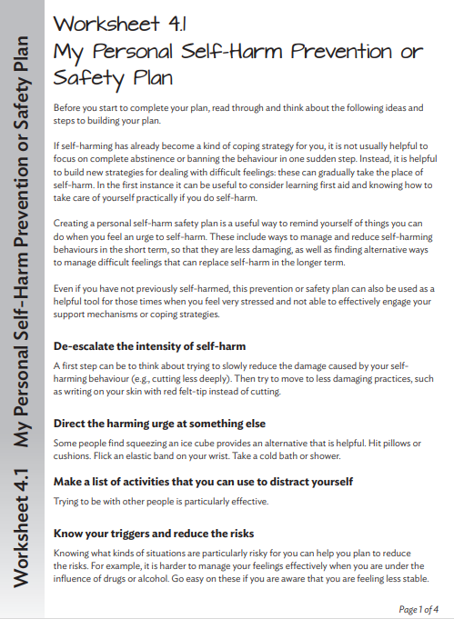

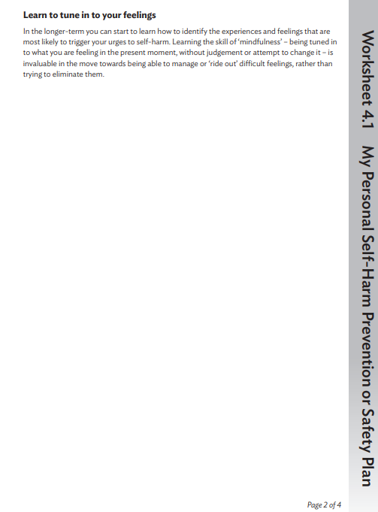

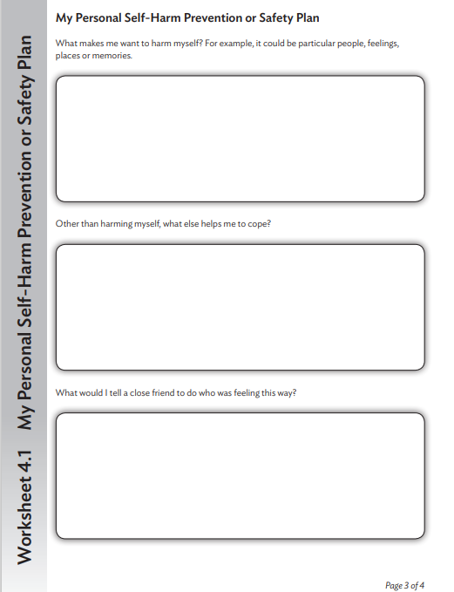

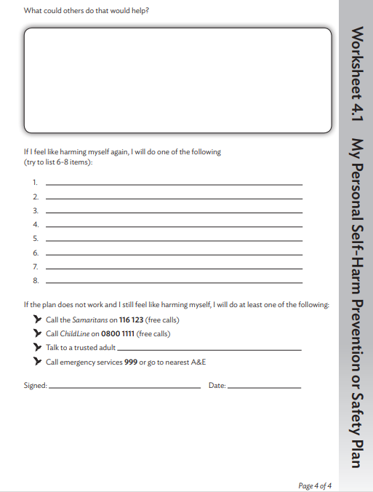

Attachment 2
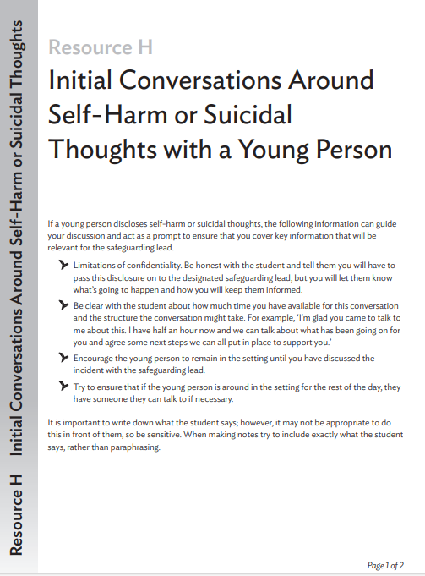
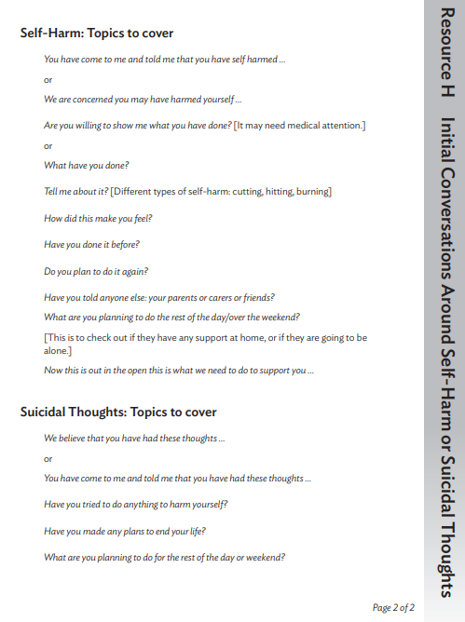

Attachment 3
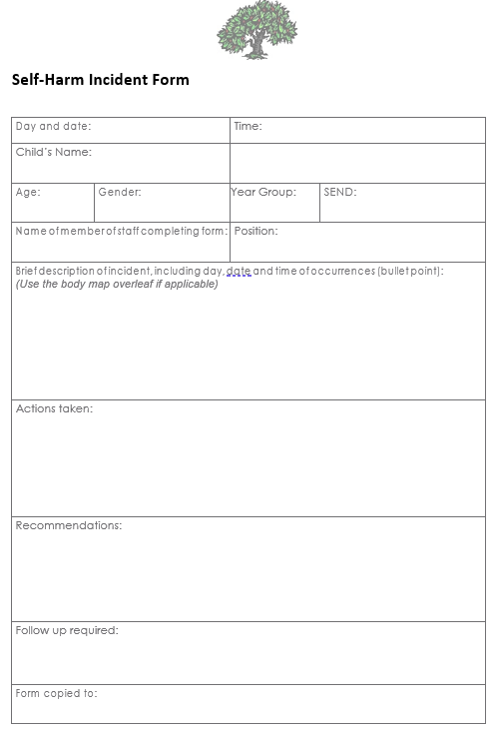
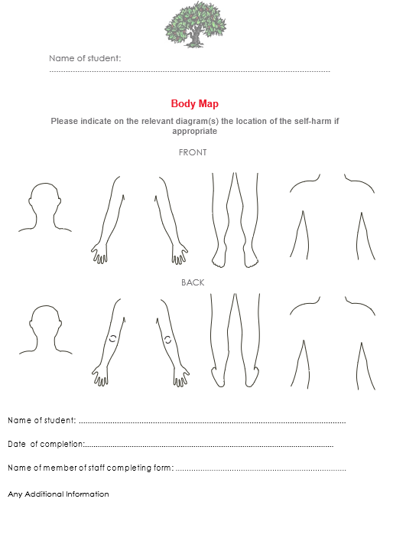

Attachment 4
