
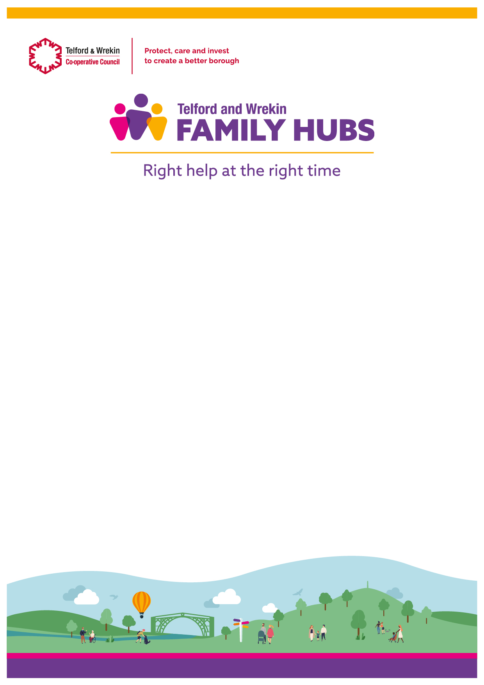
Book Launch

In partnership with Telford and Wrekin Libraries and The Dandelions a selection of books to support Parents across Telford and Wrekin with SEND, Trauma, LGBTQ+ and Neurodiversity will now be available across our Libraries.

Please join us to launch these on the
15th March 10:00 - 11:00
with Author and Illustrator
Eliza Fricker
At Southwater Library

This will be followed by a talk from Eliza Fricker about her journey
and experiences
11:30 – 12:30
Meeting Point House

To find out more or to book a seat please email telfordfamilyhubs@telford.gov.uk or call 01952 385465

