
I
Donnington Wood CE Junior School
SEND Newsletter Autumn Term 2023

Meet the Team at Donnington Wood
  Assistant Head of Inclusion  My name is Miss Ganderton and I have worked at Donnington Wood Juniors since 2018. I oversee attendance, inclusion, and I am a Safeguarding Lead. I work with families to make sure that the right support is put in place as soon as it is needed.  I meet regularly with the team in school to ensure provision is in place to meet Behaviour, Pastoral and SEND needs.  I am excited to be able to introduce Mrs Jenks and welcome her to the Donnington Wood team. Jo brings a wealth of experience to the team and I’m sure many of you have already had meetings to discuss your child’s provision. | 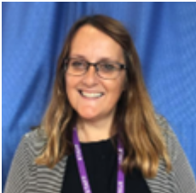  SENDCo  My name is Mrs Jenks and I have recently joined the team at Donnington Wood Junior’s as the SENCo. I will be overseeing the provision for all SEND pupils throughout the school, so I will be your first point of call if you feel that you have any concerns relating to your child’s development, learning or progress.  The SEND team at Donnington Wood are regularly looking for ways to improve the provision for SEND pupils and their parents. This SEND newsletter is a way for the team to liaise with parents sharing with you new initiatives, changes to legislation and our achievements and successes. The newsletter will be produced termly and will keep you up to date with everything that is happening in relation to SEND at Donnington Wood Junior School.
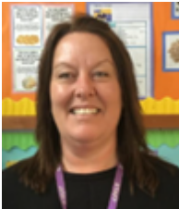  ELSA Support  My name is Mrs Rutherford and I support children to develop positive mental health and wellbeing; allowing them to enjoy learning.  I am also the school ELSA (Emotional literacy assistant support) this role enables me to support children to identify how they may be feeling and why; supporting them to manage their feelings in a positive way. | 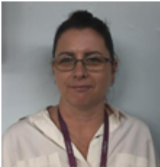  SEND Governor  My name is Mrs Worthington, and I am the governor with responsibilities for SEND (Special Educational Needs and Disabilities).  I support and challenge the school to ensure that no Learner is treated less favourably, denied opportunity or left behind because they have additional needs.


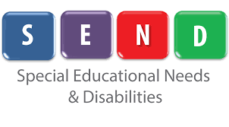


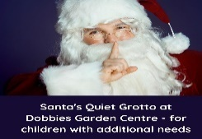


Dobbies Garden Centres in Shrewsbury, Telford and Wrexham are running a Quite Santa’s Grotto experience for children with additional needs on Friday 8th December.
These are pre-booked sessions, with no queuing on the day and a reduced number of families attending in each slot.
During your visit, Dobbies ensure:
- All music is off
- Twinkling lights are removed or switched off
- You can choose to have your child’s gift wrapped or not
Prior to your visit, they will email a photo of your specific Grotto to prepare the children for what they will see on the day
Dobbies Telford: https://events.dobbies.com/event-detail/?e=4251&v=71&r=v
Dobbies Shrewsbury: https://events.dobbies.com/event-detail/?e=4251&v=32&r=v

Christmas can be a tricky time for neurodivergent children or children with SEND. This could be the case if you child has autism, ADHD or a sensory processing disorder. Of if you child experiences anxiety or anxious feelings.

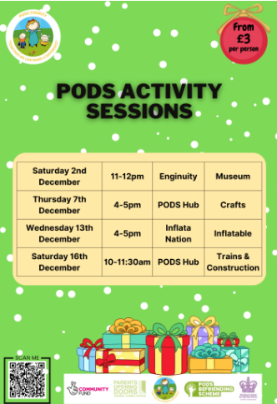
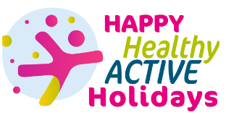
The Holiday Activities and Food (HAF) programme for the Christmas holidays is now open for bookings!
If your child is between 4-16 years old, they can get a free place if:
- You get benefits-related free school meals
- A Ukrainian guest staying in Shropshire
- Have been referred by a professional
Most providers can offer places to children with special educational needs or disabilities (SEND).
A lot of the providers also offer additional paid places that are available to everyone, so it’s worth looking if you need childcare or activities to keep your children busy during the holidays. https://www.telford.gov.uk/info/20789/happy_healthy_and_active_holidays


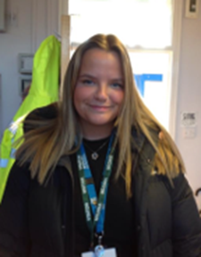

Mental Health Practitioner
My name is Sarah Partlington, I am part of BeeU and I am here to support young people in school. From November onwards, I will be offering 1:1 and group sessions which will take place in school, supporting your people with a variety of issues and concerns. Another are I will be helping school will be to think and plan how best to support children, teachers and parents around mental health. This will be raising awareness of mental health, challenging stigmas surrounding mental health and working with student. Teachers and parents to find ways in which we can improve mental health provision in school.
Contact details:
Donnington Wood Inclusion Team | 01952 386660 | Family Connect  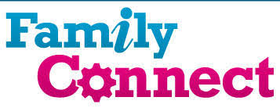 | 01952 385385  www.telford.gov.uk/info/20223/familyconnect
PODs - Parents Opening Doors  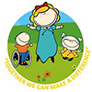 | 01952 271532  www.podstelford.org/ | Telford Autism Hub  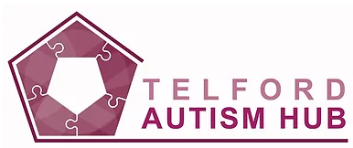 | 01952 262062  https://www.telfordautismhub.org.uk/childrens-autism-hub
Information Advice Support Service  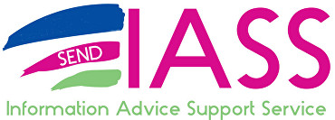 | 01952 457176  www.telfordsendiass.org.uk | SEND Telford Local Offer   | www.telfordsend.org.uk/site/index.php

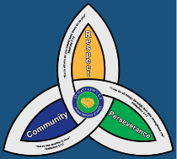


Wellbeing and Mental Health – Parent Signposting

BEAM   | All pupils | BEAM, run by The Children’s Society, is an emotional health and well-being service for children and young people across Telford and Wrekin and Shropshire. The service is available to anyone under the age of 25 and provides the opportunity to discuss, share and talk through problems in a non-judgemental environment.  https://www.childrenssociety.org.uk/beam/shropshire
Bee U   | All pupils | Bee U is another service that consists of 4 organisations (The Children’s Society, Kooth, Healios and Midlands Partnership NHS Foundation Trust) who deliver emotional health and wellbeing services across Shropshire and Telford & Wrekin. New drop-in and online services are available as well as Young People and Families Mental Health Service (previously CAMHS) to help you with, getting advice, getting help, getting more help, getting risk support  https://beeu.org.uk/
KOOTH   | 11 years+ | A free, safe, and anonymous place for young people to find online support and counselling. Kooth has a team of professionals who aim to provide early response to emotional wellbeing as well as emerging mental health needs via our online platform and counselling sessions.
Young Minds   | All pupils | Young Minds is the UK’s leading charity fighting for children and young people's mental health. They work to support parents of children and young adults with mental health issues. The helpline provides support and advice to parents and carers worried about the emotional wellbeing or behaviour of a young person in their care with confidential, expert advice.  https://youngminds.org.uk/

