 | How can i access support?  Feel free to contact us directly to discuss what we can offer you. You could:  • call into or telephone the school office to request an appointment in school or a telephone call back  • speak to your child’s teacher  • speak to a member of the school leadership team who are on duty at the beginning and end of the school day  • contact our Inclusion Team by calling the school office  We can also offer bilingual support for some languages.  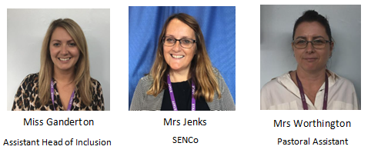    If you have any concerns regarding the welfare of a child, or require support but do not wish to approach school, please contact Family Connect on 01952 385385 or you can visit their website: www.familyconnecttelford.co.uk |  | Key Contacts  Headteacher  Mr Fox  Assistant Head of Inclusion  Miss Ganderton  SENDCo  Mrs Jenks  Pastoral Assistant  Mrs Worthington  Education Welfare Office  Rebecca Giles  Office Team  Mrs Bailey  Miss Armstrong  Designated Safeguarding Leads  Mr Fox Headteacher  Mr Rawson Deputy Head  Miss Ganderton Assistant Head of Inclusion  Mrs Jenks SENDCo
 |  |  |  | 
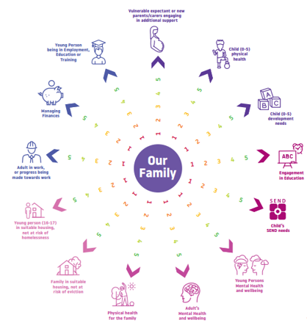
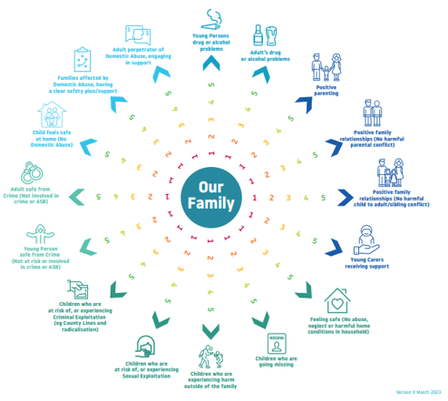
Early Help
Offer

 | What is Early Help?  Early Help is about supporting children and young people when there is a challenge in their lives, or that of their familiies, as soon as possible. It can be required at any stage In life, from pre-birth to adulthood, and applies to any problem or need that the family can’t deal with alone.  - Challenging home circumstances  - Behaviour, rules and routines  - Accessing community services  Early Help is what our school can offer to help you and your family.  There are many reasons why a family may benefit from Early Help support. We are not here to judge you or tell you what to do. |  | What will my support look like?  Every family and every situation is different, so your support will be tailored to your needs. We will always start with a conversation, listening to your concerns and identifying your family’s needs.  Sometimes, all of the support you need can be provided by school. In other cases, with your consent, we may suggest or signpost you to external services who are more specialised in the area that you would like help with.  All support that we provide is confidential and you can decide the level of help and advice that you would like. |  | 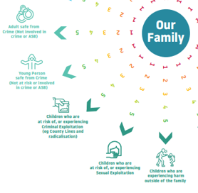

Who can i have support for?

We will try to help you with any problems that you may be having. This doesn’t mean that we can solve all of the challenges that you face, but we will listen to you, support you and signpost you to access services who can help you and your family.
You may want help because you are:
• concerned about your child’s behaviour
• concerned about your child’s mental health or anxiety
• caring for a child with additional needs
• worried about your housing situation or finances
• affected by drugs, alcohol or crime
• affected by domestic abuse
• experiencing some other form of difficulty.

