Pupil premium strategy statement
Donnington Wood CE Junior School

This statement details our school’s use of pupil premium (and recovery premium) funding to help improve the attainment of our disadvantaged pupils.
It outlines our pupil premium strategy, how we intend to spend the funding in this academic year and the outcomes for disadvantaged pupils last academic year.

School overview
Detail | Data
Number of pupils in school | 215
Proportion (%) of pupil premium eligible pupils | 110 Pupils as of 12/9/22 52% Increase of 4%
Academic year/years that our current pupil premium strategy plan covers (3 year plans are recommended) | This is year 2 of 3.
Date this statement was published | 6/9/22
Date on which it will be reviewed | September 23
Statement authorised by | Robert Fox
Pupil premium lead | Robert Fox
Governor / Trustee lead | Steve Jones

Funding overview
Detail | Amount
Pupil premium funding allocation this academic year | £144,115
Recovery premium funding allocation this academic year | £
Pupil premium (and recovery premium*) funding carried forward from previous years (enter £0 if not applicable)  *Recovery premium received in academic year 2021 to 2022 can be carried forward to academic year 2022 to 2023. Recovery premium received in academic year 2022 to 2023 cannot be carried forward to 2023 to 2024. | £o
Total budget for this academic year  If your school is an academy in a trust that pools this funding, state the amount available to your school this academic year | £144, 115

Part A: Pupil premium strategy plan

Statement of intent
This document needs to be read in conjunction with national information and intelligence around the widening gap make this an even bigger imperative for us. Of the 2022 Sats; ‘The DfE said the attainment gap between the two groups was the largest since 2012, “suggesting that disruption to learning during the Covid-19 pandemic has had a greater impact on disadvantaged pupils”.’
Though our intelligence in school, we were acutely aware of this and took decisive action to challenge it, data: Nationally 43%: our school, 38% shows us that there is still work to be done.
The main focus is on Quality first teaching and through the provision of online learning for home engagement to meet our target.
Our disadvantage pupils also have a number of additional needs and ACES (Adverse Childhood Experiences).
Our School Vision Our school is a community where each person is valued as a child of God. We are a Church of England school, inspired and guided by the life and teaching of Jesus.
We work together to create a caring, friendly and safe school family, to enable the whole school community to flourish and each person reach their full God-given potential.
Our Motto “The ones who plant and the ones who water work together as a team with the same purpose.” 1 Corinthians 3:8 We believe that with God’s help when we all work as a TEAM - Together Everyone Achieves More Our three core values of Hope, Perseverance and Friendship will provide our disadvantaged pupils with the skill to succeed in life and overcome the barriers to this success in the local area.
Our Mission (INTENT) At Donnington Wood CE Junior School we will
• put the safety of everyone as a priority so we can work in trust and peace.
• encourage everyone to understand the true meaning of friendship, fellowship and community by acting with humility, compassion and in service to each other.
• be inclusive so everyone is valued and respected and where tolerance and diversity are celebrated.
• seek out every opportunity to ensure that all of us flourish in all that we do, developing wisdom and creativity, through an ambitious and broad curriculum that challenges expectations, deepens knowledge and develops skills.
• empower pupils and adults to develop hope and perseverance, so that they are able to engage/explore the challenges of school and the wider world.
• nurture the spiritual development of our school fellowship, develop tolerance of other faiths, beliefs and cultures and build religious literacy through collective worship of God and teaching of RE.
• champion our values to equip our children ready for their future as respectful individuals, life-long learners and active citizens in society (justice).
This Vision and Mission will be evident in all we do, from the way we work together to the attitudes to life you will see us show. This Policy is one of our most important to deliver the above.
I detail below the challenges.

Challenges
This details the key challenges to achievement that we have identified among our disadvantaged pupils.

This is Year 2 of the 3 year plan.
Challenge number | Detail of challenge
1 | Disadvantaged Writers have been making lesson progress than their non- disadvantaged peers. (especially more than expected progress and catching up 6% compared to 14%). Children have not completed as high quality work at home with writing and spelling. Feeds into other targets.  This is now our main challenge.
2 | Disadvantaged Readers performed significantly lower to KS2 Sats national (in school parity) current internal data indicates around 53% readers across year groups.  Access to reading and vocab at home and high quality diet of text)
3 | This is now the Curriculum Focus. PPG pupil’s vocabulary in all subjects is weak compared to others (21 million words compared to 43 million word exposure). (continued from previous years)
4 | Community opportunities, home circumstances and skills, and outlook/aspiration can stop pupils making further progress. Esp:  Refined to 3 main areas.  • parental knowledge and opportunities to learn at home and restricted outdoor learning.  • Attendance, worry and uncertainty around the virus and returning to school/ lateness, around lack of routines.  • Mental and emotional wellbeing of the child, family and access to services. This is compounded by the high % of pupils who are both disadvantaged and are also on our Barrier to learning list, such as: the IDACI strands: Income Deprivation / Employment Deprivation / Education, Skills and Training Deprivation / Health Deprivation and Disability / Crime / Barriers to Housing and Services / Living Environment Deprivation. The main measure of this will be through attendance and progress rates.

Intended outcomes
This explains the outcomes we are aiming for by the end of our current strategy plan, and how we will measure whether they have been achieved.
Intended outcome | Success criteria
This difference in the writing progress rate between Disadvantaged and non disadvantaged in school and to national will close. (continued) | • Internal data indicates increased rates of progress.  • External data continues to diminish difference to national.
This difference in the Reading progress rate between Disadvantaged and non disadvantaged in school and to national will close. (continued) | Data will show that year 6 and Year 34 (key group) will continue to diminish. (2022 Sats showed parity in school.)  • Internal data indicates that progress rates for disadvantaged are higher than that of non-disadvantaged. Inc reading ages.
PPG pupil’s vocabulary in all subjects will increase to allow pupils to access the curriculum fully. (Continued) | Pupils will increase their reading fluency scores through online reading assessment.
The lates of disadvantages pupils  The persistent absence of | • Overall PP attendance improves from 95% to 96% in line with ’other’ pupils  • Reduction of disadvantaged pupils in the persistent absence (of less than 90%) group.

Activity in this academic year
This details how we intend to spend our pupil premium (and recovery premium) funding this academic year to address the challenges listed above.

Teaching (for example, CPD, recruitment and retention)

Teaching (for example, CPD, recruitment and retention)
Budgeted cost: £ 50’000
Activity | Evidence that supports this approach | Challenge number(s) addressed
• seek out every opportunity to ensure that all of us flourish in all that we do, developing wisdom and creativity, through an ambitious and broad curriculum that challenges expectations, deepens knowledge and develops skills.  Continued focus on CPD and for reading reasoning and reading fluency.  Continue to embed ARE reading approach with the targets and assessment system to pinpoint reading need (through VIPERS Vocab, Inference, Prediction, explanation, retrieval and summary)  Continue to enhance status of reading in school.  Enhanced work with families and access to reading materials- through Accelerated reading for all pupils and tablets taken home. https://www.renaissance.co m/products/acceleratedreader/  Volunteer reader project focus (RF to lead) | Mastery Learning +5: Mastery learning breaks subject matter and learning content into units with clearly specified objectives which are pursued until they are achieved. Learners work through each block of content in a series of sequential steps. This will enhance current systems to ensure all pupils are making progress.  The Sutton Trust recommends that this has a +8 impact in month’s progress: Feedback redirects or refocuses either the teacher’s or the learner’s actions to achieve a goal, by aligning effort and activity with an outcome. It can be about the learning activity itself, about the process of activity, about the student’s management of their learning. New targets will allow more specific teaching and targets setting.  Reading comprehension strategies +5 Reading comprehension approaches to improving reading focus on learners’ understanding of the text. They teach a range of techniques that enable pupils to comprehend the meaning of what is written, such as inferring the meaning from context, summarising or identifying key points, using graphic or semantic organisers, developing questioning strategies, and monitoring their own com  Although national data shows that Accelerated reader does not increase scores and progress, we feel that the access it gives to pupils and the way it complements exciting systems does add to the school challenge for reading. | 1
Focus on applying the basic of spelling and grammar into mastery style activities.  Oracy in to sentences and rehearsal.  Year 2 talk for writing support. | Mastery Learning +5: Mastery learning breaks subject matter and learning content into units with clearly specified objectives which are pursued until they are achieved. Learners work through each block of content in a series of sequential steps. Teachers seek to avoid unnecessary repetition by regularly assessing knowledge and skills. Those who do not reach the required level are provided with additional tuition, peer support, small group discussions, or homework so that they can reach the expected level.  Talk For writing Year 2- focus on | 2 3
C. PPG pupil’s vocabulary in all subjects will increase to allow pupils to access the curriculum fully.  CPD and training for effective use of vocab, including starters of lessons to give context to the learning and vocabulary associated with it. Development of word banks and SCs in school. Development of Literacy and Language walls to include topic walls and Mind Maps./ seesaw Increase of speaking and listening collaborative work for pupils to demonstrate their use of language. | Research indicates that disadvantaged pupils start school with ½ the language of pupils who are not disadvantaged. This research continued to emphasis the importance of closing this gap. These are:  Collaborative learning +5 Effective collaborative learning requires much more than just sitting pupils together and asking them to work together; structured approaches with well-designed tasks lead to the greatest learning gains.  The EEF reports that a focus on oral skills has a +5 impact.  Overall, studies of oral language interventions consistently show positive benefits on learning, including oral language skills and reading comprehension. On average, pupils who participate in oral language interventions make approximately five months' additional progress over the course of a year. We have invested in the literacy and language scheme to provide language rich activities for pupils and we will continue to develop this this year. | 2 3

Targeted academic support (for example, tutoring, one-to-one support, structured interventions)
Budgeted cost: £58’000
Activity | Evidence that supports this approach | Challenge number(s) addressed
• champion our values to equip our children ready for their future as respectful individuals, life-long learners and active citizens in society (justice).  C. PPG pupil’s vocabulary in all subjects will increase to allow pupils to access the curriculum fully.  Curriculum leaders Pre Teach and follow up focus with EAL and PPG additional provision to ensure that language is adopted through high Quality teaching and intervention. Provided with individual Seesaw activities. Additional reading resources through online reading and in school reading opportunities. New library/reading corners. | Individualised instruction: +2 Individualising instructions involves providing different tasks for each learner and support at the individual level. It is based on the idea that all learners are different and have different needs, and that therefore a personally tailored approach - particularly in terms of the tasks and activities that pupils undertake and the pace at which they make progress through the curriculum - will be more effective.  Will also use targeted boosters and interventions through Covid Catch up. There is national data pointing to the success of this. | 1 2 3
1 to 1 Volunteer Readers (Covid) Beanstalk readers and Reassure Volunteers. Small group Interventions Provide mini school provision for PPG Phonics. Reading recovery and Fresh Start. Identification of intervention pupil’s inc. Phonic test retakes from year 2. (inc Fresh start and Precision Reading) (TARGETTED INTERVENTION) Phonics club for selected year 3 pupils. (Mrs Mctegart timetable) | We will target hose pupils who failed the Phonics Screening at Year 1. Including 1 to 1 sessions: +5 One to one tuition is where a teacher, teaching assistant or other adult gives a pupil intensive individual support. It may be undertaken outside of normal lessons as additional teaching, for example as part of extending school time or summer schools, or as a replacement for other lessons by withdrawing the pupil for extra teaching. This will be led by specialist Phonics Lead with experience. It will be based on short term intensive support. | 1 2 3
B. This difference in the writing progress rate between Disadvantaged and non-disadvantaged in school and to national will close. | We will focus on combining many of the elements of the EEF to identify and then target individual need: This will include: Including 1 to 1 sessions: +5 One to one tuition is where a teacher, teaching assistant or other adult gives a pupil intensive individual support. It may be undertaken outside of normal lessons as additional teaching, for example as part of extending school time or summer schools, or as a replacement for other lessons by withdrawing the pupil for extra teaching. | 1 2 3

Wider strategies (for example, related to attendance, behaviour, wellbeing)
Budgeted cost: £ 23’000
Activity | Evidence that supports this approach | Challenge number(s) addressed
Team Pupil Triage focuses on addressing Pastoral support for disadvantaged pupils and pupils who have experienced other barriers. | It is reported (DFE study group) that pupils who have left care may have difficulties in: • forming trusting relationships with adults  • social skills and relationships with peers • coping with transitions and change  • planning, organising and remembering  • inhibiting their impulses, focusing their attention and initiating tasks  • speech and language  • managing their strong feelings, such as shame, sadness, anxiety and anger. | 4
Parent Pledge Pupils. (this also links to targeted support) Schools White Paper delivers real action to level up education - GOV.UK (www.gov.uk)  Increased Parent engagement through online learning and training.  Sharing information  Weekly slot for teachers and Parents to target ARE | Parental Involvement +3 covers the active engagement of parents in supporting their children’s learning at school. This includes programmes focused on parents and their skills (such as improving literacy or IT skills), general approaches to encourage parents to support their children to read or do mathematics, and more intensive programmes for families in crisis. | 1 2 3 4
Continue  Pupils can extend their learning at home ensuring that they have access to high quality resources/ and opportunities to support their progress.  Provide tablets/laptops to be used at home for school work. this means pupils can have access to online lessons and resources. Supports families with the knowledge how to support their pupils at home. | Evidence from lockdowns has shown that families are able to engage in their work and continue at home. There is a national issues and the school is determined that 100% on pupils will learn online and have access to top quality resources. This way will also increase team work around the child with parents and carers supported to support learning.  Parental Involvement +3 covers the active engagement of parents in supporting their children’s learning at school. This includes programmes focused on parents and their skills (such as improving literacy or IT skills), general approaches to encourage parents to support their children to read or do mathematics, and more intensive programmes for families in crisis. | 1 2 3 4
D. Increased attendance rates through working with outside partners/ EHA services.  Pastoral manager to monitor pupils and follow up quickly on absences. First day response provision. Breakfast club offer for PPG pupils to ensure on time to school. Traveller Liaison Office Karen Towers. | Focus on lates and persistent absences.  High attendance and being at school on time is essential to achieving the above outcomes. There is lots of research for this and is a particular issue for the school. With the virus we believe a number of children and parents will be anxious to come back to school. We will work with ese families and our emergency school to get them in and supported. Traveller pupils attendance has dropped. We are ensuring they are receiving the food parcels in a way that they feel comfortable with. This will also help build up relationships. | 1 2 3 4
Partnerships with family learning  Increase in open afternoons, workshops, parental support. We will now run two workshops a week: September plan. | Current news on the lockdown points to a number of issues, mental health, parents not being able to support their children (home schooling) and challenging behaviours.  We will provide course on these elements. This will increase engagement in school, increase support and help bridge the loss of learning.  Course booked in are Family Maths, Family Mindfulness, Understanding Child Behaviour and Crafts. | 1 2 3 4

Total budgeted cost: £ 13 000.

Total budgeted cost: £ 144 000

Part B: Review of the previous academic year

Outcomes for disadvantaged pupils
Outline outcomes for disadvantaged pupils in the 2021 to 2022 academic year and explain how their performance has been assessed.
Primary schools do not need to publish their 2022 key stage 2 results as DfE is not publishing that data. Refer to any other pupil evaluations carried out during the 2021 to 2022 academic year. For example, standardised teacher administered tests or diagnostic assessments such as rubrics or scales.
We strongly discourage comparing your school’s 2022 performance data with data from previous years. The impact of COVID-19 makes it difficult to interpret why the results are as they are. In addition, for secondary schools, changes were made to GCSE and A level exams in 2022, including grading that reflected a midway point between grading in 2021 and 2019.
The last strategy was created as we came out of lockdown 3. I have included going back to this date as we rolled over the majority of the targets from this strategy to this years. (and the end of 2020 academic when we were still in lockdown 1)..
Mid Year review Mental Health and Wellbeing Increased attendance of all pupils.

Mid Year review
Mental Health and Wellbeing
Data for PPG pupils was slightly below national combined. Internal data shows that disadvantaged outperform non disadvantaged.
Increased attendance of all pupils.
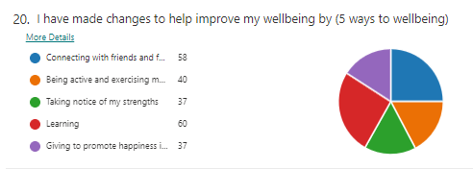
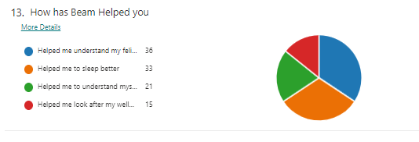
Academic achievements inc. small group support.
Interventions run by the school have been externally verified: Interventions are succinct, well planned, and organised. For example, phonics interventions in Year 3. Maths intervention teacher led with Year 4.
These are improving outcomes.
Based on December 2021 data disadvantaged pupils are making more progress than non disadvantaged pupils.
Reading focus
In the 6 months from September to March- pupils reading Pupils have made +0.25 months more progress. We want to further increase this as although more than not running the intervention, we expect greater results. Reading results show that pupils are increasing the number of questions answered.
Writing: Talk for writing
- The use of Pi Corbett strategies help staff plan for writing structures and models.

Attendance for September 2021- April 2022.
Attendance has been consistently 1% above the national attendance for disadvantaged pupils, despite prevalence of covid in our area.
Online learning
This continues to support our pupils, whether isolating or working form home.
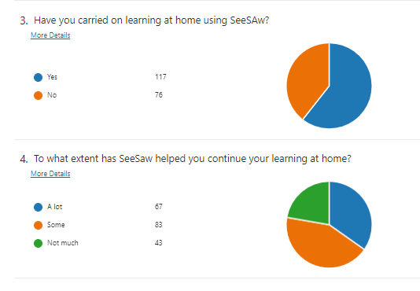
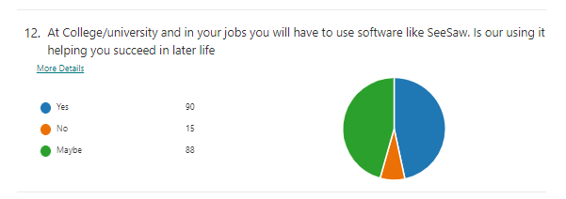
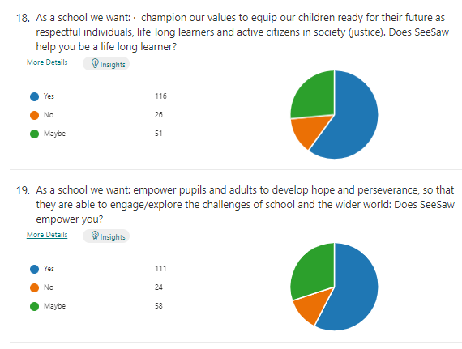
Pupil Voice
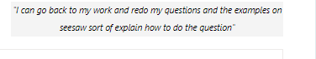

Externally provided programmes
Please include the names of any non-DfE programmes that you used your pupil premium (or recovery premium) to fund in the previous academic year.
Programme | Provider
MyON | Accelerated readers
Protocol Tuition funding (£12000) | Protocol

Service pupil premium funding (optional)
For schools that receive this funding, you may wish to provide the following information: How our service pupil premium allocation was spent last academic year
Additional pastoral support for all pupils including participation in school adventures
Additional Forest school activities.
The impact of that spending on service pupil premium eligible pupils
Pupil voice surveys show that all pupils flourished.

