Donnington Wood CE Pupil premium strategy statement


This statement details our school’s use of pupil premium (and recovery premium for the 2021 to 2022 academic year) funding to help improve the attainment of our disadvantaged pupils.

It outlines our pupil premium strategy, how we intend to spend the funding in this academic year and the effect that last year’s spending of pupil premium had within our school.

School overview
Detail | Data
School name | Donnington Wood Junior
Number of pupils in school | 222
Proportion (%) of pupil premium eligible pupils | 47%
Academic year/years that our current pupil premium strategy plan covers (3 year plans are recommended) | 3
Date this statement was published | 19/1/22
Date on which it will be reviewed | September 2022
Statement authorised by | Robert Fox
Pupil premium lead | Robert Fox
Governor / Trustee lead | Steve Jones
Funding overview
Detail | Amount
Pupil premium funding allocation this academic year | £164 547
Recovery premium funding allocation this academic year | £ 17,760.00
Pupil premium funding carried forward from previous years (enter £0 if not applicable) | £0
Total budget for this academic year  If your school is an academy in a trust that pools this funding, state the amount available to your school this academic year | £

Part A: Pupil premium strategy plan

Statement of intent
This strategy will also take into consideration the unequal effect COVID has had on our disadvantaged pupils and families. The main focus is on Quality first teaching and through the provision of online learning for home engagement to meet. This will help us meet our mission.
Our School Vision Our school is a community where each person is valued as a child of God. We are a Church of England school, inspired and guided by the life and teaching of Jesus. We work together to create a caring, friendly and safe school family, to enable the whole school community to flourish and each person reach their full God-given potential.
Our Motto “The ones who plant and the ones who water work together as a team with the same purpose.” 1 Corinthians 3:8 We believe that with God’s help when we all work as a TEAM - Together Everyone Achieves More
Our three core values of Hope, Perseverance and Friendship will provide our disadvantaged pupils with the skill to succeed in life and overcome the barriers to this success in the local area.

Our Mission (INTENT) At Donnington Wood CE Junior School we will
• put the safety of everyone as a priority so we can work in trust and peace.
• encourage everyone to understand the true meaning of friendship, fellowship and community by acting with humility, compassion and in service to each other.
• be inclusive so everyone is valued and respected and where tolerance and diversity are celebrated.
• seek out every opportunity to ensure that all of us flourish in all that we do, developing wisdom and creativity, through an ambitious and broad curriculum that challenges expectations, deepens knowledge and develops skills.
• empower pupils and adults to develop hope and perseverance, so that they are able to engage/explore the challenges of school and the wider world.
• nurture the spiritual development of our school fellowship, develop tolerance of other faiths, beliefs and cultures and build religious literacy through collective worship of God and teaching of RE.
• champion our values to equip our children ready for their future as respectful individuals, life-long learners and active citizens in society (justice).
This Vision and Mission will be evident in all we do, from the way we work together to the attitudes to life you will see us show. This Policy is one of our most important to deliver the above.

Challenges

This details the key challenges to achievement that we have identified among our disadvantaged pupils.
Challenge number | Detail of challenge
1 | Disadvantaged Readers performed significantly lower than to in school and national (from 2019 and current internal data- access to reading and vocab at home and high quality diet of text)
2 | Disadvantaged Writers have been making lesson progress than their non- disadvantaged peers. (especially more than expected progress and catching up 6% compared to 14%). Children have not completed as high quality work at home with writing and spelling. Feeds into other targets.
3 | PPG pupil’s vocabulary in all subjects is weak compared to others (21 million words compared to 43 million word exposure). (continued from previous years)
4 | Community opportunities, home circumstances and skills, and outlook/aspiration can stop pupils making further porgress. Esp:  • Lack of exercise, (clubs being closed again)  • access to online learning material including computing skills (this has been provided for no)  • parental knowledge and opportunities to learn at home and restricted outdoor learning.  • Attendance, worry and uncertainty around the virus and returning to school/ lateness, around lack of routines.  • Mental and emotional wellbeing of the child, family and access to services. This is compounded by the high % of pupils who are both disadvantaged and are also on our Barrier to learning list, such as: the IDACI strands: Income Deprivation / Employment Deprivation / Education, Skills and Training Deprivation / Health Deprivation and Disability / Crime / Barriers to Housing and Services / Living Environment Deprivation. The main measure of this will be through attendance and progress rates.

Intended outcomes
This explains the outcomes we are aiming for by the end of our current strategy plan, and how we will measure whether they have been achieved.
Intended outcome | Success criteria
This difference in the Reading progress rate between Disadvantaged and nondisadvantaged in school and to national will close. (continued) | Data will show that year 6 and Year 34 (key group) will continue to diminish.  • Internal data indicates that progress rates for disadvantaged are higher than that of non-disadvantaged. Inc reading ages.
This difference in the writing progress rate between Disadvantaged and nondisadvantaged in school and to national will close. (continued) | • Internal data indicates increased rates of progress.  • External data continues to diminish difference to national.
PPG pupil’s vocabulary in all subjects will increase to allow pupils to access the curriculum fully. (Continued) | Pupils will increase their reading fluency scores through online reading assessment.
The attendance of PPG pupils will increase to allow them to fully take part in the curriculum. (Persistent Absence for this group will reduce. ) (this target will remain due to impact of Covid) The readiness to learn and attitudes to learning will increase for PPG pupils (pupil voice and Boxhall profile scores) | • Overall PP attendance improves from 95% to 96% in line with ’other’ pupils; Pupils on track to meet A, B and C. • Reduction of disadvantaged pupils in the persistent absence (of less than 90%) group. • Increase of pupils ready for school through pupil voice and Boxall score

Activity in this academic year
This details how we intend to spend our pupil premium (and recovery premium funding) this academic year to address the challenges listed above.

Teaching (for example, CPD, recruitment and retention)
Budgeted cost: £ 60’000
Activity | Evidence that supports this approach | Challenge number(s) addressed
• seek out every opportunity to ensure that all of us flourish in all that we do, developing wisdom and creativity, through an ambitious and broad curriculum that challenges expectations, deepens knowledge and develops skills.  Continued focus on CPD and for reading reasoning and reading fluency.  Continue to embed ARE reading approach with the targets and assessment system to pinpoint reading need (through VIPERS Vocab, Inference, Prediction, explanation, retrieval and summary)  Continue to enhance status of reading in school.  Enhanced work with families and access to reading materials- through Accelerated reading for all pupils and tablets taken home. https://www.renaissance.co m/products/acceleratedreader/ | Mastery Learning +5: Mastery learning breaks subject matter and learning content into units with clearly specified objectives which are pursued until they are achieved. Learners work through each block of content in a series of sequential steps. This will enhance current systems to ensure all pupils are making progress.  The Sutton Trust recommends that this has a +8 impact in month’s progress: Feedback redirects or refocuses either the teacher’s or the learner’s actions to achieve a goal, by aligning effort and activity with an outcome. It can be about the learning activity itself, about the process of activity, about the student’s management of their learning. New targets will allow more specific teaching and targets setting.  Reading comprehension strategies +5 Reading comprehension approaches to improving reading focus on learners’ understanding of the text. They teach a range of techniques that enable pupils to comprehend the meaning of what is written, such as inferring the meaning from context, summarising or identifying key points, using graphic or semantic organisers, developing questioning strategies, and monitoring their own com | 1
Focus on applying the basic skills of handwriting and spelling into mastery style activities. Oracy in to sentences and rehearsal.  Roll out of talk for writing. | Mastery Learning +5: Mastery learning breaks subject matter and learning content into units with clearly specified objectives which are pursued until they are achieved. Learners work through each block of content in a series of sequential steps. Teachers seek to avoid unnecessary repetition by regularly assessing knowledge and skills. Those who do not reach the required level are provided with additional tuition, peer support, small group discussions, or homework so that they can reach the expected level.  Talk for learning will also bridge the oracy gap- See below. | 2 3
C. PPG pupil’s vocabulary in all subjects will increase to allow pupils to access the curriculum fully.  CPD and training for effective use of vocab, including starters of lessons to give context to the learning and vocabulary associated with it. Development of word banks and SCs in school. Development of Literacy and Language walls to include topic walls and Mind Maps./ seesaw Increase of speaking and listening collaborative work for pupils to demonstrate their use of language. | Research indicates that disadvantaged pupils start school with ½ the language of pupils who are not disadvantaged. This research continued to emphasis the importance of closing this gap. These are:  Collaborative learning +5 Effective collaborative learning requires much more than just sitting pupils together and asking them to work together; structured approaches with well-designed tasks lead to the greatest learning gains.  The EEF reports that a focus on oral skills has a +5 impact.  Overall, studies of oral language interventions consistently show positive benefits on learning, including oral language skills and reading comprehension. On average, pupils who participate in oral language interventions make approximately five months' additional progress over the course of a year. We have invested in the literacy and language scheme to provide language rich activities for pupils and we will continue to develop this this year. | 2 3

Targeted academic support (for example, tutoring, one-to-one support structured interventions)
Budgeted cost: £80’000
Activity | Evidence that supports this approach | Challenge number(s) addressed
• champion our values to equip our children ready for their future as respectful individuals, life-long learners and active citizens in society (justice).  C. PPG pupil’s vocabulary in all subjects will increase to allow pupils to access the curriculum fully.  EAL and PPG additional provision to ensure that language is adopted through high Quality teaching and intervention. Provided with individual Seesaw activities. Additional reading resources through online reading and in school reading opportunities. New library/reading corners.  Extra sessions from volunteer readers to ensure reading Flash academy and seesaw links. | Individualised instruction: +2 Individualising instructions involves providing different tasks for each learner and support at the individual level. It is based on the idea that all learners are different and have different needs, and that therefore a personally tailored approach - particularly in terms of the tasks and activities that pupils undertake and the pace at which they make progress through the curriculum - will be more effective. | 1 2 3
1 to 1 Volunteer Readers (Covid) Beanstalk readers (Covid) Small group Interventions Provide mini school provision for PPG Phonics. Reading recovery and Fresh Start. Identification of intervention pupil’s inc. Phonic test retakes from year 2. (inc Fresh start and Precision Reading) (TARGETTED INTERVENTION) Phonics club for selected year 3 pupils. | We will target hose pupils who failed the Phonics Screening at Year 1. Including 1 to 1 sessions: +5 One to one tuition is where a teacher, teaching assistant or other adult gives a pupil intensive individual support. It may be undertaken outside of normal lessons as additional teaching, for example as part of extending school time or summer schools, or as a replacement for other lessons by withdrawing the pupil for extra teaching. This will be led by specialist Phonics Lead with experience. It will be based on short term intensive support. | 1 2 3
B. This difference in the writing progress rate between Disadvantaged and non-disadvantaged in school and to national will close.  1 to 1 Small group (Increased teacher numbers) Interventions and Seesaw including RWI phonics support. Provide mini school provision for PPG. Running of after school clubs Individualised instruction: +2 Individualising instructions involves providing different tasks for each learner and support at the individual level. It is based on the idea that all learners are different and have different needs, and that therefore a personally tailored approach - particularly in terms of the tasks and activities that pupils undertake and the pace at which they make progress through the curriculum - will be more effective. | We will focus on combining many of the elements of the EEF to identify and then target individual need: This will include: Including 1 to 1 sessions: +5 One to one tuition is where a teacher, teaching assistant or other adult gives a pupil intensive individual support. It may be undertaken outside of normal lessons as additional teaching, for example as part of extending school time or summer schools, or as a replacement for other lessons by withdrawing the pupil for extra teaching. | 1 2 3

Wider strategies (for example, related to attendance, behaviour, wellbeing)
Budgeted cost: £ 23’000
Activity | Evidence that supports this approach | Challenge number(s) addressed
Pastoral support for disadvantaged pupils and pupils who have experienced other barriers.  Encourage pupils to feel part of our school. Will subsidise extra curricular clubs and discount breakfast club to ensure stable start to day. PSM training and Bedazzle workshops on social skills. This will better allow us to support pupils.  New Government support for families has been announced. . | It is reported (DFE study group) that pupils who have left care may have difficulties in: • forming trusting relationships with adults  • social skills and relationships with peers • coping with transitions and change  • planning, organising and remembering  • inhibiting their impulses, focusing their attention and initiating tasks  • speech and language  • managing their strong feelings, such as shame, sadness, anxiety and anger. | 4
Coaching and mentoring sessions for PPG Pupils. The PPG team to regularly meet and mentor and coach pupils to support them to meet their targets and life goals. Triage team to identify issues around school. Bedazzle support 2x a week.  Increased Parent engagement through online learning and training.  Additional PE sessions. | To build positive relationships for learning behaviour and act as a role model. Research from the EEF show that although this can have a low impact, +1 month impact, the school feels that this is effective in helping develop pupils’ social and emotional resilience. Improving attendance will directly improve maths progress due to maths being first and Maths EMW.  Parental Involvement +3 covers the active engagement of parents in supporting their children’s learning at school. This includes programmes focused on parents and their skills (such as improving literacy or IT skills), general approaches to encourage parents to support their children to read or do mathematics, and more intensive programmes for families in crisis. | 1 2 3 4
Pupils can extend their learning at home ensuring that they have access to high quality resources/ and opportunities to support their progress.  Provide tablets/laptops to be used at home for school work. this means pupils can have access to online lessons and resources. Supports families with the knowledge how to support their pupils at home. | Evidence from lockdowns has shown that families are able to engage in their work and continue at home. There is a national issues and the school is determined that 100% on pupils will learn online and have access to top quality resources. This way will also increase team work around the child with parents and carers supported to support learning.  Parental Involvement +3 covers the active engagement of parents in supporting their children’s learning at school. This includes programmes focused on parents and their skills (such as improving literacy or IT skills), general approaches to encourage parents to support their children to read or do mathematics, and more intensive programmes for families in crisis. | 1 2 3 4
D. Increased attendance rates through working with outside partners/ EHA services.  Pastoral manager to monitor pupils and follow up quickly on absences. First day response provision. Breakfast club offer for PPG pupils to ensure on time to school. Traveller Liaison Office Karen Towers. | High attendance and being at school on time is essential to achieving the above outcomes. There is lots of research for this and is a particular issue for the school. With the virus we believe a number of children and parents will be anxious to come back to school. We will work with ese families and our emergency school to get them in and supported. Traveller pupils attendance has dropped. We are ensuring they are receiving the food parcels in a way that they feel comfortable with. This will also help build up relationships. | 1 2 3 4
Partnerships with family learning  Increase in open afternoons, workshops, parental support. We will now run two workshops a week: September plan. | Current news on the lockdown points to a number of issues, mental health, parents not being able to support their children (home schooling) and challenging behaviours.  We will provide course on these elements. This will increase engagement in school, increase support and help bridge the loss of learning.  Course booked in are Family Maths, Family Mindfulness, Understanding Child Behaviour and Crafts. | 1 2 3 4

Total budgeted cost: £ 163 000.

Part B: Review of outcomes in the previous academic year

Pupil premium strategy outcomes
This details the impact that our pupil premium activity had on pupils in the 2020 to 2022 academic year.
Due to COVID-19, performance measures have not been published for 2020 to 2021, and 2020 to 2021 results will not be used to hold schools to account. Data for 2021 and 2022 is going to be created but there are uncertainties if it will be publicly published. For the report we have used the current data we have, including pupil voice.
The last strategy was created as we came out of lockdown 3. I have included going back to this date as we rolled over the majority of the targets from this strategy to this years. (and the end of 2020 academic when we were still in lockdown 1).

Mid Year review
Mental Health and Wellbeing
Increased attendance of all pupils.
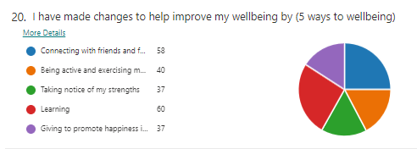
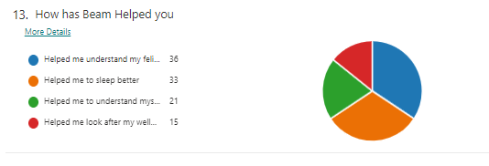
Academic achievements inc. small group support.
Interventions run by the school have been externally verified: Interventions are succinct, well planned, and organised. For example, phonics interventions in Year 3. Maths intervention teacher led with Year 4.
These are improving outcomes.
Based on December 2021 data disadvantaged pupils are making more progress than non disadvantaged pupils.
Reading focus
In the 6 months from September to March- pupils reading Pupils have made +0.25 months more progress. We want to further increase this as although more than not running the intervention, we expect greater results. Reading results show that pupils are increasing the number of questions answered.
Writing: Talk for writing
- The use of Pi Corbett strategies help staff plan for writing structures and models.

Attendance for September 2021- April 2022.
Attendance has been consistently 1% above the national attendance for disadvantaged pupils, despite prevalence of covid in our area.
Online learning
This continues to support our pupils, whether isolating or working form home.
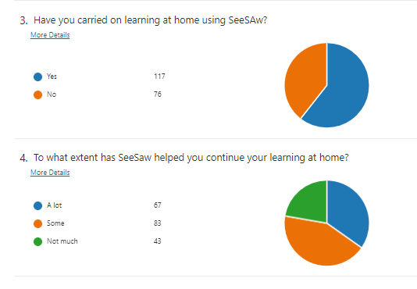
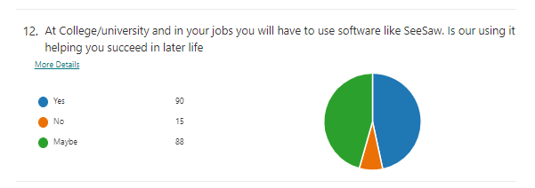
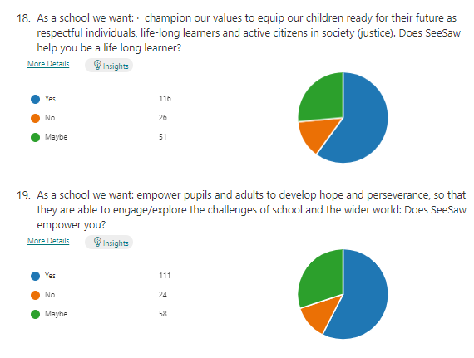
Pupil Voice
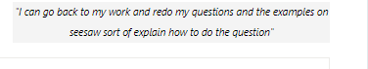

Externally provided programmes
Please include the names of any non-DfE programmes that you purchased in the previous academic year. This will help the Department for Education identify which ones are popular in England
Programme | Provider
MyOn

Service pupil premium funding (optional)
For schools that receive this funding, you may wish to provide the following information:
Measure | Details
How did you spend your service pupil premium allocation last academic year?
What was the impact of that spending on service pupil premium eligible pupils? | Pupil Voice Surveys

Further information (optional)
Use this space to provide any further information about your pupil premium strategy. For example, about your strategy planning, or other activity that you are implementing to support disadvantaged pupils, that is not dependent on pupil premium or recovery premium funding.

