Hobby Hour

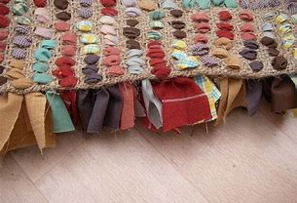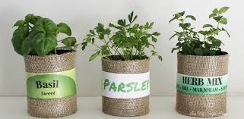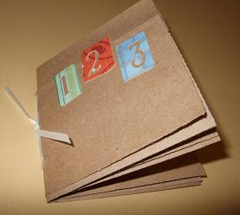

A free online activity hour sharing hobby interests from the comfort of your home.

Activity date:

Wednesday 3, 10, 17 and 24 February
10:00am – 11:00am

- Join us and share your hobby interests
- Explore and try new recipes ideas
- Discover places to walk local to you
- Discuss favourite books
- Support to try new crafts
- Resource pack and materials provided

For more information or to book a place please contact Learn Telford on 01952 382888 or text/call us on
07800 671757 / 07800 671797

Online

