

Donnington Wood Infants and Juniors School
- For parents with children in all years!
- Fun art based activities that support Family Wellbeing
- Enjoy socialising online
- Experienced tutor
- Join us with a cuppa and a snack!
- All materials supplied FREE!

You will need to download MSTeams in order to access this course.
Please register your interest for this course at:
http://www.learntelford.ac.uk/Search/FullDetails/7931621

Our tutor will make contact with you to support you throughout.

Tuesday 10th November – 15th December 2020
3:30 – 5:30 pm
6 Week ONLINE COURSE for Parents and Children

9:30 – 11:30 am

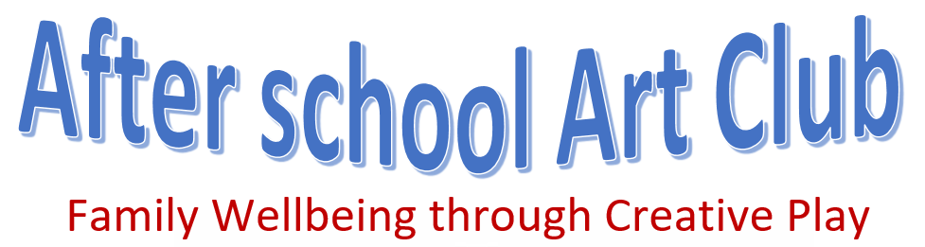

9:30 – 11:30 am


After School Art and Wellbeing Club

Please return your slip to your School Administrator on register On-Line (click link below) to book your place on the After School Art and Wellbeing Course at Donnington Wood Infants School
Tuesday 10th November – 15th December 2020 from 3:30 – 5:30 pm

http://www.learntelford.ac.uk/Search/FullDetails/7931621

Child’s name and School Year …………………………………………………………………………………………..
Name of adult attending ..……………….…………………………………………………………………………
Telephone number ..……………….…………………………………………………………………………
Email…………………………………………………………………………...…………………………..

