Donnington Wood CE Junior School

Welcome back to Year 4
Spring term 2020
Our Year 4 staff
4DM 4B
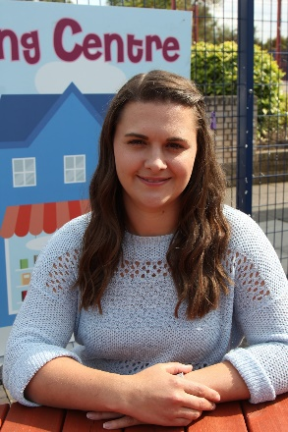  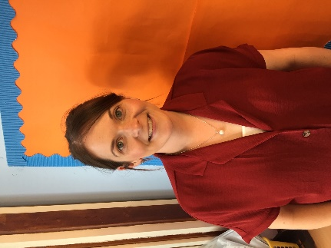  Mrs Davies and Mrs Medlyn | 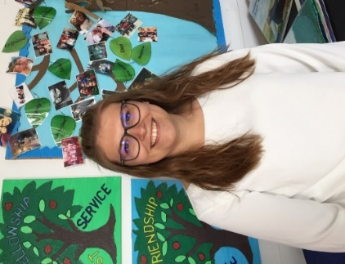  Miss Barden
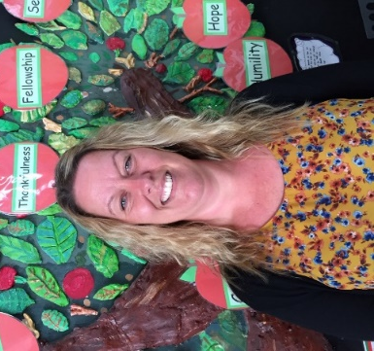  Mrs Rutherford | 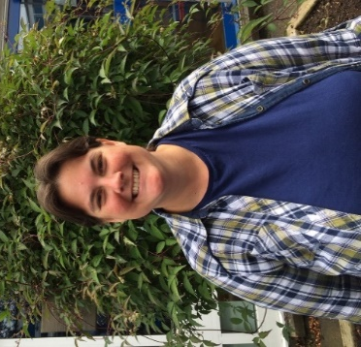  Mrs Morgan

Happy New Year! We are excited to welcome back all of our Year 4 pupils this Spring term and we are sure this will be another fantastic term for all of us. We have been delighted with the progress and achievements of our children last term. If you have any questions about their work this term please contact us through the school office or visit our website for additional information.
Our Year 4 Curriculum
Spring term
Maths every day 8:45 -10:00 4DM Mrs Davies - Monday – Wednesday 4DM Mrs Medlyn – Wednesday – Friday 4B Miss Barden
Skills to cover:
Reading, writing and ordering numbers over 1000; Estimating and using inverse; Number facts to 20 and to 100; Addition and Subtraction of 4-digit numbers using efficient methods; All multiplication and division facts up to 12x12; Measurement: using mm, cm and m and converting all units of measure; Classifying and sorting 2D shapes; Identifying lines of symmetry; Multiplication of 1 digit by 2 digit numbers using a formal written layout: Multiply and divide by 10 and 100; Fractions: recognise families of common equivalent fractions; Recognise any amounts of tenths and hundredths; Measurement of time; Solve comparison problems from graphs.
Literacy every day 10:45- 12:30 4DM Mrs Davies - Monday – Wednesday
4DM Mrs Medlyn - Wednesday – Friday
4B Miss Barden
Accurate use of punctuation to show direct speech, pronoun to prevent repetition, fronted adverbials to add detail, expanded noun phrases and apostrophes to show contraction and possession.
Develop the use of inference skills within reading to strengthen writing skills, writing in paragraphs, using organisational devices for non-fiction writing.
History Mondays (half term block) Mr Davda
Topic/Skills to cover:
Exploring life during Roman times. What have the Romans ever done for us?
Geography Mondays pm (half term block) Miss Barden and Mrs F Davies
Topic/Skills to cover:
Mountains – what is it like to live in a mountain region?
Science Thursdays pm (half term block) Miss O’Shea
Topic/Skills to cover:
Investigating electricity and sound.
Design and Technology Fridays am (half term block) Mrs R Davies
Skills to cover:
Design and make sound box guitars.
Art Thursdays pm (half term block) Miss Percival
Skills to cover:
Mixed media abstract art inspired by sound.
Music Tuesdays pm (half term block) Mr Vince
Skills to cover:
Exploring folk music.
PE Wednesdays pm (half term block) Mr Field
Skills to cover:
Gymnastics
French Wednesdays pm (half term block) Mrs Minor
Skills to cover:
Counting numbers 1-20, talking about my family and writing simple sentences.
RE Tuesdays pm (half term block) Mr Rawson
Skills to cover:
How do Muslims keep the 5 pillars of Islam?
Why is Jesus inspiring? (Easter).
ICT Linked to our topics
Skills to cover:
WeDo simulation
PSHE Fridays am (half term block) Mrs Medlyn
Discussing and understanding core values and how to develop them in life situations.
Notices for your diaries
7th January 2020 return to school
17th-21st February Half term week
26th February Ash Wednesday –season of Lent begins
3rd April End of Spring term

Reminders
Reading diaries  Please encourage your child to read each evening and record their reading comments in their purple record books. Please help them look after these books and bring them to school each day in their school bag. There is an example of how to fill this in at the back of your child’s homework book. | Homework  Two pieces of homework will be given out every Friday in their purple Homework book. Please encourage your child to complete it on time and record the level of support they have needed.
PE kit  PE will be every Wednesday afternoon for Year 4. PE kit should be worn to school on this day but can we remind you that this should be school PE kit with dark tracksuit trousers and top for outdoor lessons. | Personal items  Personal items such as pens, pencil cases, toys and items of value should not be brought into school and we cannot take any responsibility for any items brought to school becoming lost or broken.
Times Tables  Times tables continue to be an important aspect of our maths curriculum. Please encourage your child to practise these at home remembering that they can access a variety of resources including Times Table Rockstars (login details are in their reading diaries). | Reading Books  The children have access to a range of reading books to include a book suitable to their reading age as well as a choice of books from the reading corner. They are encouraged to have two books to take home, with the banded book being one that they can read independently. Support may be needed for books chosen from the reading corner.  We may also occasionally send the class text home for them to complete a short activity on. These will be outlined in their reading diary.

Helping your child at home

The more support and encouragement children get the more progress they will make. We would ask you to regularly make a special time to sit and support your child with their learning this year.
Reading
- Please read stories to and with your child.
- Join Donnington or Telford library.
- Point out labels and signs in the area when you are out and about.
- Show them newspaper and magazine articles.
Writing
- It helps children to have easy access to pencils, pens, paper and notebooks at home.
- Writing lists, cards, notes, letters helps with writing skills and composition.
- Regular drawing and colouring helps with pencil grip and hand control.
Spelling
- Regularly test their spelling of key words, days, months, names, place names, addresses, etc.
Maths
- Encourage the recognition of coins and money.
- Use clocks and watches to tell the time and discuss time lengths.
- Count items at home out and share out to develop division and fraction understanding.
- Look at shapes and designs of home items.
- Play maths games.
- Practise times tables up to 12x12, focusing on accuracy and speed.
Websites
- Children love to use computers, ipads and tablets to access fun games. There are many fun sites available that encourage and support school learning.
- Visit our school website to see recommendations for good learning sites.
- www.bbc.co.uk/bitesize/
- www.mathletics.co.uk
- www.woodlands-junior.kent.sch.uk/maths/
- www.mathszone.co.uk
- www.educationquizzes.com/ks2/
Homework
- Always make a special time and place to complete homework assignments.
- Praise and reward rather than moan and nag.
- Encourage research of school topics to find out background information. Independent projects will be rewarded in school with prizes.

