Donnington Wood CE Junior School

Welcome back to Year 3
Spring term 2020
Our Year 3 staff
3R 3O
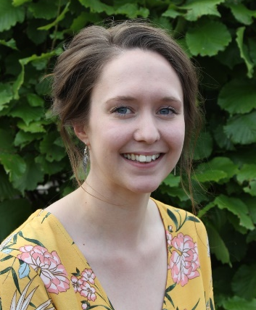  Miss Percival | 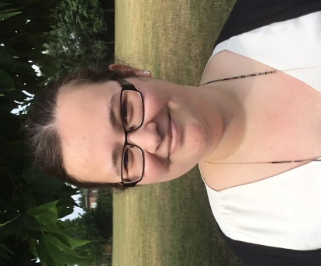  Miss O’Shea
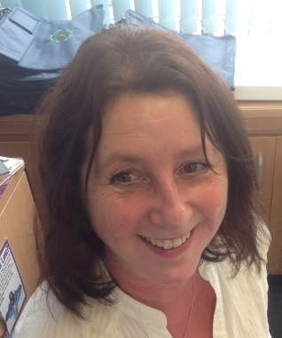  Mrs Brennan | 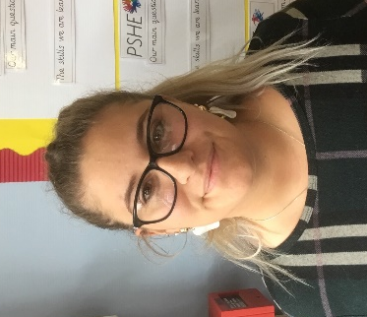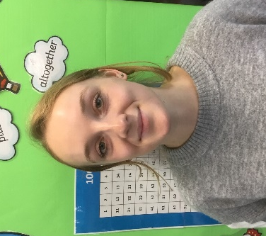  Miss Price Miss Vaughan

Happy New Year! We are excited to welcome back all of our Year 3 pupils this Spring term and we are sure this will be another fantastic term for all of us. We have been delighted with how quickly our children settled into school and how they made great progress last term. If you have any questions about their work this term please contact us through the school office or visit our website for additional information.

Our Year 3 Curriculum
Spring term
Maths every day 8:45 -10:00 3R Miss Percival 3O Miss O’Shea
Skills to cover:
Reading, writing and ordering two- and three-digit numbers; Counting and estimating; Number facts to 20 and to 100; Addition and Subtraction of 1 and 2-digit numbers; Multiplication and division facts; Measurement: using mm, cm and metres; Recognising, describing and making 2D and 3D shapes; Addition and subtraction of two- and three-digit numbers, using a number line and columns ; Multiplication and division: doubling, halving and TU × U; Fractions: representing, comparing and ordering unit fractions of shapes and numbers ; Measurement of time; Statistics: read, present and interpret pictograms and tables
Reading and Literacy every day 10:45- 12:30 3R Miss Percival 3O Miss O’Shea
Skills to cover:
Reading stories with familiar settings; writing character descriptions for stories; writing sentences using adverbs; punctuating speech using inverted commas; reading and writing information texts; spelling using suffixes and prefixes; homophone words
History Tuesdays pm (half term block) Mr Davda
Topic/Skills to cover:
How did society change in Victorian times?
Geography Tuesdays pm (half term block) Miss Barden
Topic/Skills to cover:
Investigating river flooding and the River Severn.
Science Fridays am (half term block) Miss O’Shea / Mr Field
Topic/Skills to cover:
Investigating forces and magnets.
Design and Technology Wednesdays pm (half term block) Mr Cadle
Skills to cover:
Design and make a boat; design, measure, cut, make, evaluate.
Art Fridays am (half term block) Miss Percival
Skills to cover:
Painting the River Severn in the style of Impressionism (Claude Monet)
Music Mondays pm (half term block) Mr Vince
Skills to cover:
Introduction to performing music – playing music by ear, basic note reading
PE Thursdays pm Mr Field/ Miss Barden
Skills to cover:
Gymnastics/Team Invasion Games (catching and throwing techniques)
French Thursdays pm Miss Barden
Skills to cover:
Numbers up to 10, Colours, Days of the week/months
RE Mondays pm (half term block) Mr Rawson
Skills to cover:
What are the special moments on the journey of life?
ICT Wednesdays pm Mr Osman
Learning to follow sequences and basic commands.
PSHE Thursdays pm Mrs Davies
Discussing and understanding our core values and how to develop them in life situations.

Notices for your diaries
7th January 2020 return to school
17th-21st February Half term week
26th February Ash Wednesday –season of Lent begins
3rd April End of Spring term

Reminders
Reading diaries  Please encourage your child to read at home for at least 10 minutes every day and record their reading comments in their purple record books. Please help them look after these books and bring them to school each day in their school bag. | Homework  Two pieces of homework will be given out every Friday in their Purple Homework book. Please encourage your child to complete it on time (Monday to receive Homework Prizes, Wednesday at the very latest) and record the level of support they have needed.
PE kit  PE will be every Thursday for Year 3. PE kit should be worn to school on this day but may we remind you that this should be school PE kit only with dark tracksuit trousers and tops for outdoor lessons. | Personal items  Personal items such as pens, pencil cases, toys and items of value should not be brought into school and we cannot take any responsibility for any items brought to school becoming lost or broken.

Helping your child at home
The more support and encouragement children get the more progress they will make. We would ask you to regularly make a special time to sit and support your child with their learning this year.
Reading
- Please read stories to and with your child. Make a bedroom library of books or comics.
- Join Donnington or Telford library.
- Point out labels and signs in the area when you are out and about.
- Show them newspaper and magazine articles.
Writing
- It helps children to have easy access to pencils, pens, paper and notebooks at home.
- Writing lists, cards, notes, letters helps with writing skills and composition.
- Regular drawing and colouring helps with pencil grip and hand control.
Spelling
- Regularly test their spelling of key words, days, months, names, place names, addresses, etc.
Maths
- Encourage the recognition of coins and money
- Use clocks and watches to tell the time and discuss time lengths
- Count items at home out and share out to develop division and fraction understanding
- Look at shapes and designs of home items
- Play maths games
Websites
- Children love to use computers, ipads and tablets to access fun games. There are many fun sites available that encourage and support school learning.
- Visit our school website to see recommendations for good learning sites.
- www.bbc.co.uk/bitesize/
- www.mathletics.co.uk
- www.woodlands-junior.kent.sch.uk/maths/
- www.mathszone.co.uk
- www.educationquizzes.com/ks2/
Homework
- Always make a special time and place to complete homework assignments.
- Praise and reward rather than moan and nag.
- Encourage research of school topics to find out background information. Independent projects will be rewarded in school with prizes.

