November 2018

Dear Parent / Carer

Year 5 Christmas Disco

We are holding a Christmas Disco for Year 5 students and you are all invited to celebrate some pre-Christmas fun! The disco will take place on Wednesday, 12th December 2018 between 5.00pm and 6.00pm in our dance studio. Entry is free and drinks will be provided, including hot drinks for any parents wanting to stay.

We are asking that you book your ticket in advance as space is limited, but booking couldn’t be easier. Simply visit our website;

http://telfordprioryschool.co.uk/news-and-events/year-5-christmas-disco/

Children will be dismissed from the dance studio to be collected from the canteen area.

Yours faithfully
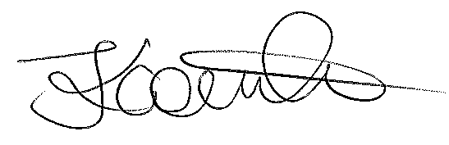
Mrs J Couch
Interim Transition Manager

