Donnington Wood Junior School
Christmas Crafts

A 6 week course for grandparents, parents, carers
Venue: Donnington Wood Junior School
Dates: Monday 5th November – 10th December 2018
Time: 12:45 pm – 2:45 pm

Free Crèche available on request

No previous knowledge or experience is needed for this course.

Enjoy learning new craft techniques

This course is fun, friendly and FREE

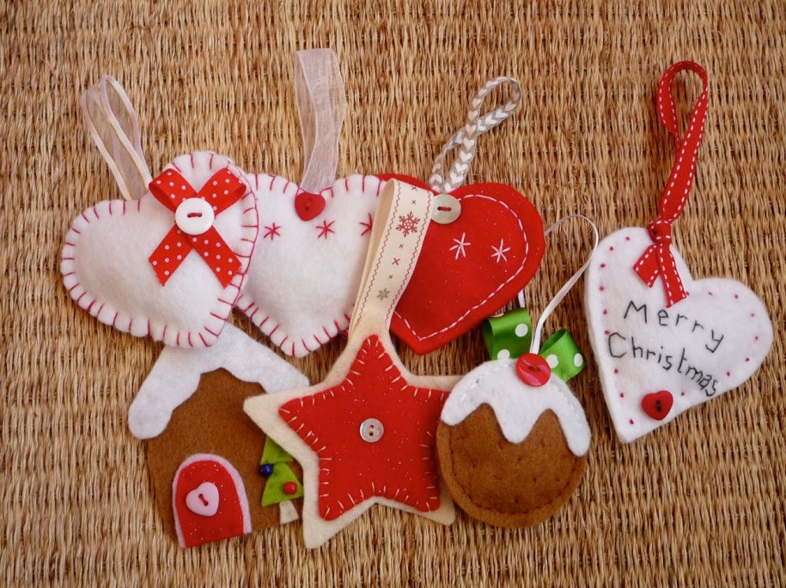
Work with a supportive and experienced tutor

Make your own Christmas decorations and presents.

Register your interest in one of the following ways
- use our website - www.learntelford.ac.uk
- complete the form overleaf and hand it in at the school office
- phone 01952 382888

Please return your slip to your School Administrator to book your place on the Christmas Crafts course at Donnington Wood Junior School running Monday 5th November 2018 to 10th December 2018, from 12:45 pm to 2:45pm. Please bring ID with you.

Child’s Name:
Name of adult attending:
Contact number:
Free Crèche? | YES | NO

