Assessment Policy
Assessment at Donnington wood is constant. Assessment serves many purposes, but the main purpose of assessment in our school is to help teachers, pupils and parents plan their next steps in learning. We also use the outcomes of assessment to check and support our teaching standards and help us improve. Through working with other schools and using standardised external tests and assessments, we will compare our performance with that of other schools both locally and nationally and target any differences.
GUIDELINES
- All children in Years 3-6 will be assessed using the Sheffield Stat document for Reading, Writing, GPS and Mathematics.
- Teachers are responsible for keeping their own formative assessment records and uploading these onto our in school excel software.
- Summative assessments will be carried out at different points in the year.
- Teachers will complete Sheffield Stat assessments for every child at least half termly. Combined with day to day formative assessment will ensure teachers effectively plan for the next stage of learning. Autumn term will be indicated in Green, Pink for Spring and Yellow for Summer.
- Teachers will submit teacher assessment data: twice during the autumn term, target pupil data during Spring 1 and Summer 1 and fully at Spring 2 and Summer 2, in school and cross school moderation will accompany this. External Moderation occurs with the local Cluster at 3 point during the year and uses the Interim Assessment from DFE.
- Professional meetings to agree final teacher assessment will be carried out after moderation process and after any summative assessment has taken place, including the setting of targets.
- Teacher Assessments are generated in our in school system through the analysis of the formative data.
- Any child causing concern, either by not making expected progress or being behind ARE, will receive extra closing the gap targets and/or interventions.
- Children who are identified to require a specific intervention programme or have an additional need intervention will be placed on a provision map and monitored. Children who are on an intervention will be assessed for baseline and exit assessment of that intervention.
- Senior Leaders will hold half termly achievement meetings with leaders to discuss progress and attainment of children in their subject.
- Governors will hold challenge meetings with the Head to challenge the attainment data.
- Pupils will update their Rockets with the KPIs
- We equate a 2b and above as on track at KS1.
- Parents will have feedback on the pupil progress and attainment at 3 points during the year; Parents Evening Autumn and Spring, and end of year report.
- We specify the ideal number of stars to achieve each term to track the trajectory of progress and attainment.
- Formal standardised testing is once a year using the raising star tests. This moderates our teacher assessment. Year 6 are also formally tested during SATs.

Feedback to pupils
We believe that feedback to pupils is very important, as it tells them how well they have done and what they need to do next in order to further improve their learning.
- We give children instant verbal feedback on their work whenever possible (usually during the lesson).
- Pupils are also provided with regular written feedback from their class teacher. Such feedback often requires a written response from the child (response marking).
- Children are given time to respond to this feedback.
- If further support is needed, a CTG is entered and highlighted (see separate Marking and Feedback Policy).
- Pupils update their rocket tracking sheets to give them ownership of learning.
STAT Assessment
The Sheffield Assessment Scale is based on progressive learning benchmarked on a continuous curriculum from Development Matters (Early Education, 2012) into The National Curriculum in England (DfE, 2015).
- Every learning goal is broken down into beginning, progressing and embedded stars
- Over a period of one year a typical pupil make enough stars to reach embedded. This would be expected progress for an ARE pupil.
- Pupils are assessed on their year group and the number of stars they have attained. This is then tracked as to how many less or more they have- as below.
4. Tracked on spreadsheet to identify progress against expected no. stars. | This is then translated on to progress grid. For example, Mrs Osman arrived not on track but has made more than expected progress. Mr Rawson has arrived at Aged related and remains at aged related. This is expected progress. Mr Fox has made less than expected progress.
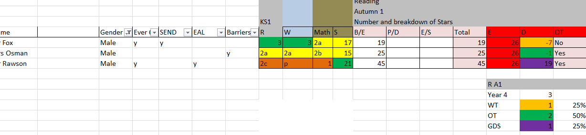 | 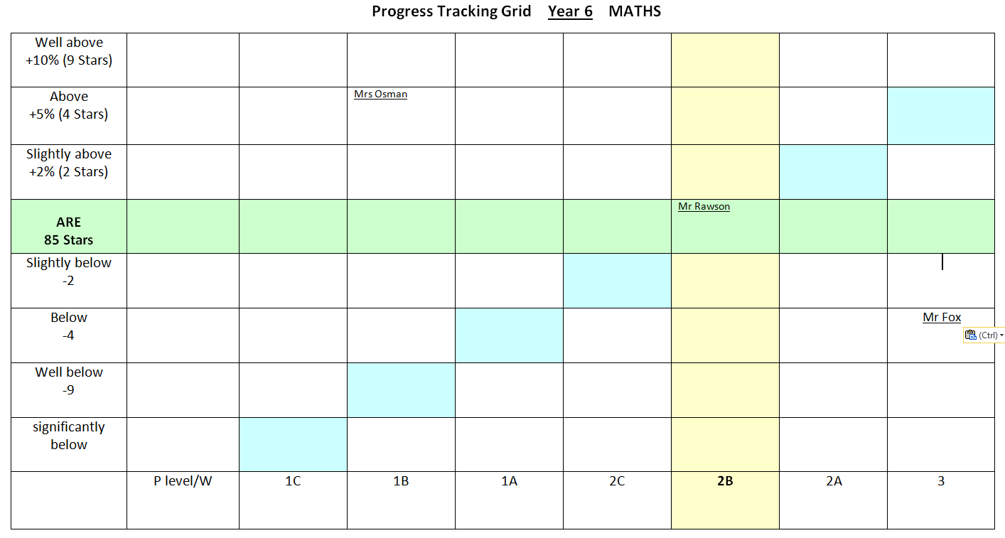

Key Performance Indicators (KPIs)
We believe that if not embedded, some skills within a subject will hinder children progressing at a later stage. These skills are hierarchical. They are considered as essential aspects for pupils to understand if the Secure or the Extending section on an assessment grid is to be awarded. In the English-related planning and assessment grids this means they must be evidenced at the embedded level. In mathematics they must be acquired. These skills are given priority in the curriculum.
- We use a range of assessment strategies
- We use a wide range of assessment tools to monitor progress and attainment.
- The two main areas or through teacher assessment and formal standardised test.

Internal Moderation Example.
Moderation: As part of the pupil progress meetings we will be moderating your assessments. n the first instance we will be moderating your assessment with your year group partners- and then will look for and ask for evidence as to your assessment. For instance, you state that this KPI is progressing, can you show the evidence? Is there reasoning and evidence in speech bubbles to give further evidence: The 3 divisions within each statement, annotated as stars, are an indication of the depth of pupil understanding, not the number of times observed. The number of stars routinely required for a step to be achieved is given for consistency and moderation purposes.
As part of the data analysis/pupil progress meetings, we will then ask you to plan interventions and identify where you need to develop your AFL.
Question 1: Is there consistency across the year group?
Question 2: Is the detailed evidence of this skill?
Question 3: Is there evidence of reasoning skills and depth of understanding to warrant progressing or embedded?
Question 4: Is the work suitably ambitious against the aged related expectations? (How does it compare to other year groups?)
Question 5: Is there evidence of the work being independent when awarding developing or secure?
Question 6: Does all the evidence add up (assessment, everyday work (topic etc…)) to justify that award?
We also moderate these judgements through formal testing, using a nationally recognised test, in Summer 1, to ensure that our judgements match national expectations.

Example to Stars needed
Autumn Term 1 Moderation The purpose of tonight’s moderation is to moderate our assessments and ensure that our judgements are sound. We are focusing on the number of stars tonight and you will work through the books identifying whether enough evidence has been found.
 | End of Autumn 1 |  |  |  | End of Autumn 2 |  |  |  | End of Spring 2 |  |  |  | End of Summer 2
Number of Weeks | 9 |  |  |  | 5 |  |  |  | 13 |  |  |  | 12
 | To meet ARE you will need, on average: Maths 3 Stars per Week, Writing 0.5 SPW, SPAG 1 SPW and R 0.5 SPW. To work out the amount of stars each half term/term we have used the number of weeks and multiplied by the SPW. These score have then been slightly adjusted to reflect certain factors (such as PD days etc). This gives a very steady trajectory, but as a school, we are looking for outstanding progress and attainment and to exceed these amounts.
 | M | W | S | R | M | W | S | R | M | W | S | R | M | W | S | R
Year 3 | 25 | 3 | 6 | 4 | 38 | 5 | 9 | 9 | 74 | 10 | 19 | 15 | 106 | 15 | 29 | 22
Year 4 | 25 | 18 (3) | 7 | 26(4) | 40 | 20 (5) | 12 | 30 (8) | 74 | 24 (9) | 25 | 37 (15) | 108 | 29 (14) | 38 | 43 (21)
Year 5 | 27 | 4 | 7 | 4 | 46 | 7 | 11 | 9 | 85 | 13 | 22 | 17 | 127 | 19 | 33 | 25
Year 6 | 27 | 23 (4) | 9 | 29 (4) | 44 | 26 (7) | 14 | 34 (9) | 85 | 32 (13) | 29 | 42 (17) | 122 | 38 (19) | 43 | 50 (25)

Example of moderation sheet.
Name of Child: | Moderated by:
Year: | Maths | SPAG | Writing | Reading
Whole Books and Number of stars. Is there enough evidence to support the number of stars? | Total Stars Awarded:  The evidence shows that: They are on track/WT/on track to exceed.
One KPI does the evidence show Independent/ Reasoning/ Topic/ using and applying.  Write a brief description of the evidence. inc dates. | KPI:  Evidence:  How does this support the star/stars being awarded?
Moderation Judgement: | Need more evidence |  | Judgements confirmed

