30 x 5 = ?
3 lots of 10
0 units

X | 30 | 0
5 | 150 | 0
150
0 +
150

or
150 + 0 = 0

5 x 0 = 0
5 x 30 = 150

The answer is 150
5 x 3 = 15 then add a 0

23 x 3 = ?
2 lots of 10
3 units

X | 20 | 3
5 | 100 | 15

100 + 15 = 115
or
100
15 +
115

5 x 3 = 15
5 x 20 = 100

5 x 2 = 10 then add a 0
The answer is 115


Grid method Multiplication
Here is a reminder of how you do it.
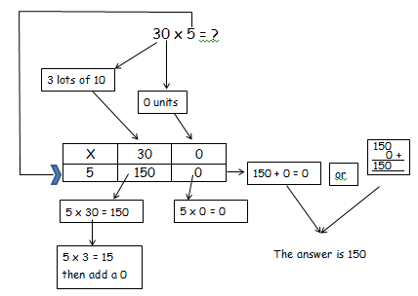
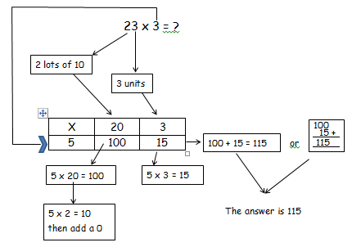

You just give me the answers, I do not want all of the arrows !
x | 20 | 1
3 | 60 | 3
21 x 3 =
60
3 +

60 + 3 =

54 x 5 =
x | 50 | 4
5 |  | + =
250
20 +

65 x 2 =
x

+

+ =

13 x 6 =
x

+

+ =

