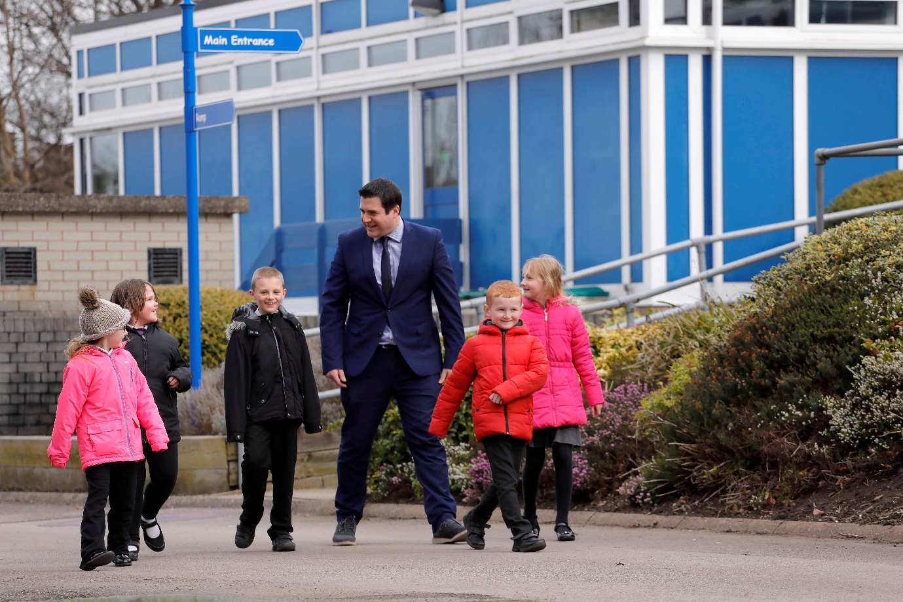

Headteacher Governor
Mr R Fox

I was appointed Headtecher of Donnington Wood in September 2018. I am passionate about making a difference to every child in the school and empowering pupils, staff and parents to succeed.

I have a varied background in education, from working in a residential special needs school to teaching computing across Greenwich, London.

I am responsible for the leadership and management of the school and work very closely with the governing body. I sit on all of the committees that decide how we can continue to improve our school. Everyone at our school works very hard to ensure that our school is happy and hard-working.

I particularly enjoy seeing all of the pupils in school make progress and grow up as confident, responsible children ready to succeed in our world.

