………………………………………………………………………………………………………………………………………………………


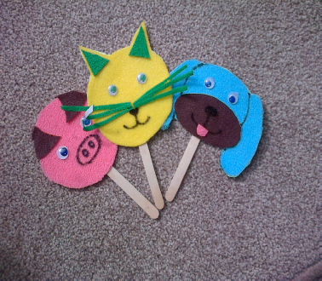
Family Crafts Course at
Donnington Wood Juniors
No previous experience or knowledge required

FREE, fun craft activities for Parents, Grandparents, Carers and your children.

Come and joins us for 6 weeks:
Venue: Donnington Wood Juniors
Date: Tuesday 3rd June
Time: 1:30-3:30pm

Please bring ID with you

Free crèche available subject to demand

If you would like to attend please complete the form overleaf and hand to the School office.
Or e mail us at community.learning@telford.gov.uk
Or Ring: 01952 382888
Or Text: 07797 873891

Have the opportunity to try something new

Enjoy making crafts with your child

Meet other local families

Telford Community Learning

